**IFT530FinalProjectWritten Submission**

E-Clinical Work - Improving Healthcare Together

Ayan Gupta, Pavani Bethireddy, Pujitha Kakkireni, Snehal Pohokar

Department of Information Technology, Arizona State University

IFT 530: Advanced Database Management Systems

April 30, 2021

**Table of Contents**

Introduction 3

Questions That the Database Can Answer 5

ORM Diagram 6

Relational Schema 7

Database Creation 8

Data Insertion 20

Select Statements 37

Stored Procedures 41

Triggers 45

Functions 47

Couchbase 49

Creation of Buckets 49

Insertions 55

Queries 82

Window Function 86

Summary 87

Conclusion 87

References 88

`

# Introduction

The IT framework has revolutionized the world of medicine. In this fast-paced world of healthcare, managing a multi-speciality hospital is a daunting mission. E-Clinical Work - Improving Healthcare Together is a database system that facilitates managing the functioning of the hospital or any medical facility. This system would continue to make the whole operation paperless. It incorporates all information on patients, doctors, staff, hospital administrative data, etc. This system incorporates and facilitates different types of hospital user area: Doctor, Patients, Departments, Reports, Accountant, and occupancies. It has sections for the various professionals that build up a hospital. This database was designed to cut down on the amount of pen paperwork in hospitals. It is a system used in hospitals to keep track of patients, doctors, accountants, and other medical personnel's records. When it comes to health, no one in the world is completely safe. Every single person is afflicted with some kind of illness, and hospitals play a vital role in resolving these issues. You can do your best work if you are in good health. The user will be able to retrieve information about the patient, doctor, beds, and the payments received. There will be a large number of patients admitted to the hospital, so it will be necessary to keep track of information such as personal details, current treatments, and so on. There will be doctors who treat these patients. Many patients can be treated by a single doctor. As a result, the patient and the doctor are related in the database. This system helps in strengthening patient relationships and building personalized engagements that drive healthcare outcomes. Personalize treatment schedules and prioritize tasks based on immediate needs and level of priority is the main advantage of this database. This helps in Connecting the patients to the right treatment more quickly by integrating specific medical data from various networks into a single view (J. Sokpo, 2017).

The information system that we are proposing will contain these as main elements.

**Doctor:**

This section includes the list of the doctors and their schedules. It has information about the doctor. It also includes doctors’ emergency numbers. The doctor can check his schedule and that of other doctors too. This helps a doctor to edit his schedule accordingly. The patient can be given an appointment referring to the doctors’ schedule. This makes the coordination between a doctor and patient easy and hassle-free.

**Patient:**

It has basic data of the patient. New patients can be registered in the system. It includes the patient’s profile, reports, and the invoices that the patient paid to the accountant and can quickly check the availability of rooms/beds.

**Occupancy:**

One can quickly check the availability of beds, bed’s type and description. It also includes data like bed allotment and discharge time.

**Payments**:

It has all the payment-related information, such as invoice, amount and transaction time and date etc. It helps to sum up all the patient's expenses at one time and to deliver a complete bill at the close of the visit or at the time of discharge. This saves time and effort for each department since they do not need to produce separately.

**Accountant**:

It has all the information related to the accountant which includes his personal details. Creates an invoice for the payment to the patient.

**Report:**

The report has all the details such as report type, case history and details of the patient (Patient ID)

**Department:**

Department includes the details of different departments present and the doctors belonging to each department and it also contains the description of each department.

# Questions That the Database Can Answer

1. What is the status of bed availability?
2. How many appointments on a particular date?
3. How it will be beneficial to the doctor?
4. How to retrieve the payment history of a patient on a particular date?
5. How to get details of a particular patient?

# 

# ORM Diagram

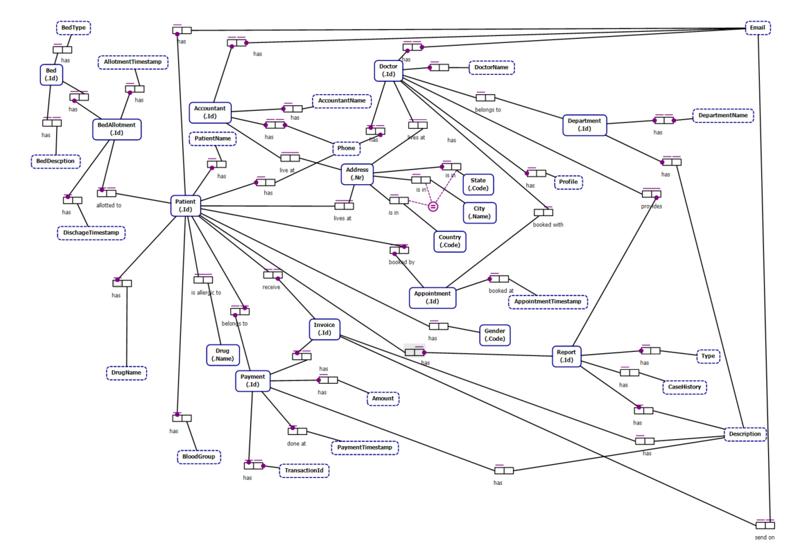

# Relational Schema

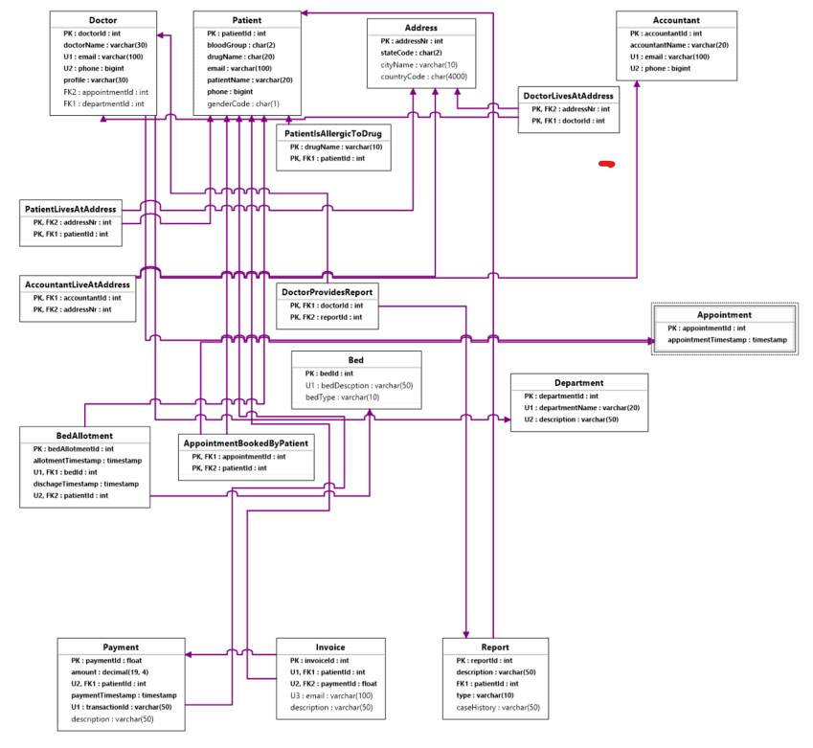

# Database Creation

The following is the creation of E-Clinical Work database and table creation.

**Query:**

USE EClinicalWork;

GO

IF DB_ID('EClinicalWork') IS NOT NULL

DROP DATABASE EClinicalWork;

GO

CREATE DATABASE EClinicalWork;

GO

USE EClinicalWork;

GO

**Screenshot:**

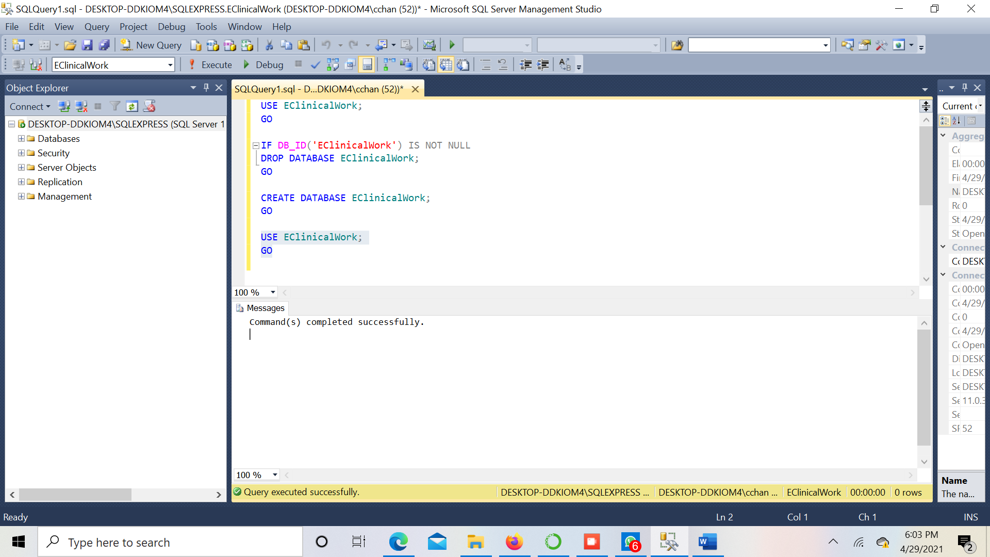

**Table 1 – Accountant**

**Query:**

CREATE TABLE Accountant

(

accountantId int IDENTITY (1, 1) NOT NULL,

accountantName nvarchar(20) NOT NULL,

email nvarchar(100) NOT NULL,

phone bigint NOT NULL,

CONSTRAINT Accountant_PK PRIMARY KEY(accountantId),

CONSTRAINT Accountant_UC1 UNIQUE(email),

CONSTRAINT Accountant_UC2 UNIQUE(phone)

)

GO

**Screenshot:**

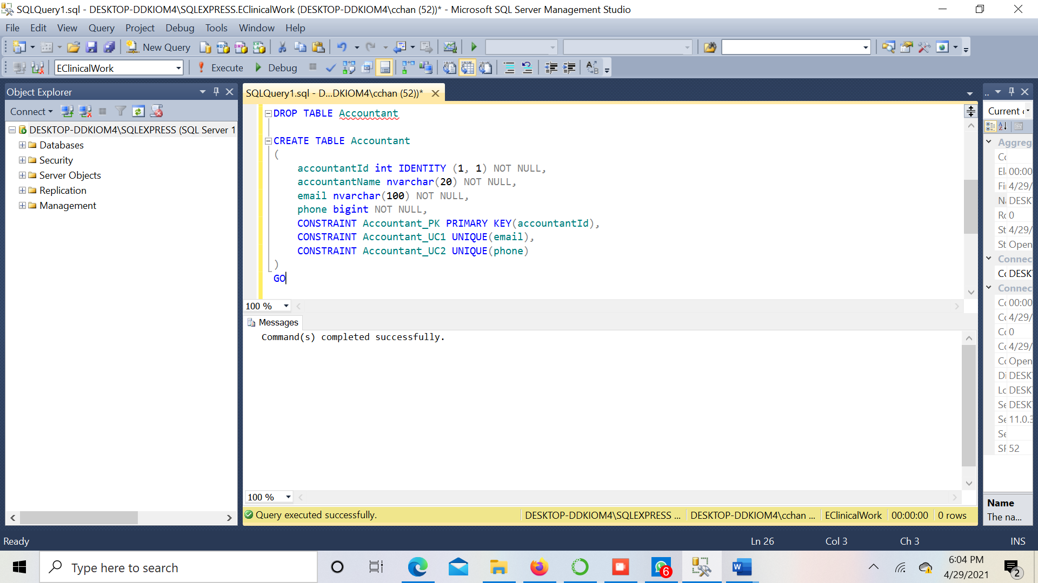

**Table 2 – Address**

**Query:**

CREATE TABLE Address

(

addressNr int NOT NULL,

stateCode nchar(2) NOT NULL,

cityName nvarchar(10),

countryCode nchar(4000),

CONSTRAINT Address_PK PRIMARY KEY(addressNr)

)

GO

**Screenshot:**

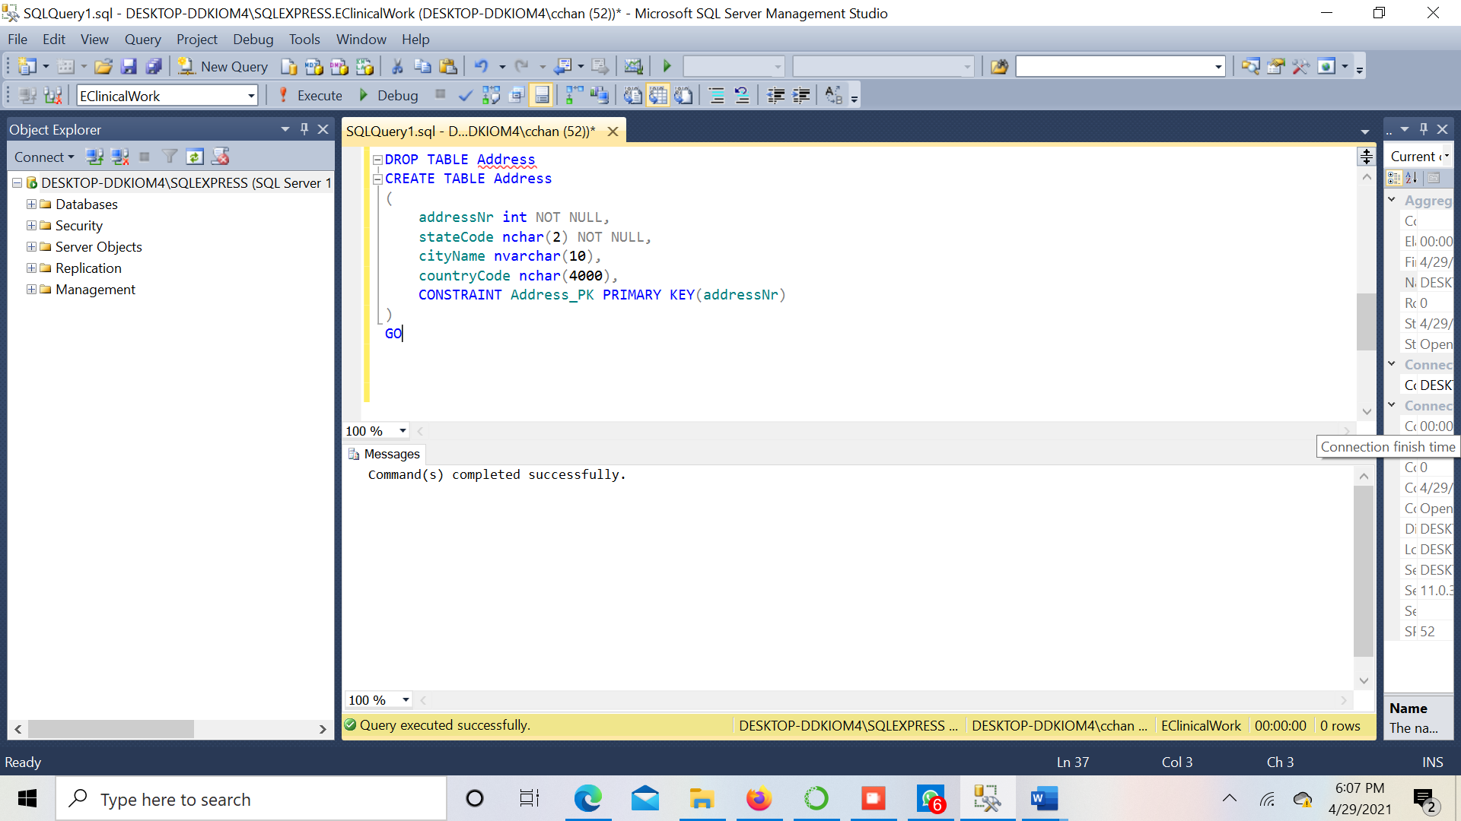

**Table 3 – Doctor**

**Query:**

CREATE TABLE Doctor

(

doctorId int IDENTITY (1, 1) NOT NULL,

doctorName nvarchar(30) NOT NULL,

email nvarchar(30) NOT NULL,

phone bigint NOT NULL,

profile nvarchar(30) NOT NULL,

appointmentId int,

departmentId int,

CONSTRAINT Doctor_PK PRIMARY KEY(doctorId),

CONSTRAINT Doctor_UC1 UNIQUE(email),

CONSTRAINT Doctor_UC2 UNIQUE(phone)

)

GO

**Screenshot:**

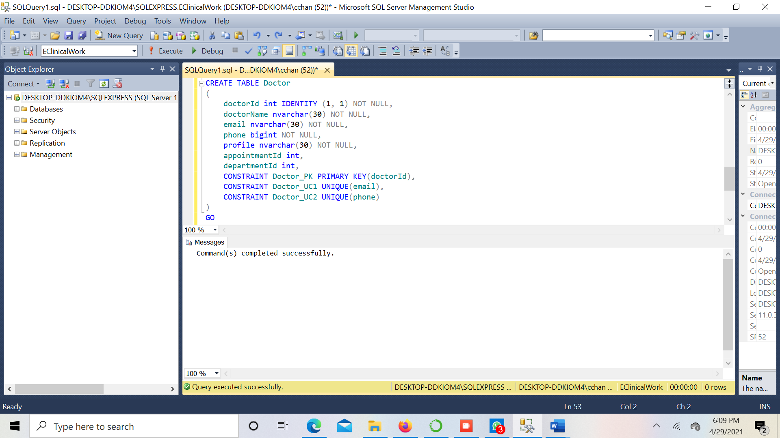

**Table 4 – Patient**

**Query:**

CREATE TABLE Patient

(

patientId int IDENTITY (1, 1) NOT NULL,

bloodGroup nchar(2) NOT NULL,

email nvarchar(30) NOT NULL,

patientName nvarchar(20) NOT NULL,

phone bigint NOT NULL,

genderCode nchar(1),

drugName nvarchar(20),

CONSTRAINT Patient_PK PRIMARY KEY(patientId)

)

GO

**Screenshot:**

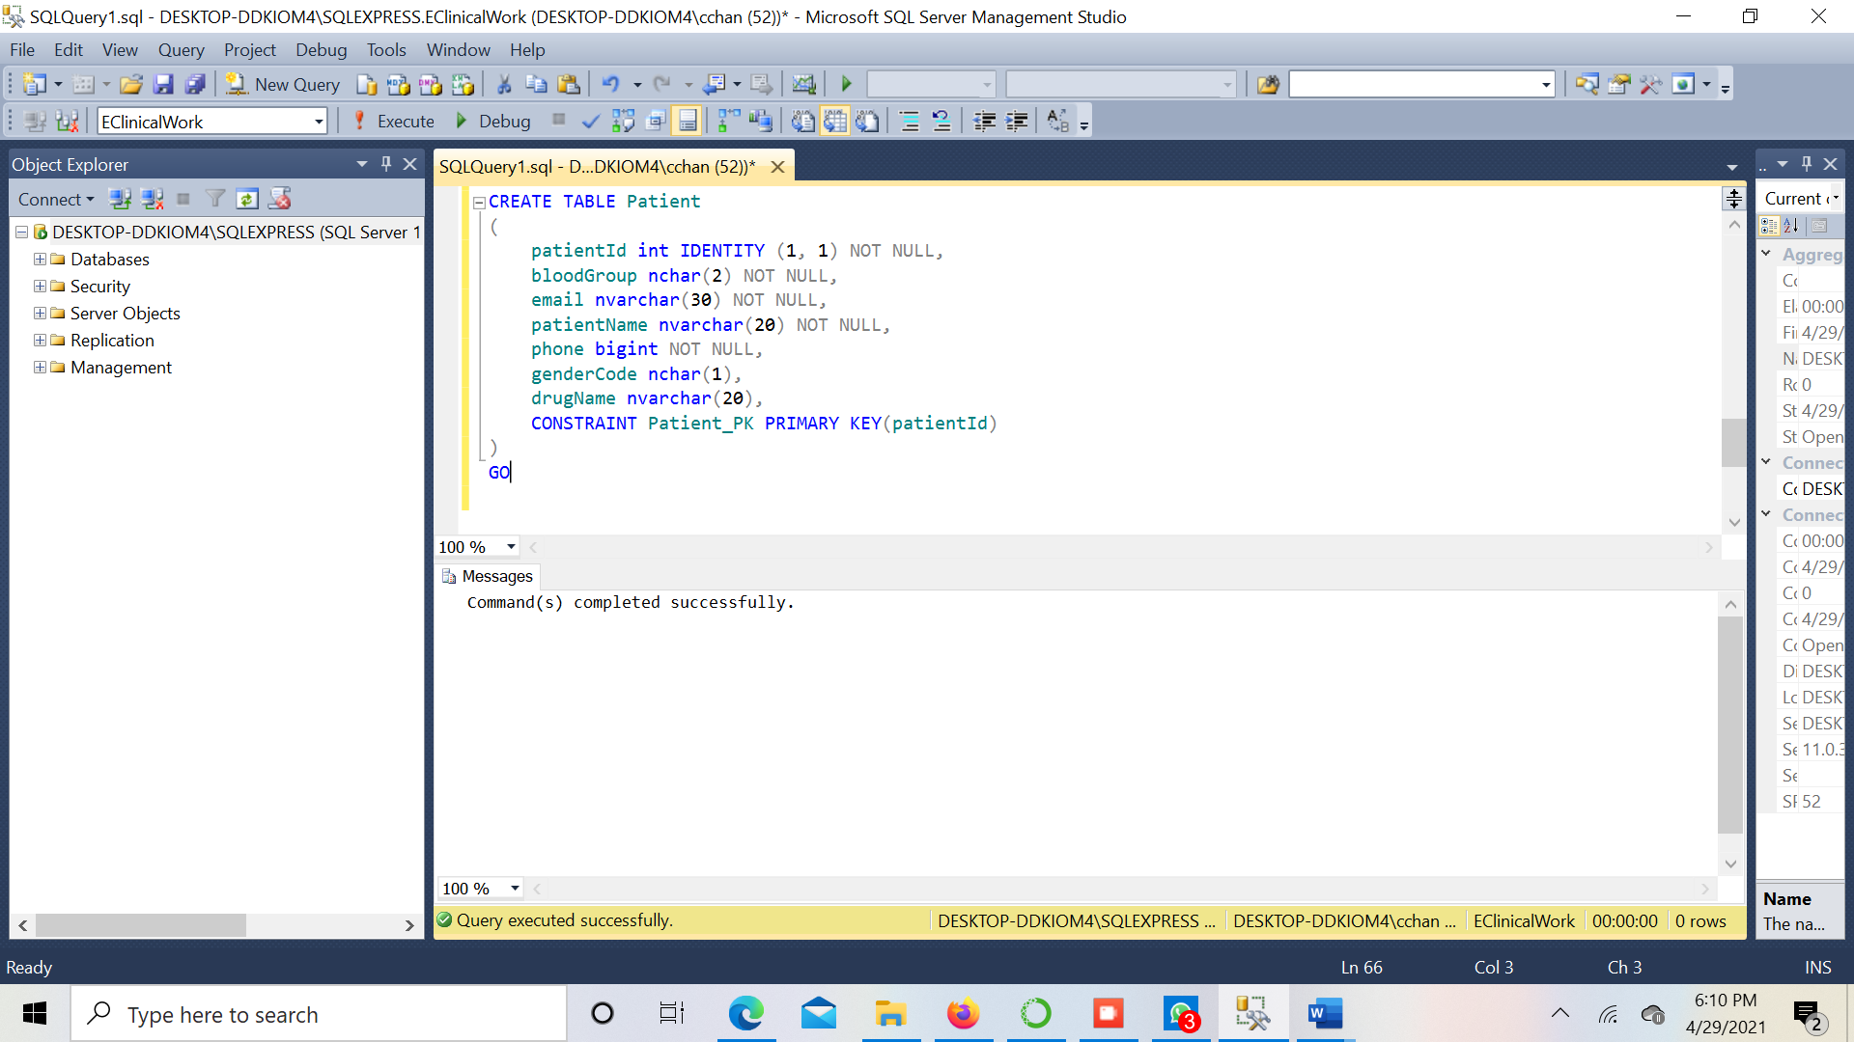

**Table 5 – Department**

**Query:**

CREATE TABLE Department

(

departmentId int IDENTITY (1, 1) NOT NULL,

departmentName nvarchar(20) NOT NULL,

description nvarchar(50) NOT NULL,

CONSTRAINT Department_PK PRIMARY KEY(departmentId),

CONSTRAINT Department_UC1 UNIQUE(departmentName),

CONSTRAINT Department_UC2 UNIQUE(description)

)

GO

**Screenshot:**

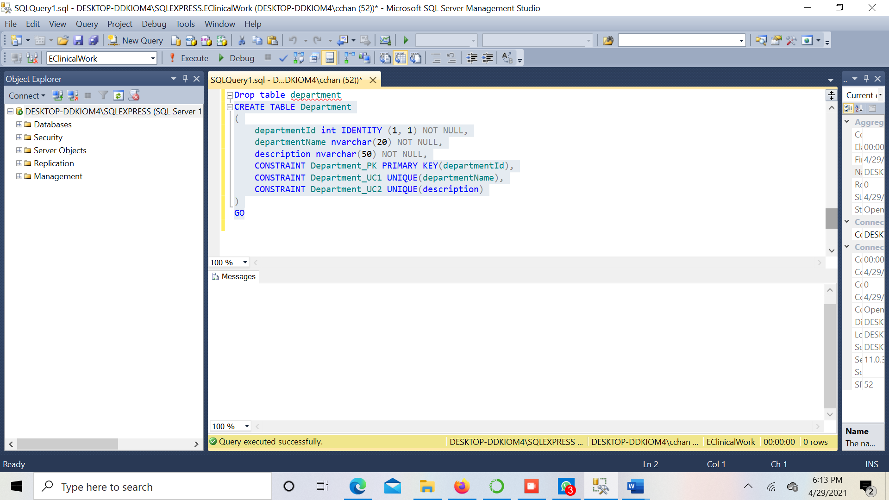

**Table 6 – Invoice**

**Query:**

CREATE TABLE Invoice

(

invoiceId int IDENTITY (1, 1) NOT NULL,

patientId int NOT NULL,

paymentId float NOT NULL,

email nvarchar(30),

description nvarchar(50),

CONSTRAINT Invoice_PK PRIMARY KEY(invoiceId),

CONSTRAINT Invoice_UC1 UNIQUE(patientId),

CONSTRAINT Invoice_UC2 UNIQUE(paymentId)

)

GO

**Screenshot:**

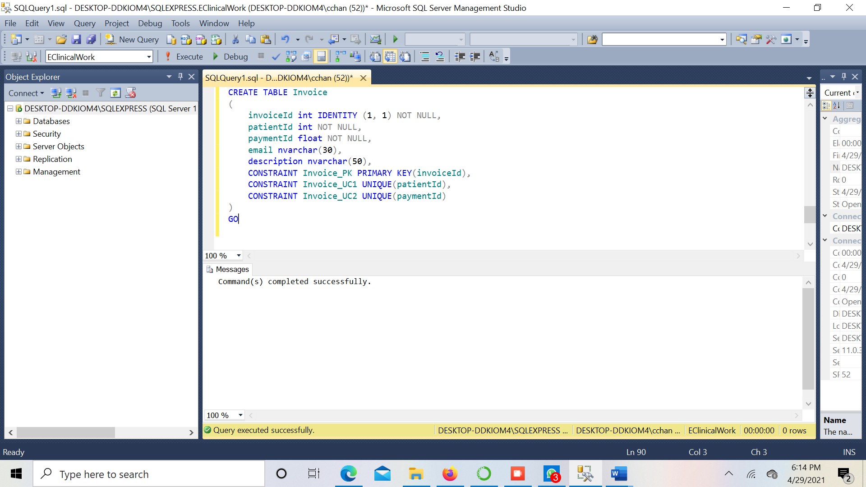

**Table 7 – Payment**

**Query:**

CREATE TABLE Payment

(

paymentId int NOT NULL,

amount decimal(19,4) NOT NULL,

patientId int NOT NULL,

paymentTimestamp datetime NOT NULL,

transactionId nvarchar(18) NOT NULL,

description nvarchar(50),

CONSTRAINT Payment_PK PRIMARY KEY(paymentId),

CONSTRAINT Payment_UC1 UNIQUE(transactionId),

CONSTRAINT Payment_UC2 UNIQUE(patientId)

)

GO

**Screenshot:**

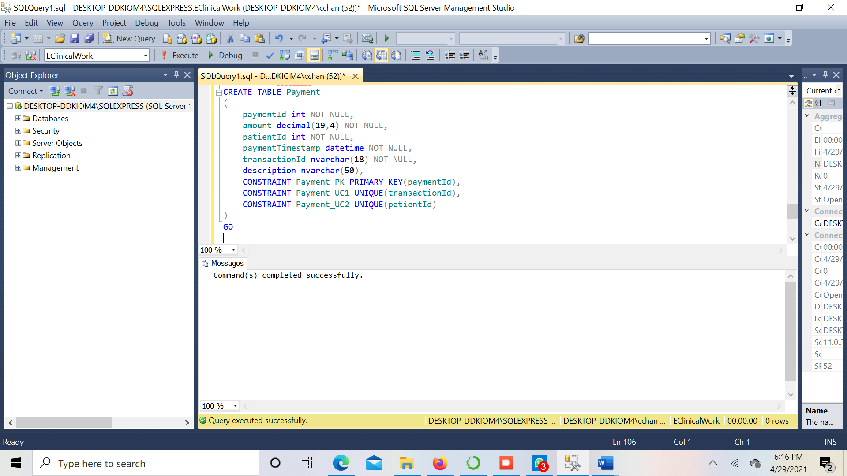

**Table 8 – Appointment**

**Query:**

CREATE TABLE Appointment

(

appointmentId int IDENTITY (1, 1) NOT NULL,

appointmentTimestamp datetime NOT NULL,

CONSTRAINT Appointment_PK PRIMARY KEY(appointmentId)

)

GO

**Screenshot:**

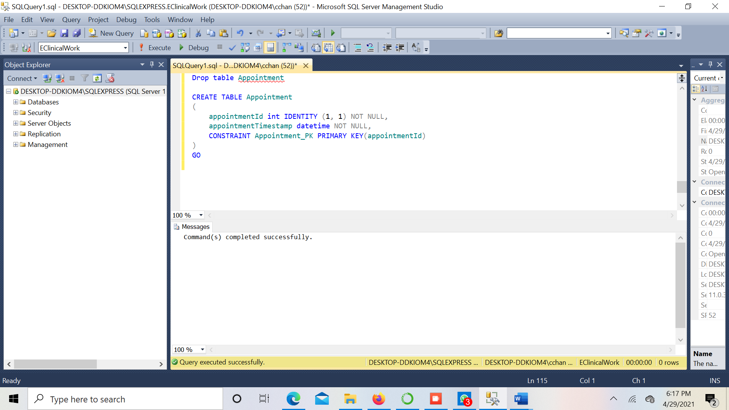

**Table 9 – AccountantLiveAtAddress**

**Query:**

CREATE TABLE AccountantLiveAtAddress

(

accountantId int NOT NULL,

addressNr int NOT NULL,

CONSTRAINT AccountantLiveAtAddress_PK PRIMARY KEY(accountantId, addressNr)

)

GO

**Screenshot:**

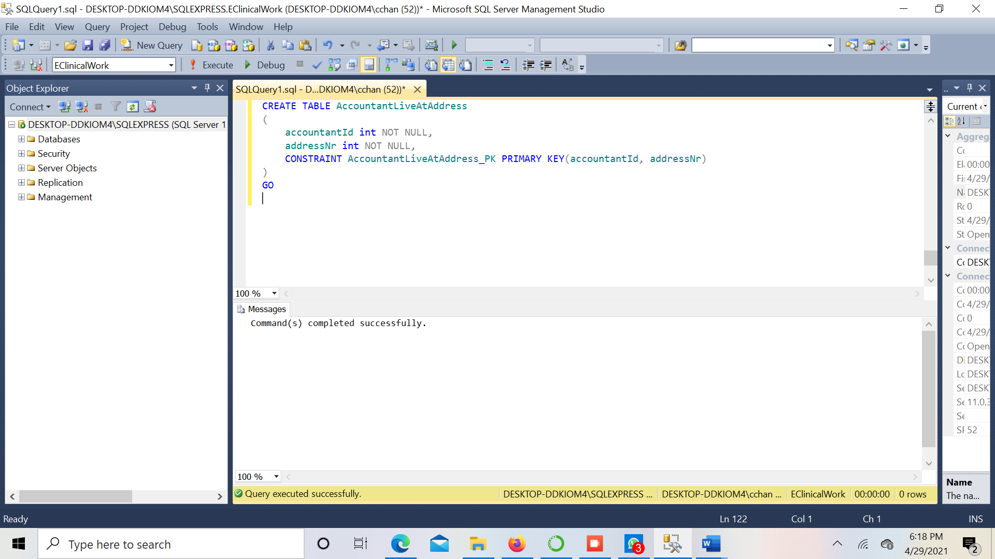

**Table 10 – PatientLivesAtAddress**

**Query:**

CREATE TABLE PatientLivesAtAddress

(

addressNr int NOT NULL,

patientId int NOT NULL,

CONSTRAINT PatientLivesAtAddress_PK PRIMARY KEY(patientId, addressNr)

)

GO

**Screenshot:**

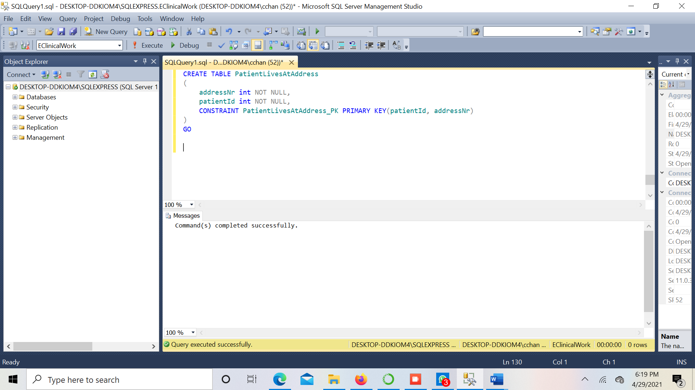

**Table 11– DoctorLivesAtAddress**

**Query:**

CREATE TABLE DoctorLivesAtAddress

(

addressNr int NOT NULL,

doctorId int NOT NULL,

CONSTRAINT DoctorLivesAtAddress_PK PRIMARY KEY(doctorId, addressNr)

)

GO

**Screenshot:**

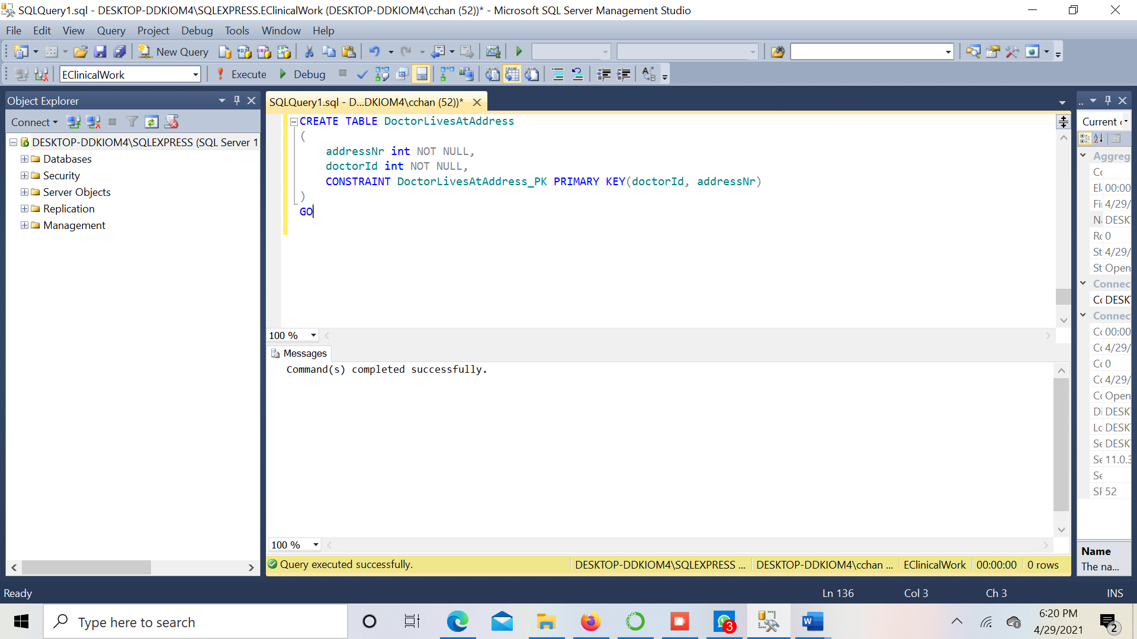

**Table 12 – DoctorProvidesReport**

**Query:**

CREATE TABLE DoctorProvidesReport

(

doctorId int NOT NULL,

reportId int NOT NULL,

CONSTRAINT DoctorProvidesReport_PK PRIMARY KEY(doctorId, reportId)

)

GO

**Screenshot:**

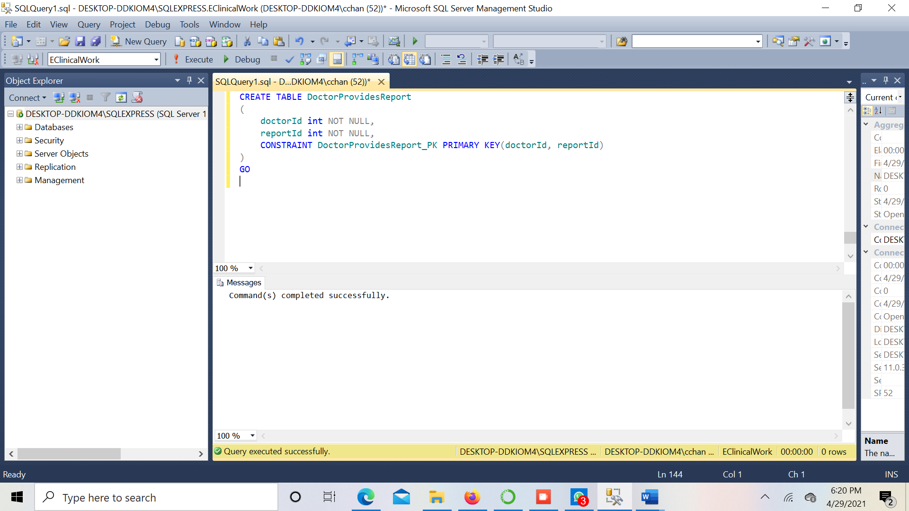

**Table 13 – Bed**

**Query:**

CREATE TABLE Bed

(

bedId int IDENTITY (1, 1) NOT NULL,

bedDescption nvarchar(50),

bedType nvarchar(10),

CONSTRAINT Bed_PK PRIMARY KEY(bedId)

)

GO

**Screenshot:**

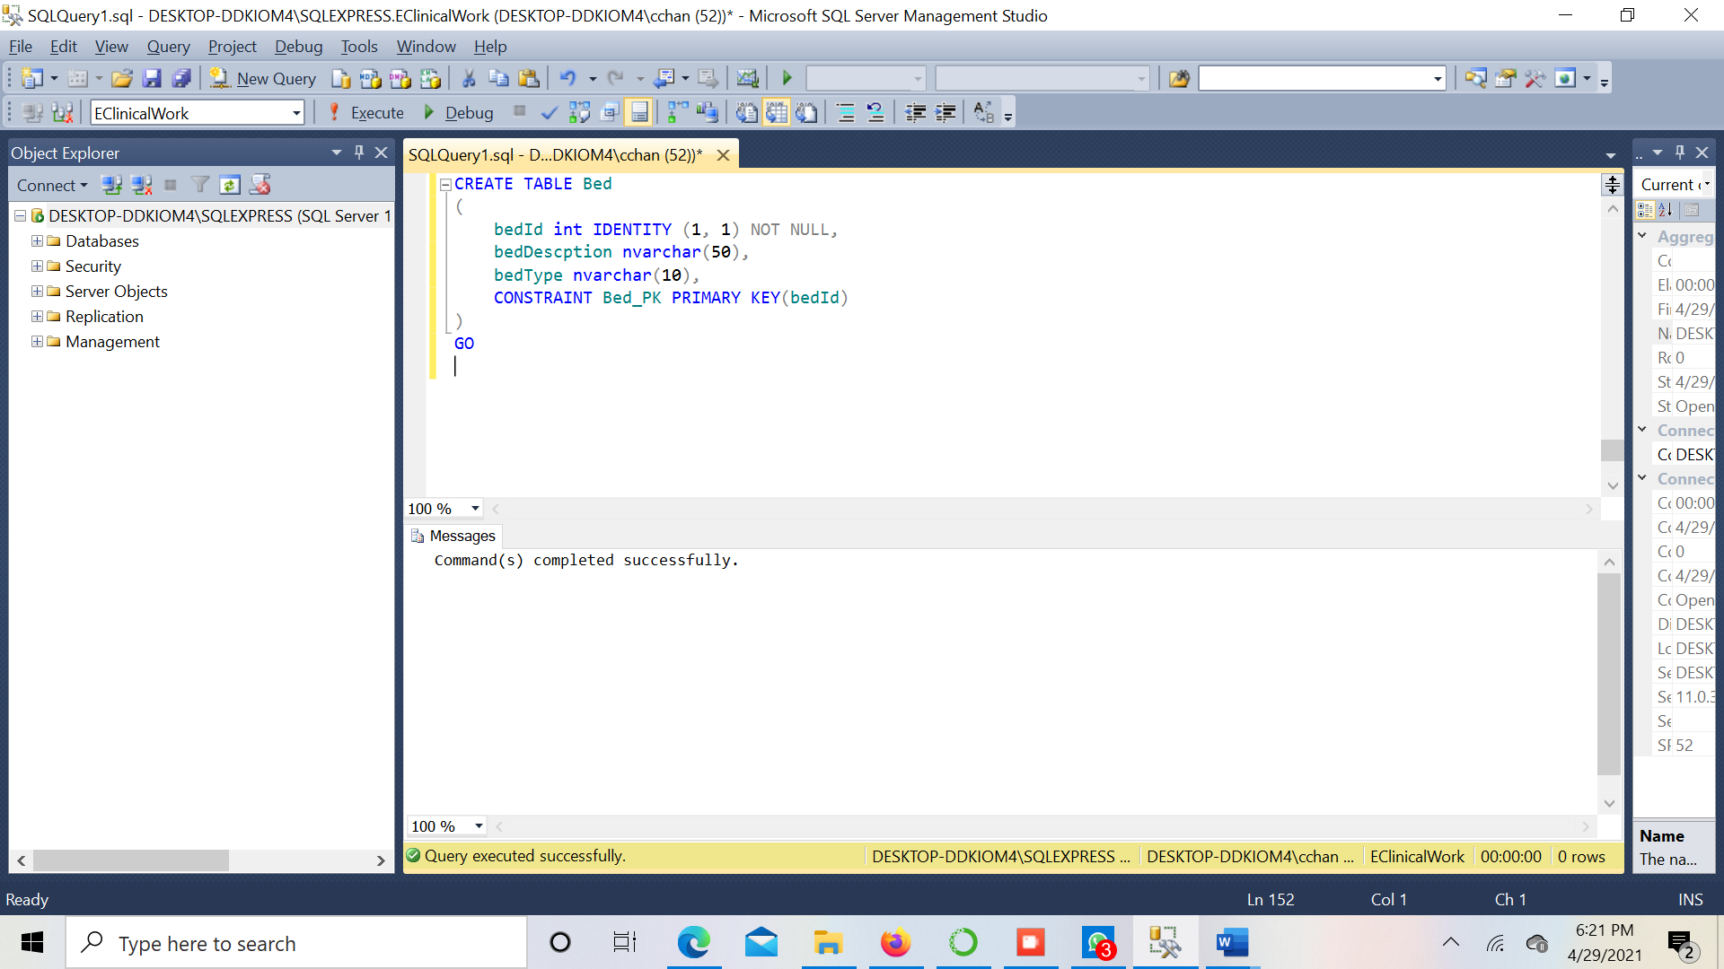

**Table 14 – AppointmentBookedByPatient**

**Query:**

CREATE TABLE AppointmentBookedByPatient

(

appointmentId int NOT NULL,

patientId int NOT NULL,

CONSTRAINT AppointmentBookedByPatient_PK PRIMARY KEY(appointmentId, patientId)

)

GO

**Screenshot:**

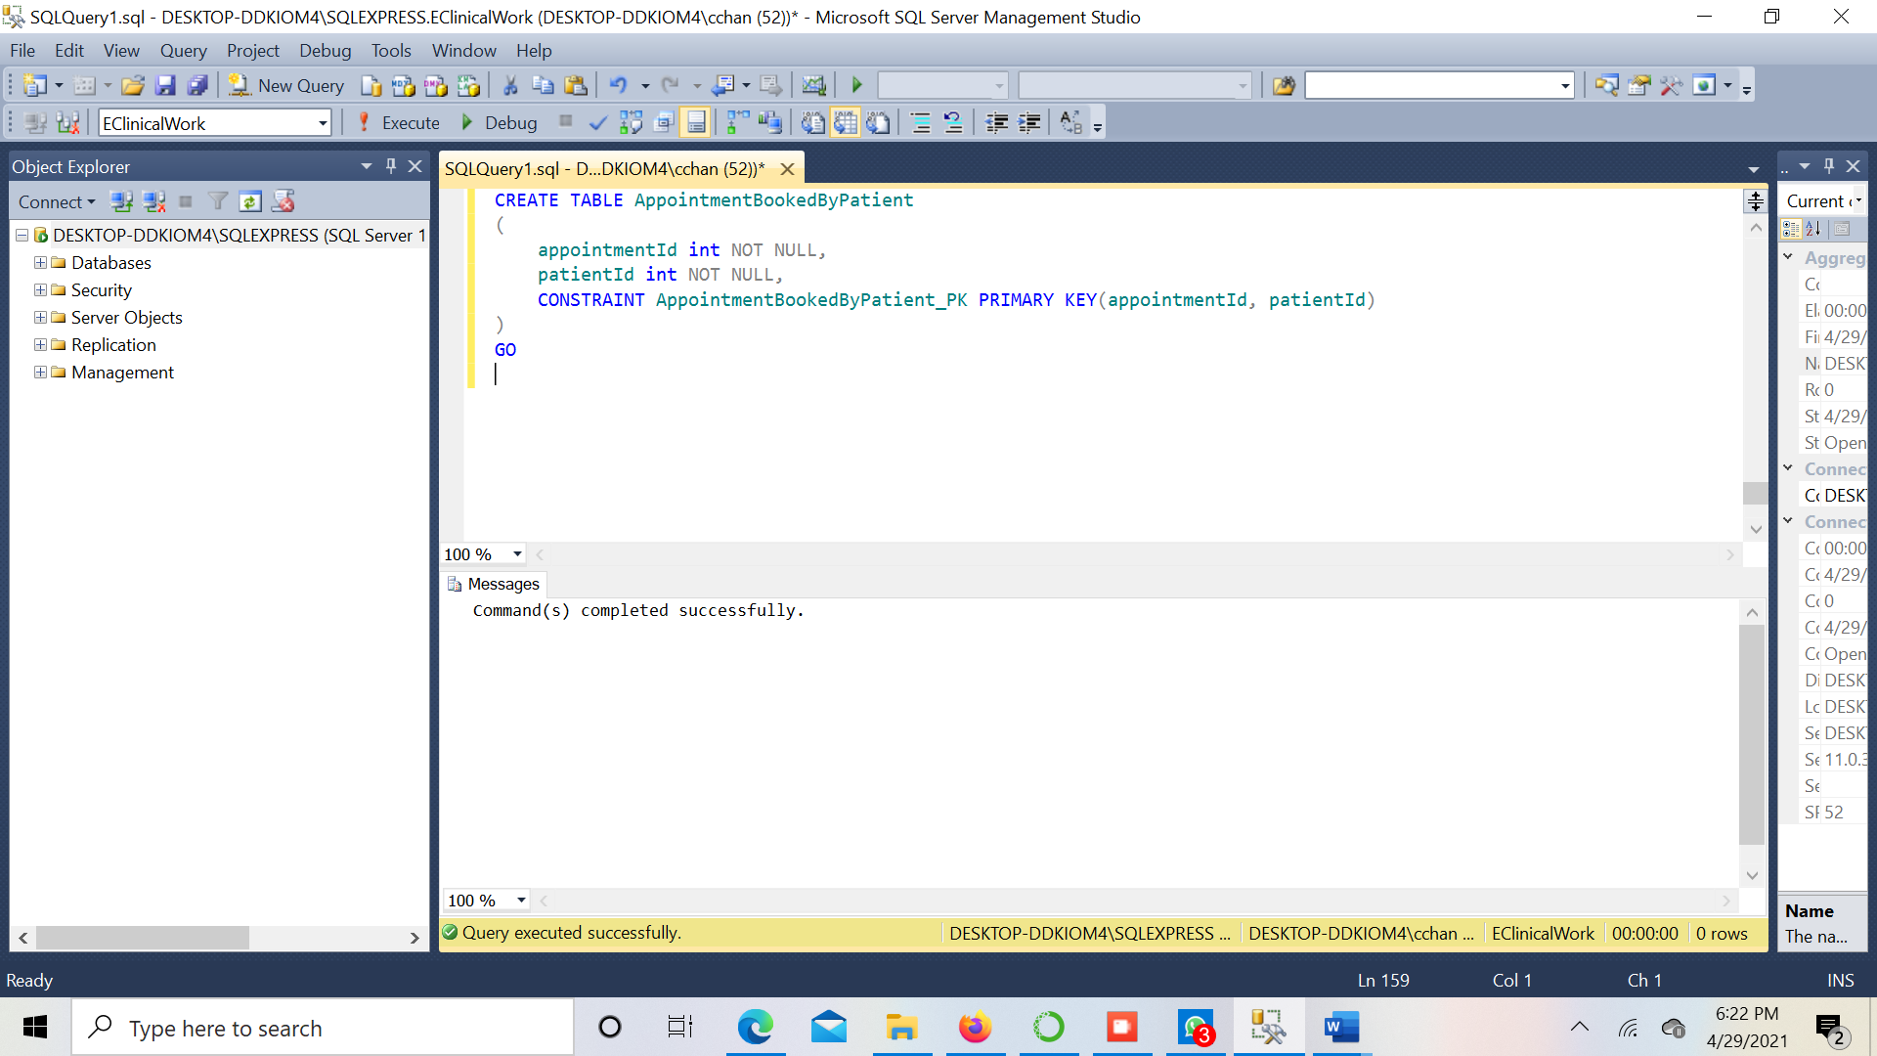

**Table 15 – BedAllotment**

**Query:**

CREATE TABLE BedAllotment

(

bedAllotmentId int IDENTITY (1, 1) NOT NULL,

allotmentTimestamp datetime NOT NULL,

bedId int NOT NULL,

dischageTimestamp datetime NOT NULL,

patientId int NOT NULL,

CONSTRAINT BedAllotment_PK PRIMARY KEY(bedAllotmentId),

CONSTRAINT BedAllotment_UC1 FOREIGN KEY(bedId) REFERENCES Bed(bedId),

CONSTRAINT BedAllotment_UC2 UNIQUE(patientId)

)

GO

**Screenshot:**

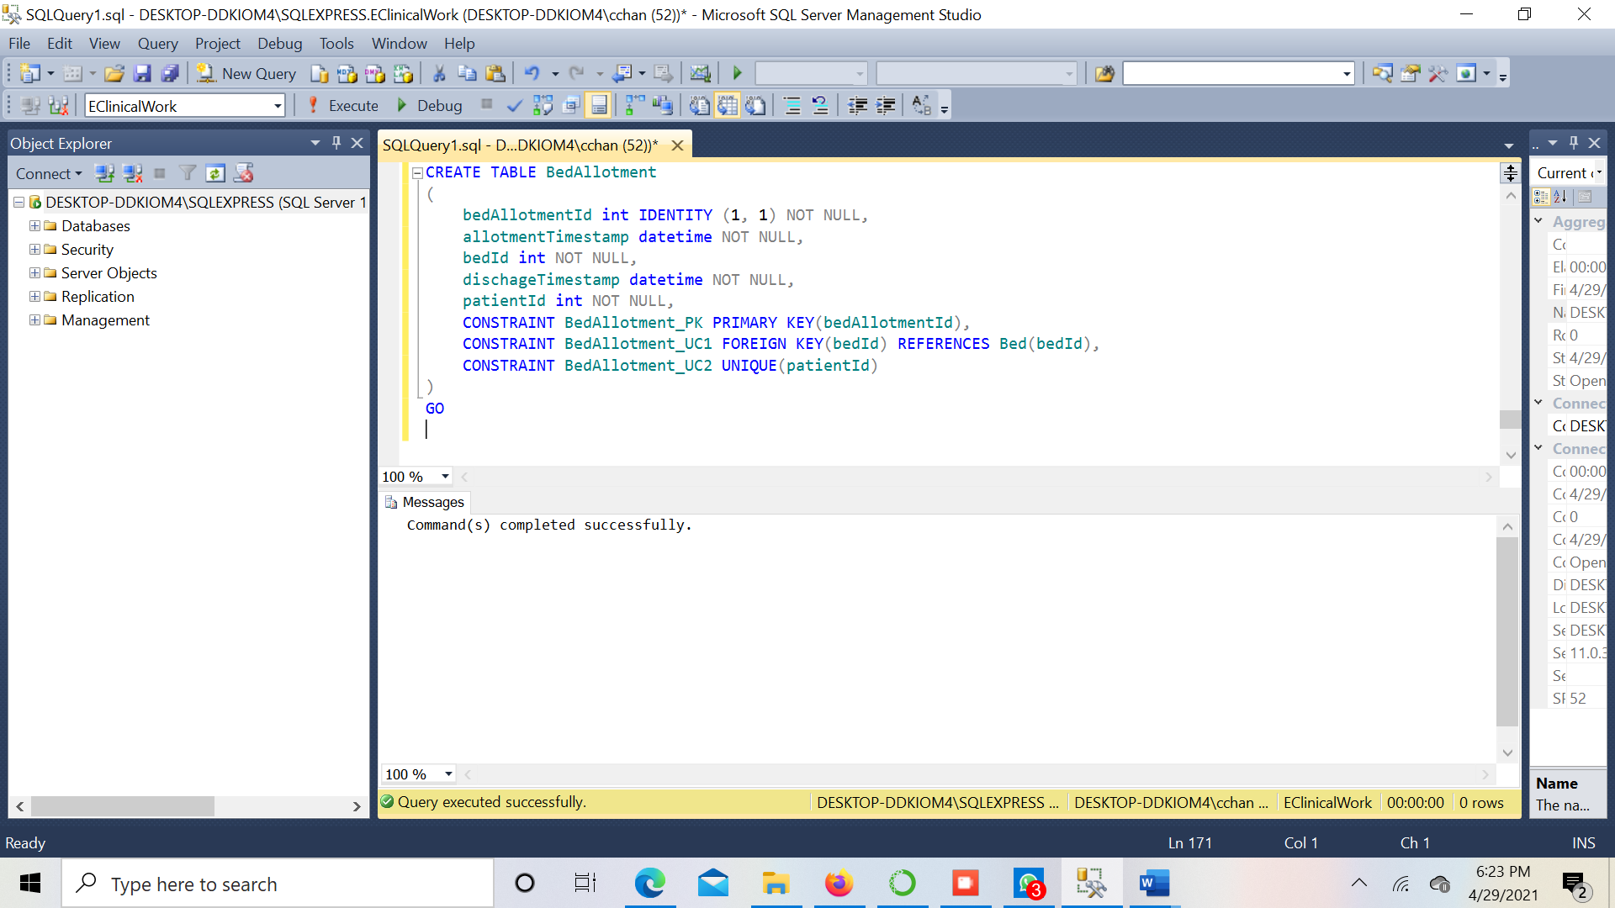

**Table 16 –** **Report**

**Query:**

CREATE TABLE Report

(

reportId int IDENTITY (1, 1) NOT NULL,

description nvarchar(50) NOT NULL,

patientId int NOT NULL,

type nvarchar(10) NOT NULL,

caseHistory nvarchar(50) NOT NULL,

CONSTRAINT Report_PK PRIMARY KEY(reportId)

)

GO

**Screenshot:**

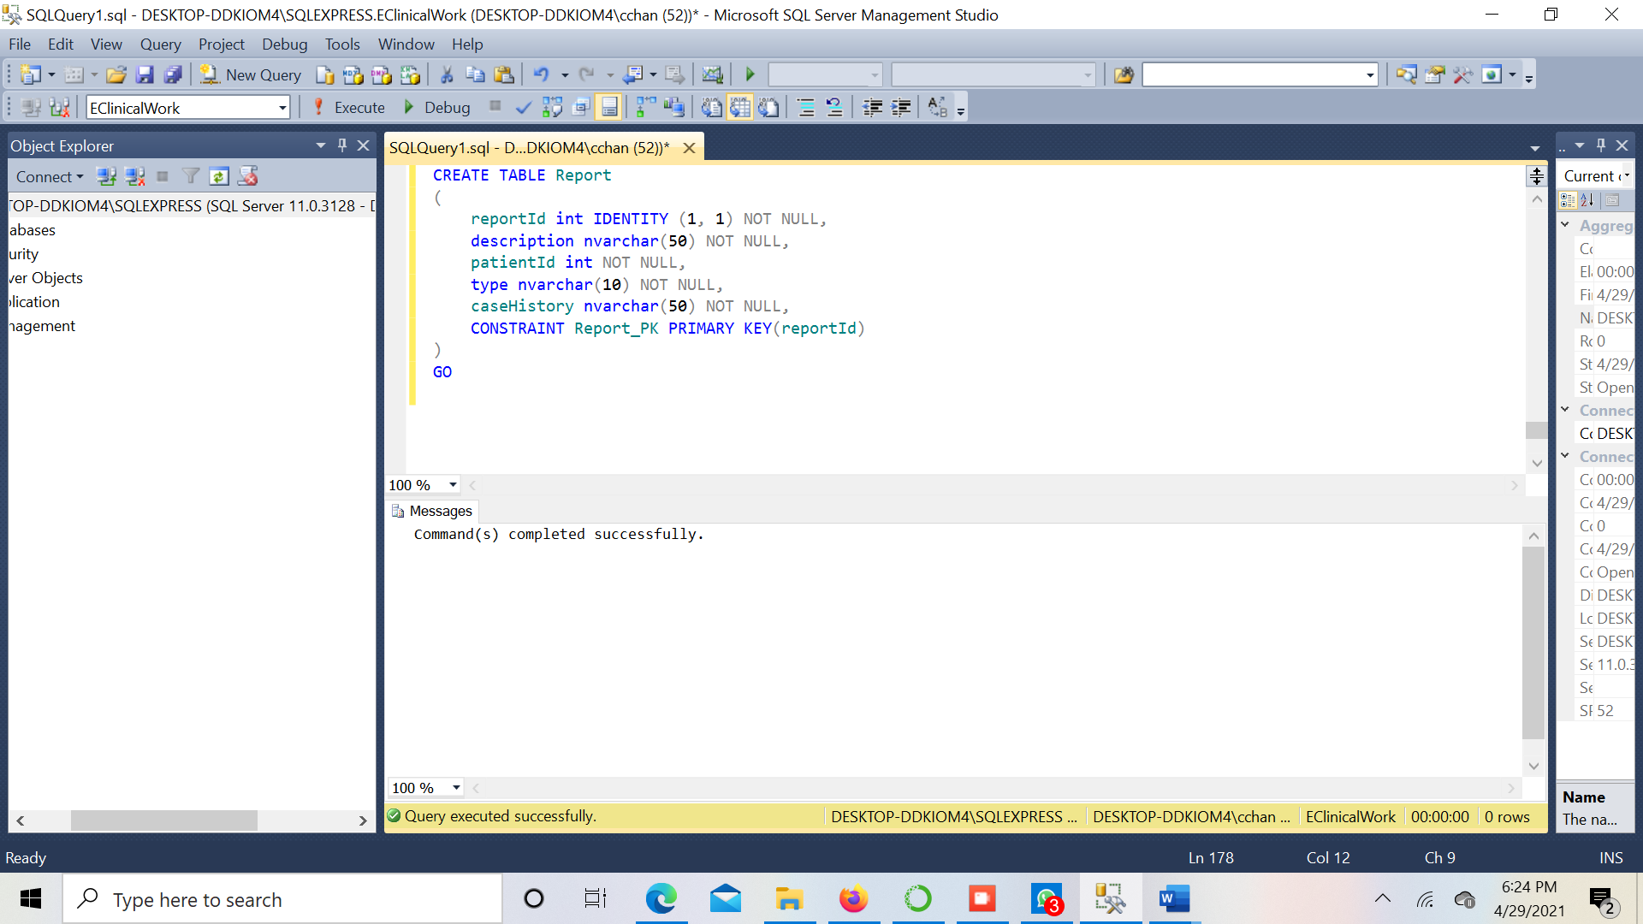

**Table 17 –** **AccountantAuditTable**

**Query:**

CREATE TABLE AccountantAuditTable

(

accountantId int NOT NULL,

accountantName nvarchar(20) NOT NULL,

email nvarchar(100) NOT NULL,

phone bigint NOT NULL,

deletedTime datetime NOT NULL,

)

GO

**Screenshot:**

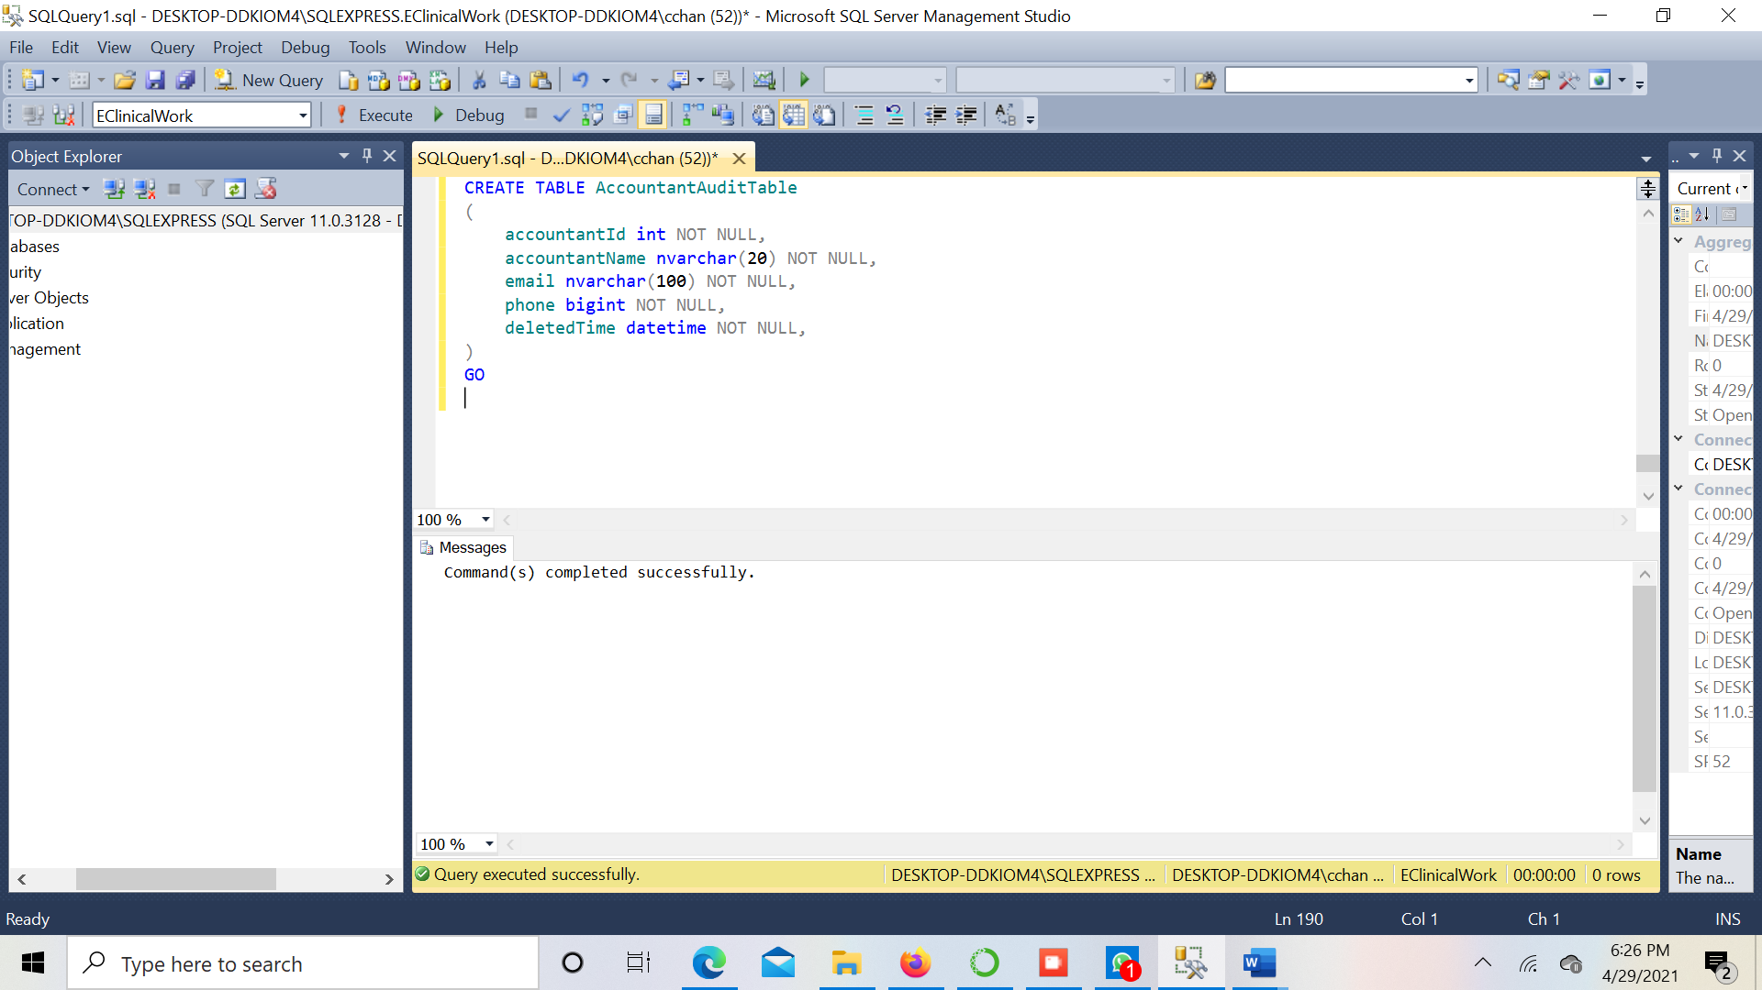

# Data Insertion

We are currently in the project's data insertion phase. The code following displays the data that has been inserted.

**Table 1 – Accountant**

INSERT INTO Accountant (accountantId, accountantName, email, phone) VALUES

(1, 'Himanshu Sharma', 'hsharma@gmail.com', +18765742285),

(2, 'Rahul Gupta', 'rgupta@gmail.com', +16543387992),

(3, 'Sushil Kumar', 'skumar@gmail.com', +127765732443),

(4, 'Mohan Bansal', 'mbansal@gmail.com', +14329987653),

(5, 'Pankaj Raj', 'praj@gmail.com', +16543321273),

(6, 'Harsh Vardhan', 'hvardhan@gmail.com', +13434876484),

(7, 'Sidhant Lalvani', 'sidlal@gmail.com', +14563827389),

(8, 'Bal Veer', 'balveer@gmail.com', +18389493948),

(9, 'James Alabi', 'jalabi@gmail.com', +14437782902),

(10, 'Om Kapoor', 'omkap@gmail.com', +17564795389);

**Screenshots:**

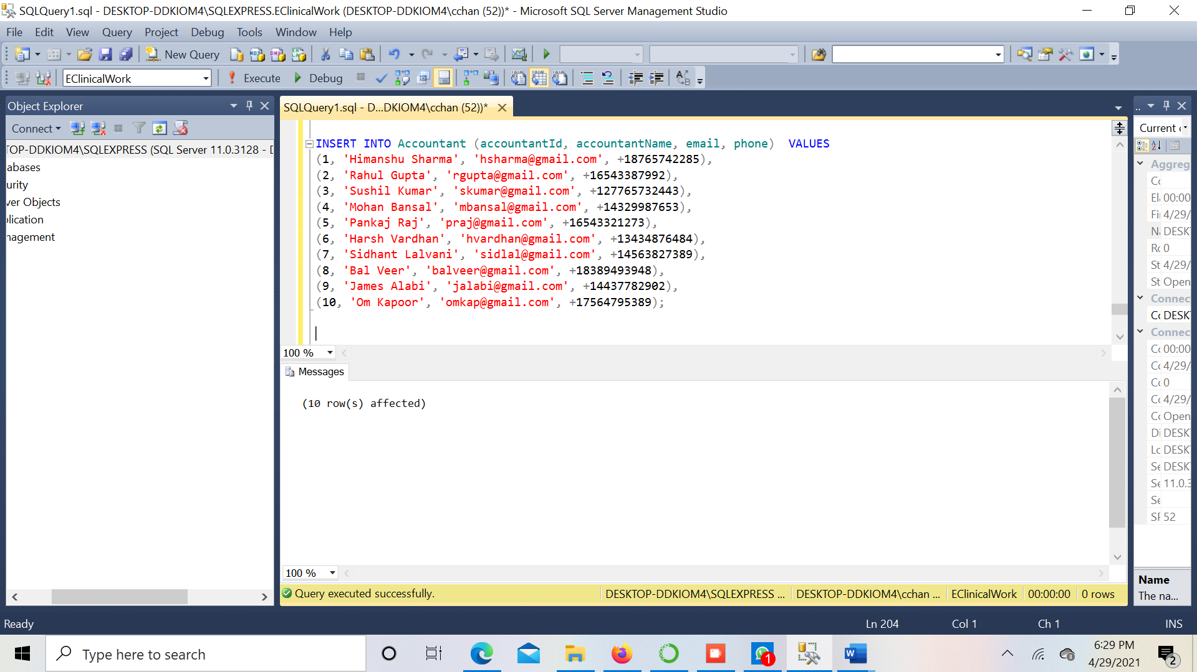

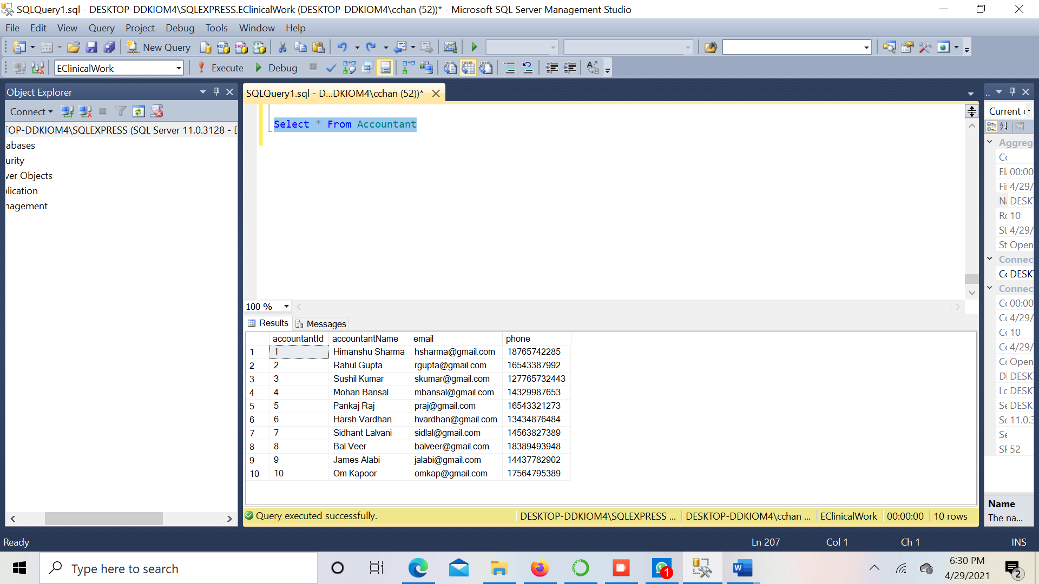

**Table 2 – Address**

INSERT INTO Address (addressNr, stateCode, cityName, countryCode)

Values

(1, 'AZ', 'Tempe', 1),

(2, 'CA', 'San Diego', 1),

(3, 'AZ', 'Phoenix', 1),

(4, 'CT', 'Hartford', 1),

(5, 'DE', 'Dover', 1),

(6, 'FL', 'Miami', 1),

(7, 'GA', 'Atlanta', 1),

(8, 'HI', 'Hilo', 1),

(9, 'ID', 'Boise', 1),

(10, 'IL', 'Chicago', 1),

(11, 'IN', 'Indianap', 1),

(12, 'IA', 'Iowa City', 1),

(13, 'KS', 'Topeka', 1),

(14, 'KY', 'Kentucky', 1),

(15, 'MI', 'Detroit', 1);

**Screenshots:**

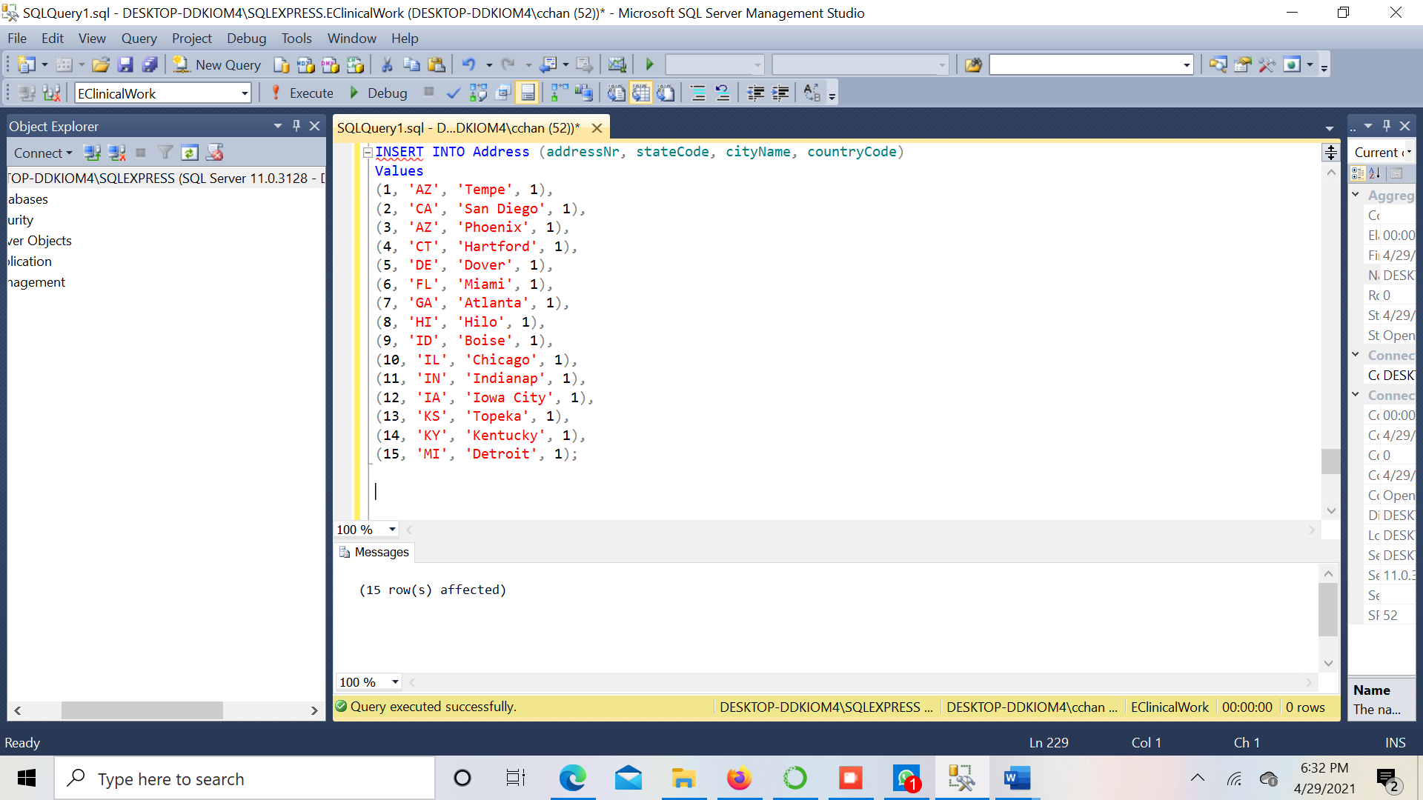

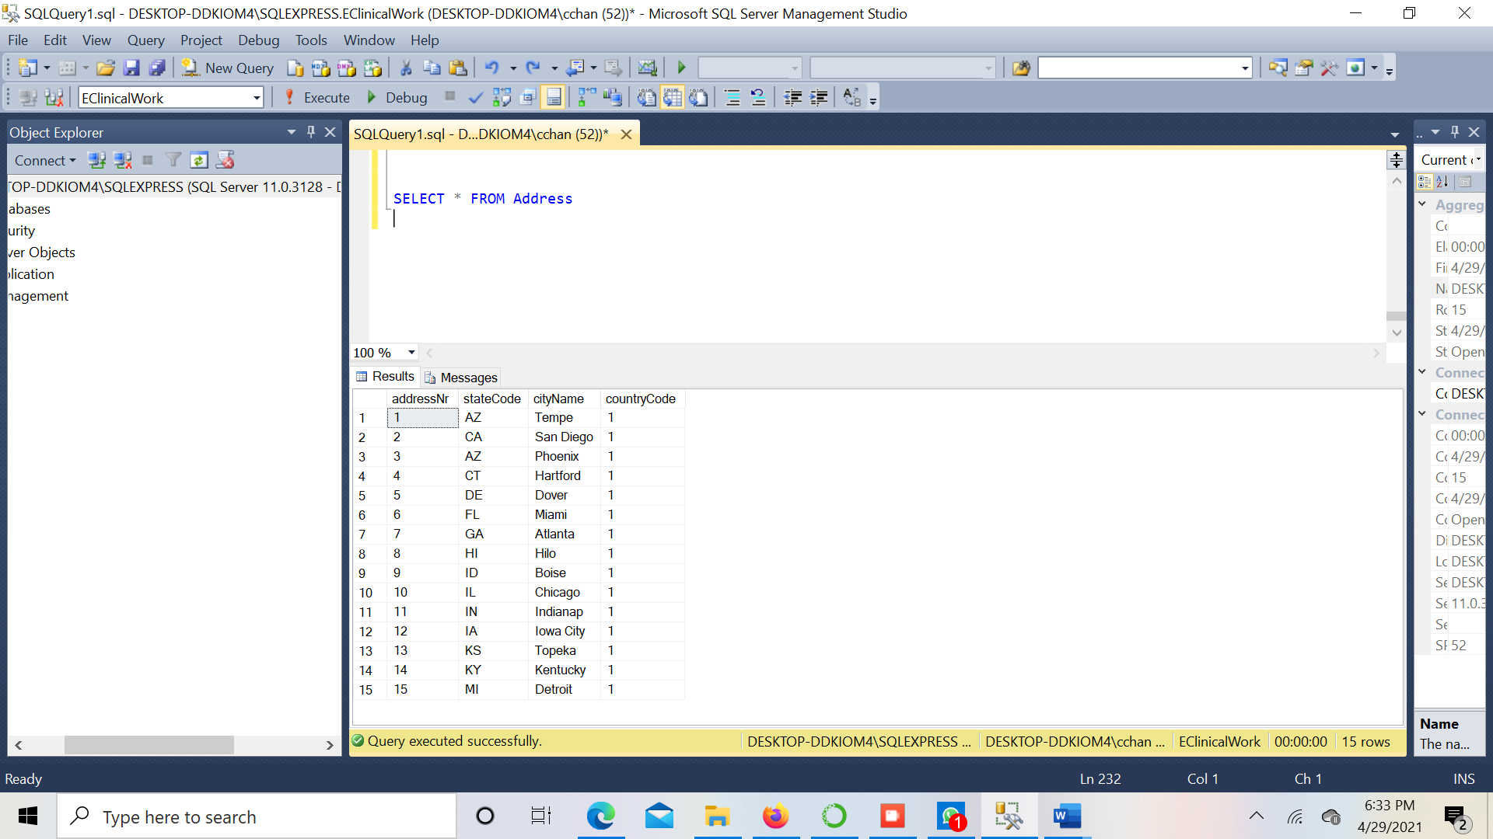

**Table 3 – Doctor**

Insert INTO Doctor (doctorId, doctorName, email, phone, profile, appointmentId,departmentId)

VALUES

(1, 'Anil Kumar', 'akumar@gmail.com', +12234434339, 'Profile', 2, 1),

(2, 'Brij Mohan', 'bmohan@gmail.com', +15757473989, 'Profile', 4, 3),

(3, 'Veer Singh', 'vsingh@gmail.com', +12324345496, 'Profile', 1, 6),

(4, 'Baal Gupta', 'bgupta@gmail.com', +15439856332, 'Profile', 3, 4),

(5, 'Harshit Arora', 'harora@gmail.com', +19984342345, 'Profile',5,2),

(6, 'Bilu Singh', 'bsingh@gmail.com', +14562134568, 'Profile', 6,3),

(7, 'Raj Kumar', 'rajkum@gmail.com', +18478349827, 'Profile',7,9 ),

(8, 'Sanddy Singh', 'sandsing@gmail.com', +17654687652, 'Profile',8,7 ),

(9, 'Brandy Jain', 'brandjain@gmail.com', +17674537386, 'Profile',9,8),

(10, 'Himanshu Rana', 'himrana@gmail.com', +19654364736, 'Profile',10,10);

**Screenshots:**

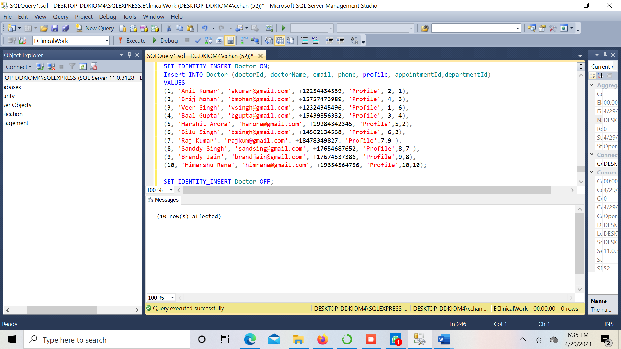

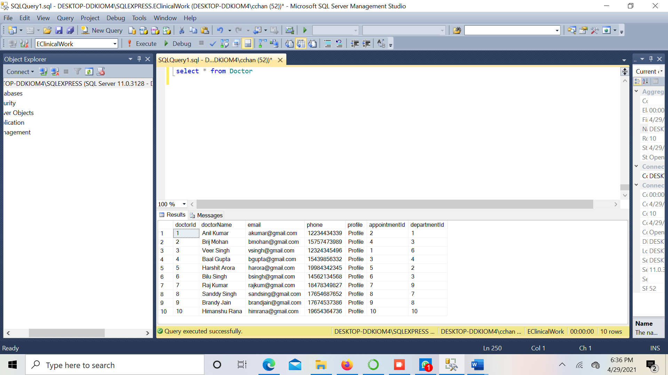

**Table 4 – Patient**

INSERT INTO Patient (patientId, bloodGroup, email, patientName, phone, genderCode, drugName)

VALUES

(1, 'A+', 'pkumar@gmail.com', 'Peter Kumar', +18857757849, 'M', 'Brompheniramine'),

(2, 'O+', 'mpandey@gmail.com', 'Mahesh Pandey', +15543437554, 'M', 'Cetirizine'),

(3, 'B-', 'isingh@gmail.com', 'Ishika Sigh', +14352876543, 'F', 'Fexofenadine'),

(4, 'B+', 'araj@gmail.com', 'Anjali Raj', +15643263884, 'F',NULL),

(5, 'A-', 'plal@gmail.com', 'Pyare Lal', +14384649364, 'M',NULL),

(6, 'O-', 'bverma@gmail.com', 'Bipin Verma',+14536873887, 'M','Brompheniramine'),

(7, 'A+', 'psinha@gmail.com', 'Priyanshi Sinha', +14537468379, 'F', NULL),

(8, 'B+', 'schoud@gmail.com', 'Soham Choudhury', +14807635483, 'M', 'Brompheniramine'),

(9, 'O+', 'ssharma@gmail.com', 'Shubham Sharma', +16573849398, 'M', 'Fexofenadine'),

(10, 'B-', 'pgupta@gmail.com', 'Palak Gupta', +14809876745, 'F', 'Fexofenadine');

**Screenshots:**

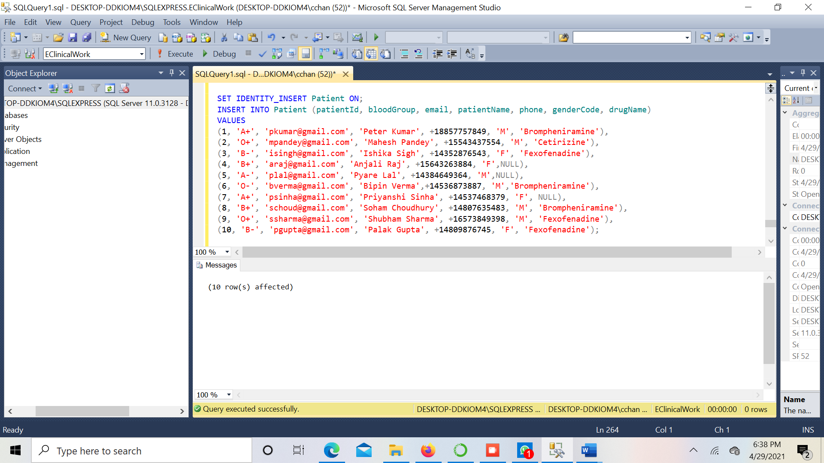

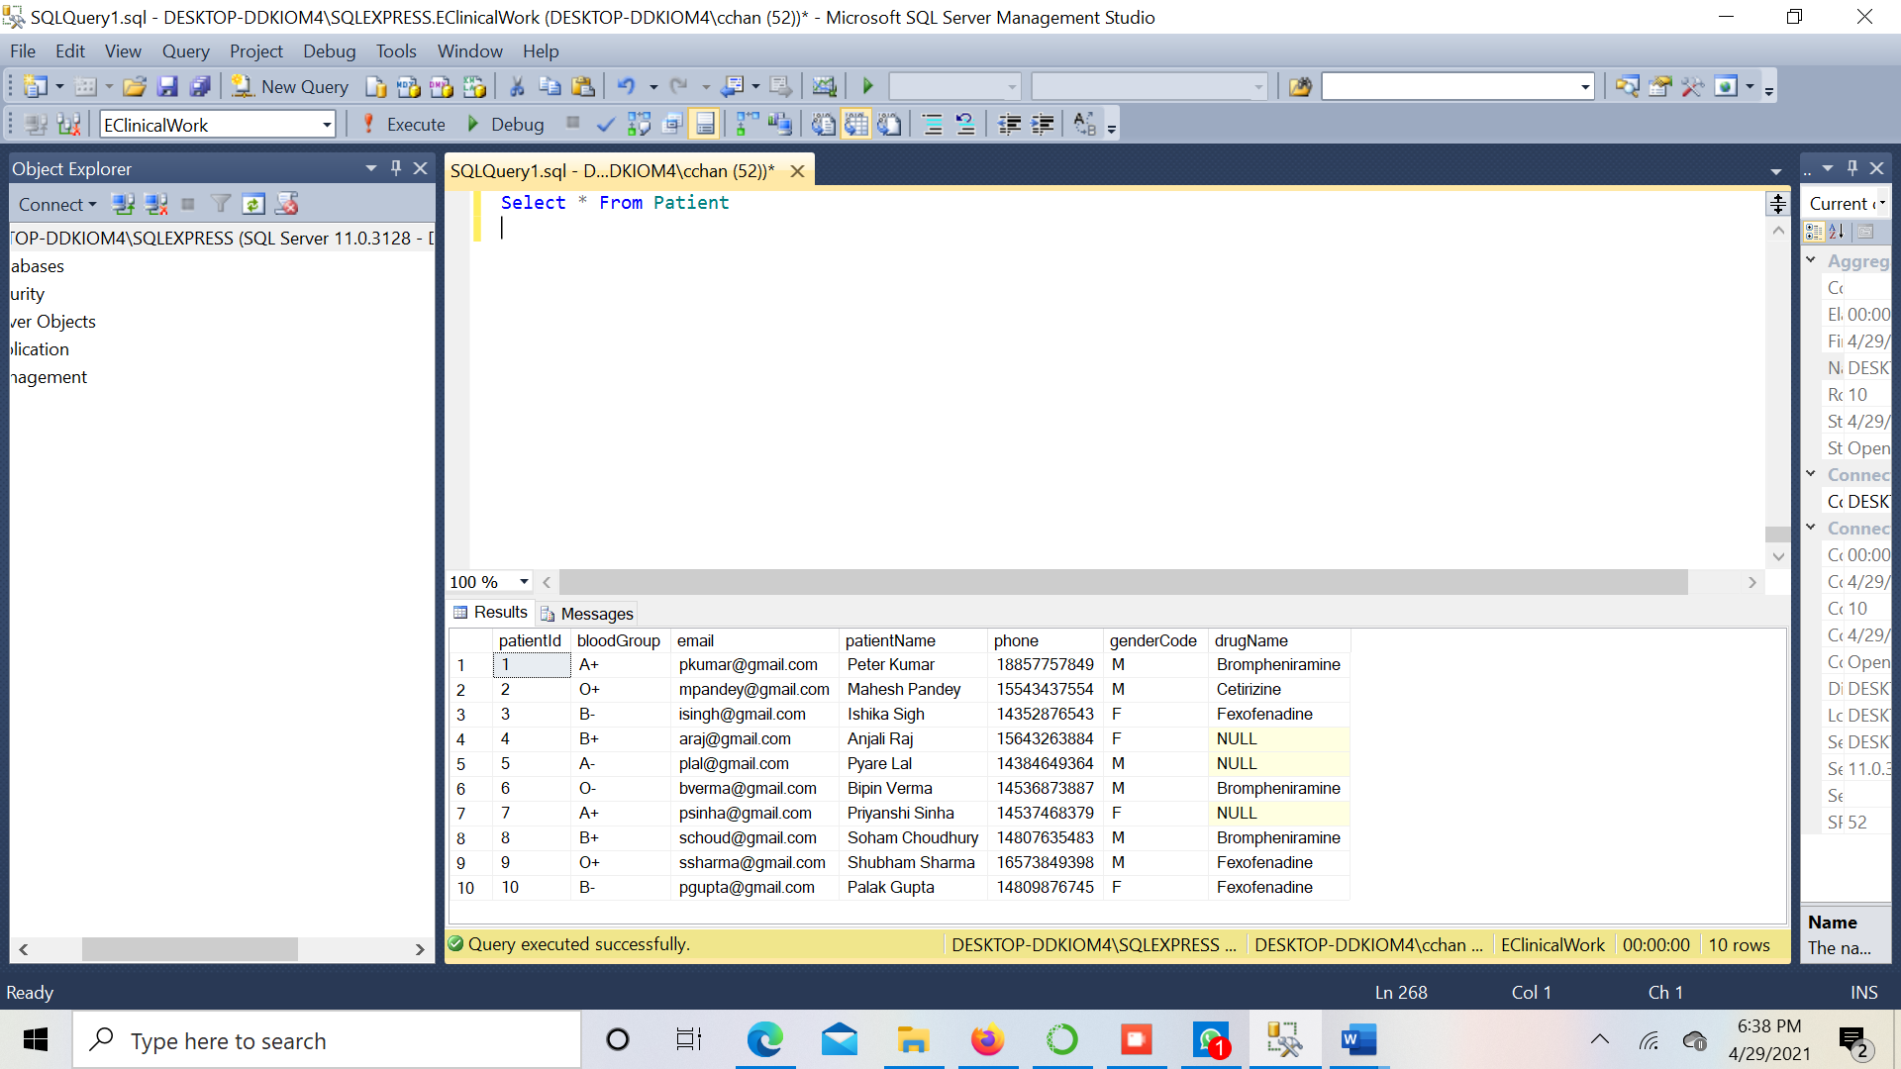

**Table 5 – Department**

INSERT INTO Department (departmentId, departmentName,description)

VALUES

(1,'Pediatrician','Child Doctor'),

(2, 'Surgeon','Surgery Purpose Ony'),

(3, 'Dermatologist', 'Skin Care'),

(4, 'Cardiologist', 'Heart Specialist'),

(5, 'OB/GYN','Pregnent Ladies Doctor'),

(6, 'Allergists', 'some autoimmune diseases'),

(7, 'Endocrinologists', 'experts on hormones and metabolism'),

(8, 'Gastroenterologists', 'specialists in digestive organs'),

(9, 'Hematologists', 'specialists in diseases of the blood, spleen'),

(10, 'Neurologists', 'specialists in the nervous system');

**Screenshots:**

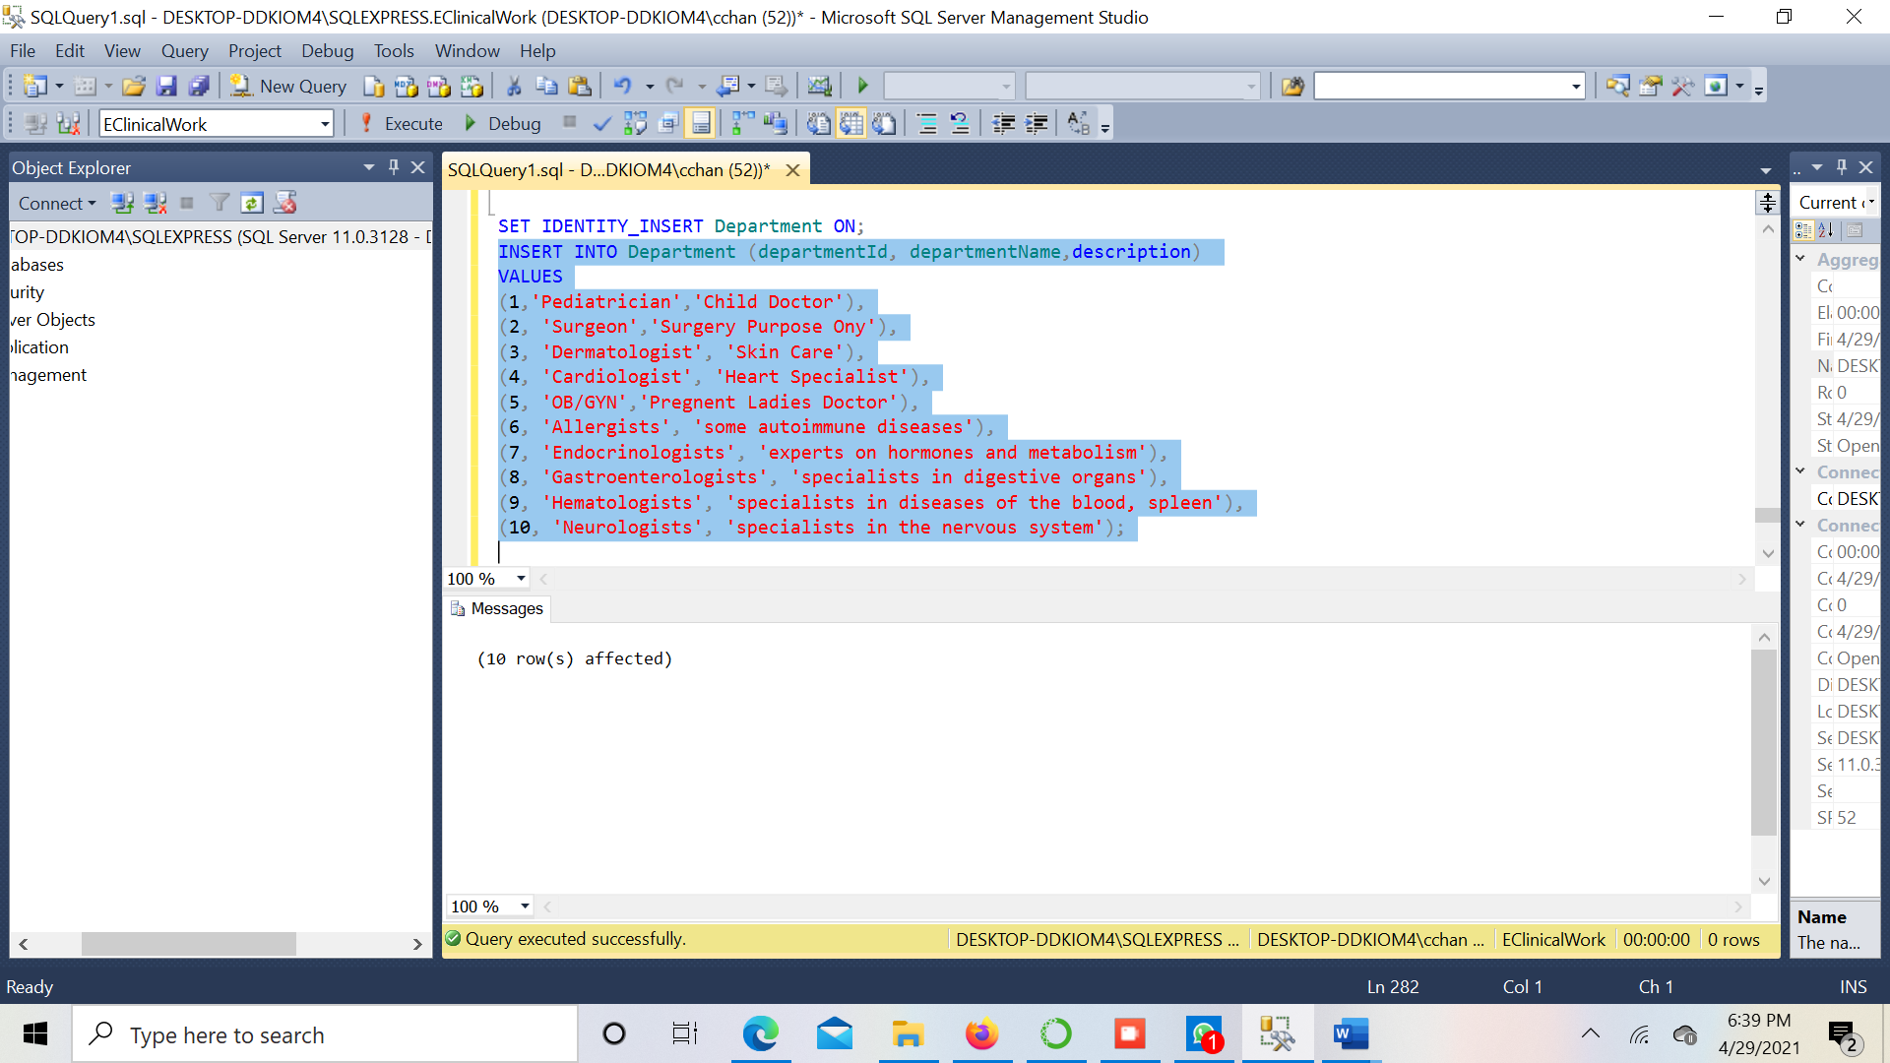

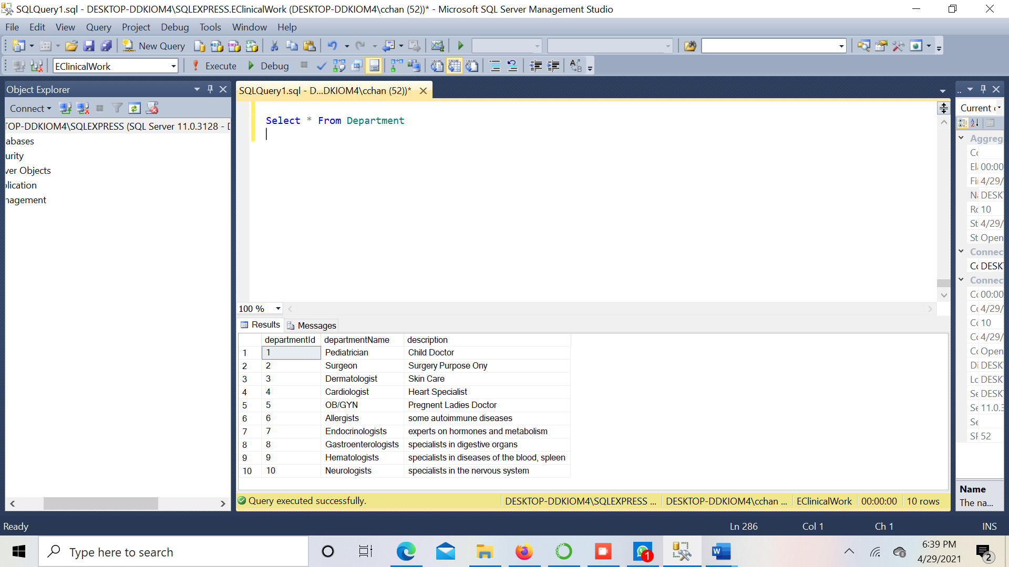

**Table 6 – Invoice**

INSERT INTO Invoice (invoiceId,patientId,paymentId,email,description)

VALUES

(1, 1, 1,'pkumar@gmail.com', 'Appointment Confirmation of Peter Kumar'),

(2,2,2,'mpandey@gmail.com', 'Appointment Confirmation of Mahesh Pandey'),

(3,3,3,'isingh@gmail.com', 'Appointment Confirmation of Ishika Sigh'),

(4,4,4,'araj@gmail.com', 'Appointment Confirmation of Anjali Raj'),

(5,5,5,'plal@gmail.com', 'Appointment Confirmation of Pyare Lal'),

(6,6,6, 'bverma@gmail.com', 'Appointment Confirmation of Bipin Verma'),

(7,7,7, 'psinha@gmail.com', 'Appointment Confirmation of Priyanshi Sinha'),

(8,8,8, 'schoud@gmail.com', 'Appointment Confirmation of Soham Choudhury'),

(9,9,9, 'ssharma@gmail.com', 'Appointment Confirmation of Shubham Sharma'),

(10,10,10, 'pgupta@gmail.com', 'Appointment Confirmation of Palak Gupta');

**Screenshots:**

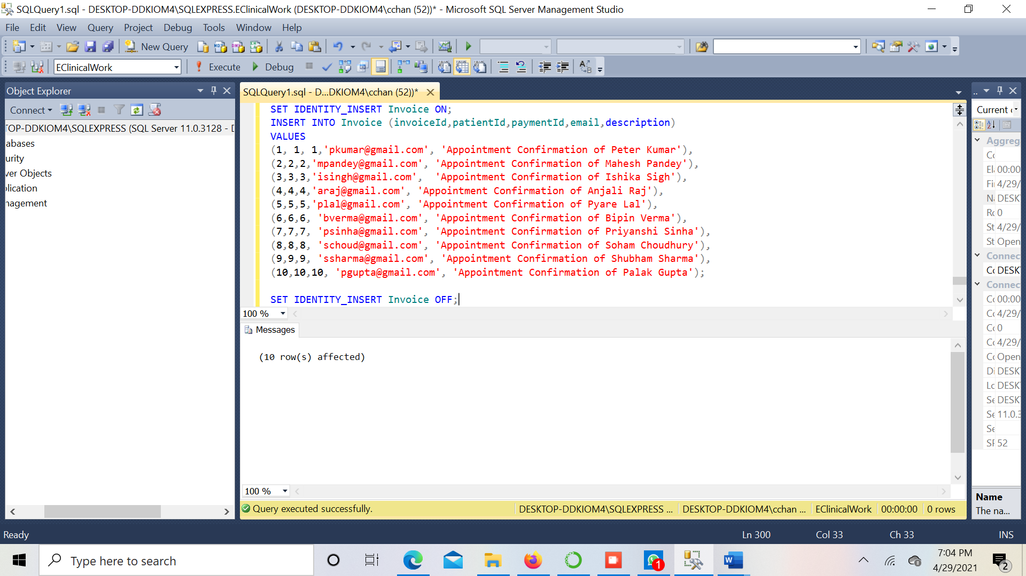

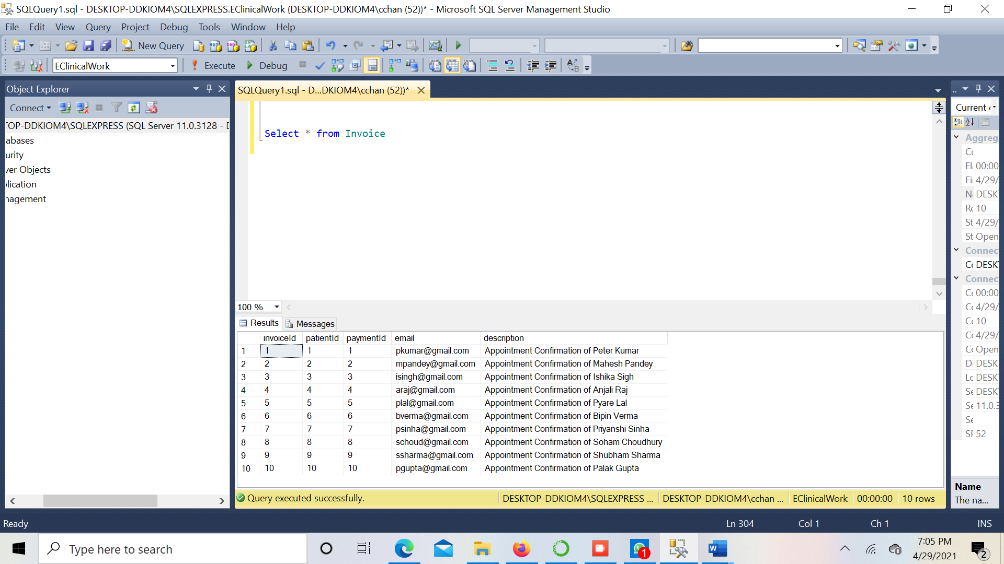

**Table 7 – Payment**

INSERT INTO Payment (paymentId,amount,patientId,paymentTimestamp,transactionId,description)

VALUES

(1, 450.32, 1, convert(datetime, '2021-04-06 09:26:56'), 'WSS333331345','Payment Sucessful' ),

(2, 100.65, 2, convert(datetime, '2021-04-06 12:49:43'), 'WAB33333AG11','Payment Sucessful' ),

(3, 654.87, 3, convert(datetime, '2021-04-08 10:05:34'), 'WSS33333SG10','Payment Sucessful' ),

(4, 765.79, 4, convert(datetime, '2021-04-09 15:54:22'), 'APP33333SG10','Payment Sucessful' ),

(5, 1032.88, 5, convert(datetime, '2021-04-10 09:26:56'), 'DVV33333SG10','Payment Sucessful' ),

(6, 567.43, 6, convert(datetime, '2021-04-12 13:39:42'), 'WSS667883SG10', 'Payment Sucessful'),

(7, 648.21, 7, convert(datetime, '2021-04-12 17:15:31'), 'WSS6672225610', 'Payment Sucessful'),

(8, 824.89, 8, convert(datetime, '2021-04-12 17:15:31'), 'WSS667883S101', 'Payment Sucessful'),

(9, 2324.44, 9, convert(datetime, '2021-03-12 17:15:31'), 'WS99993SG1000', 'Payment Sucessful'),

(10, 3421.32, 10, convert(datetime, '2021-03-12 17:15:31'), 'WS99993SG11111', 'Payment Sucessful');

**Screenshots:**

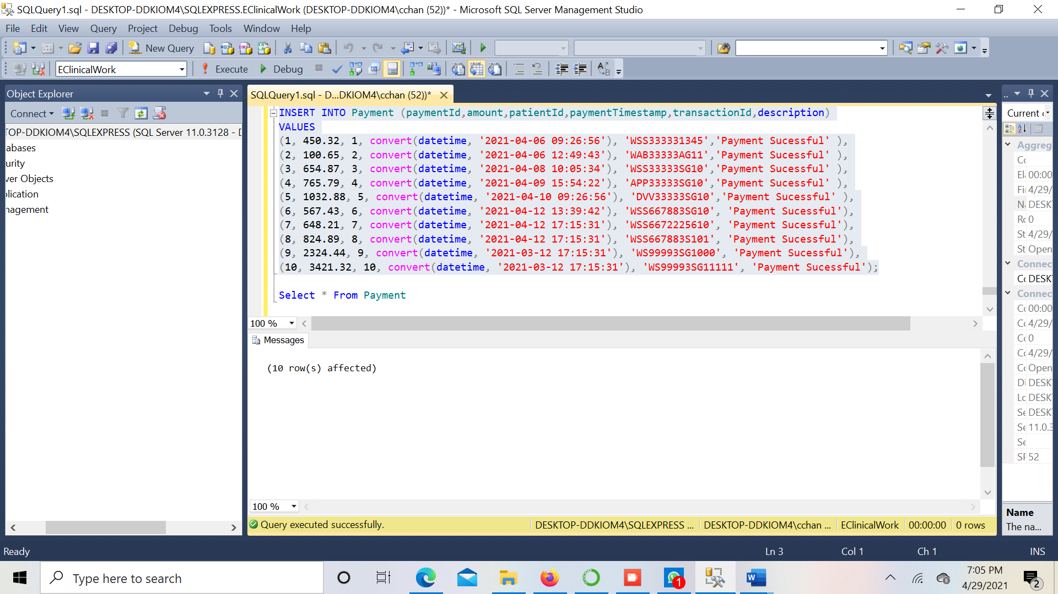

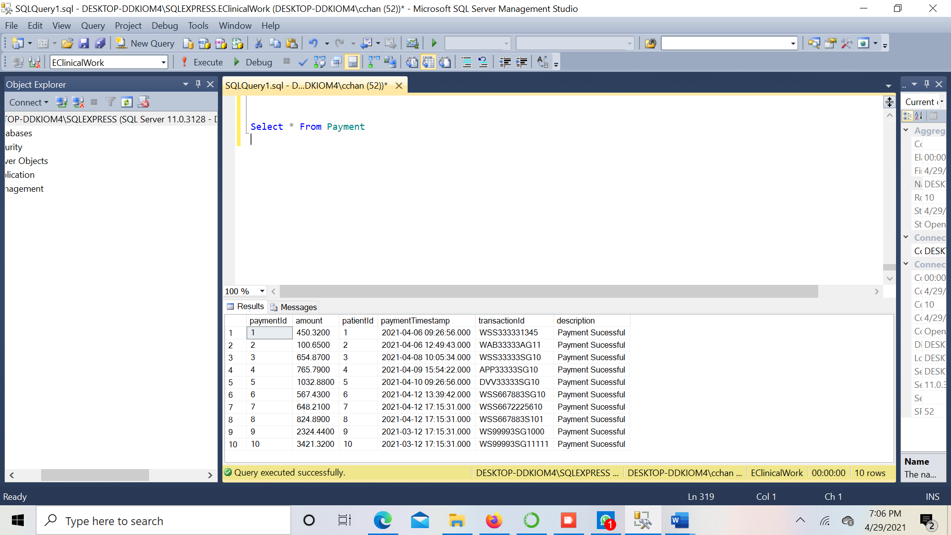

**Table 8 – Appointment**

INSERT INTO Appointment(appointmentId, appointmentTimestamp)

VALUES

(1,convert(datetime, '2021-04-08 09:20:56')),

(2,convert(datetime, '2021-04-09 10:30:45')),

(3,convert(datetime, '2021-04-10 15:00:15')),

(4,convert(datetime, '2021-04-11 11:30:38')),

(5,convert(datetime, '2021-04-13 18:15:34')),

(6, convert(datetime, '2021-04-12 09:30:43')),

(7, convert(datetime, '2021-04-12 13:15:20')),

(8, convert(datetime, '2021-04-14 18:15:34')),

(9, convert(datetime, '2021-03-14 18:15:34')),

(10, convert(datetime, '2021-03-15 18:

**Screenshots:**

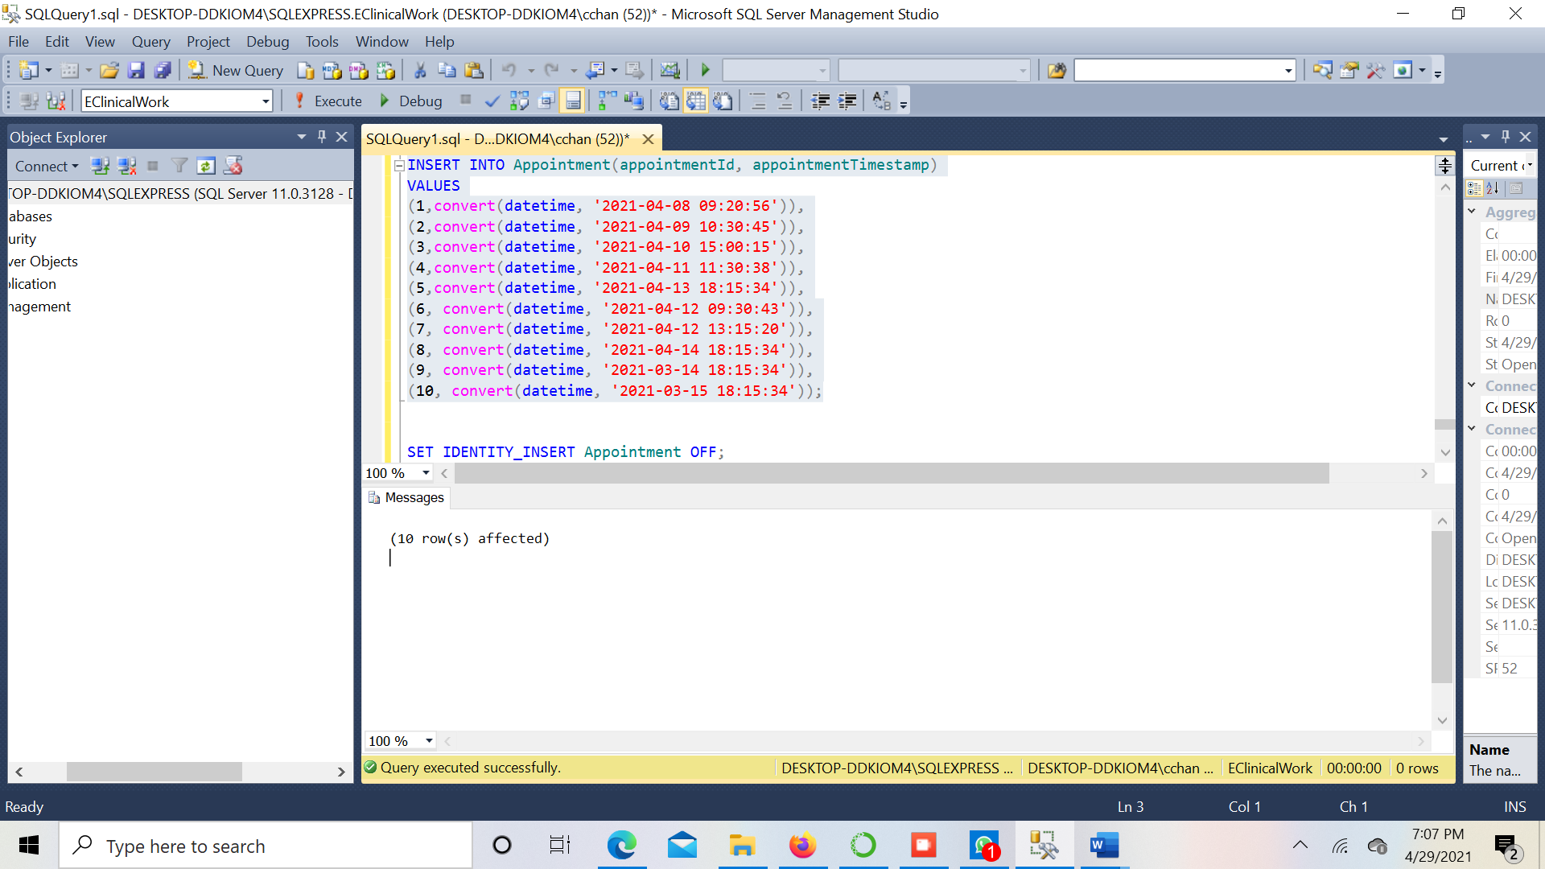

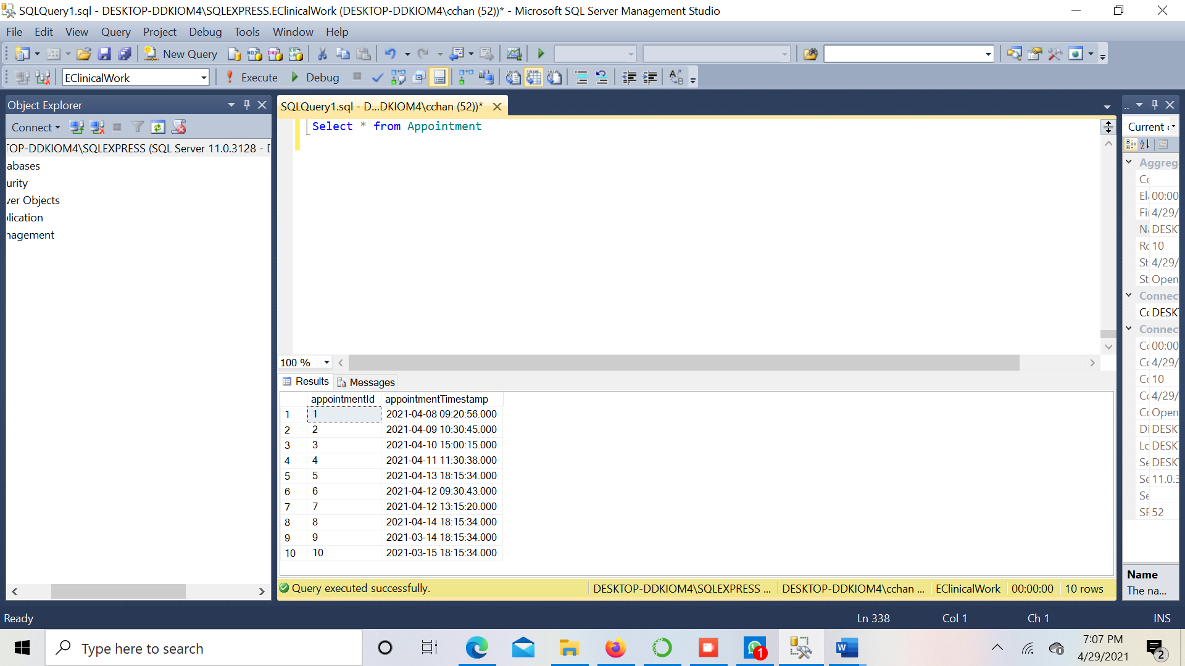

**Table 9 – AccountantLiveAtAddress**

INSERT INTO AccountantLiveAtAddress(accountantId,addressNr)

VALUES

(1,1),

(2,2),

(3,3),

(4,4),

(5,5),

(6,1),

(7,3),

(8,4),

(9,2),

(10,8);

**Screenshots:**

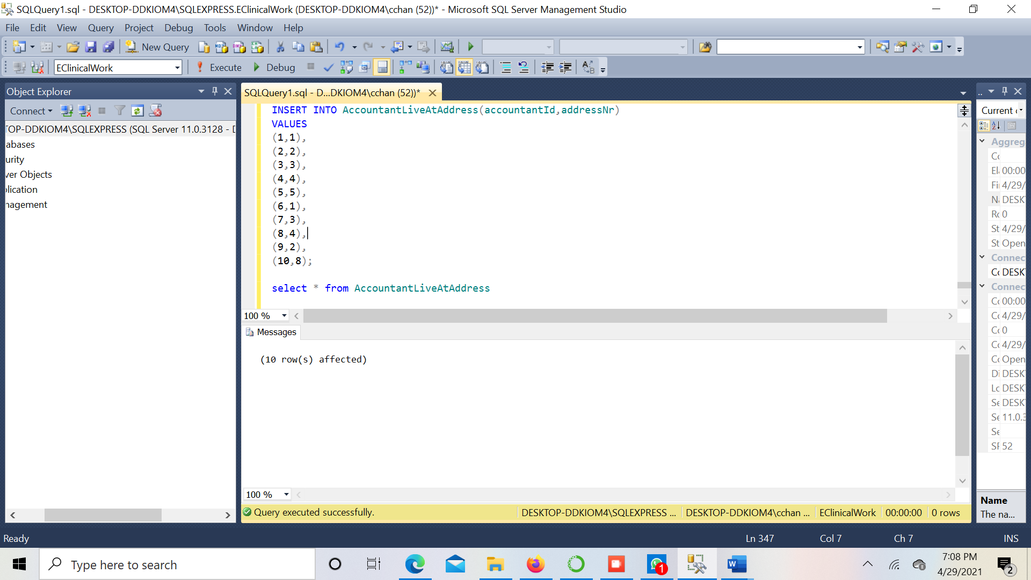

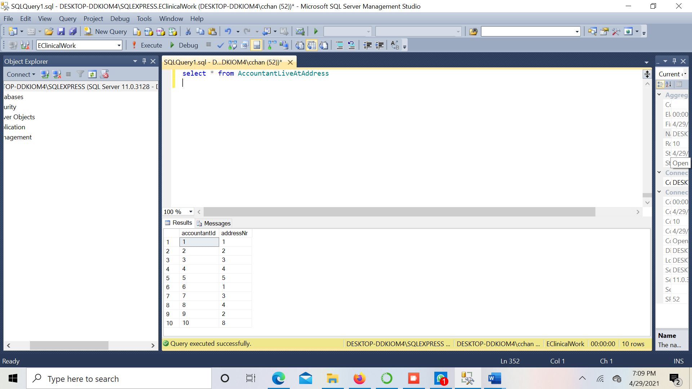

**Table 10 – PatientLivesAtAddress**

INSERT INTO PatientLivesAtAddress(addressNr,patientId)

VALUES

(4,1),

(7,2),

(8,3),

(9,4),

(10,5),

(1,6),

(1,7),

(3,8),

(3,9),

(4,10);

**Screenshots:**

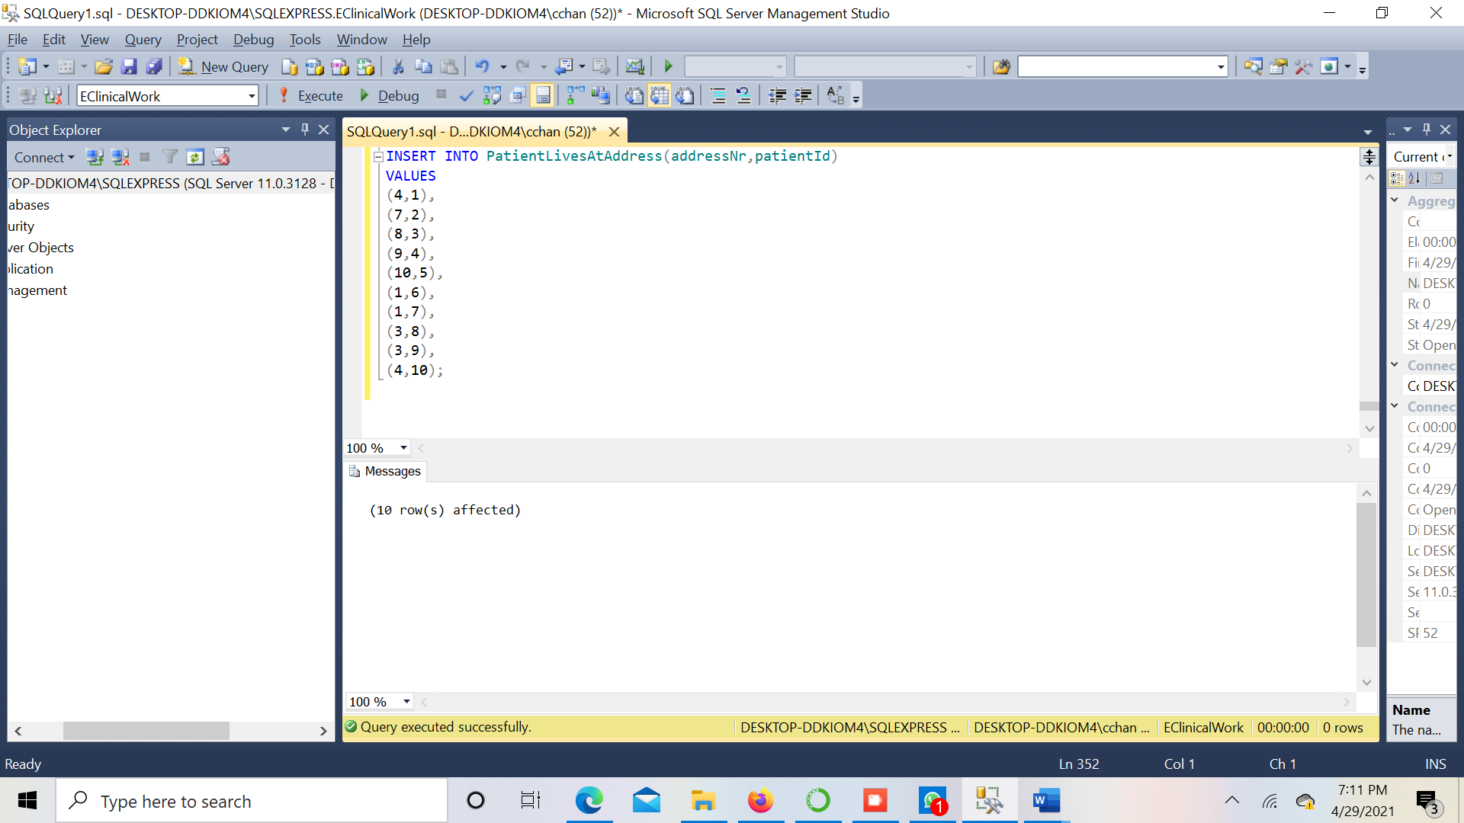

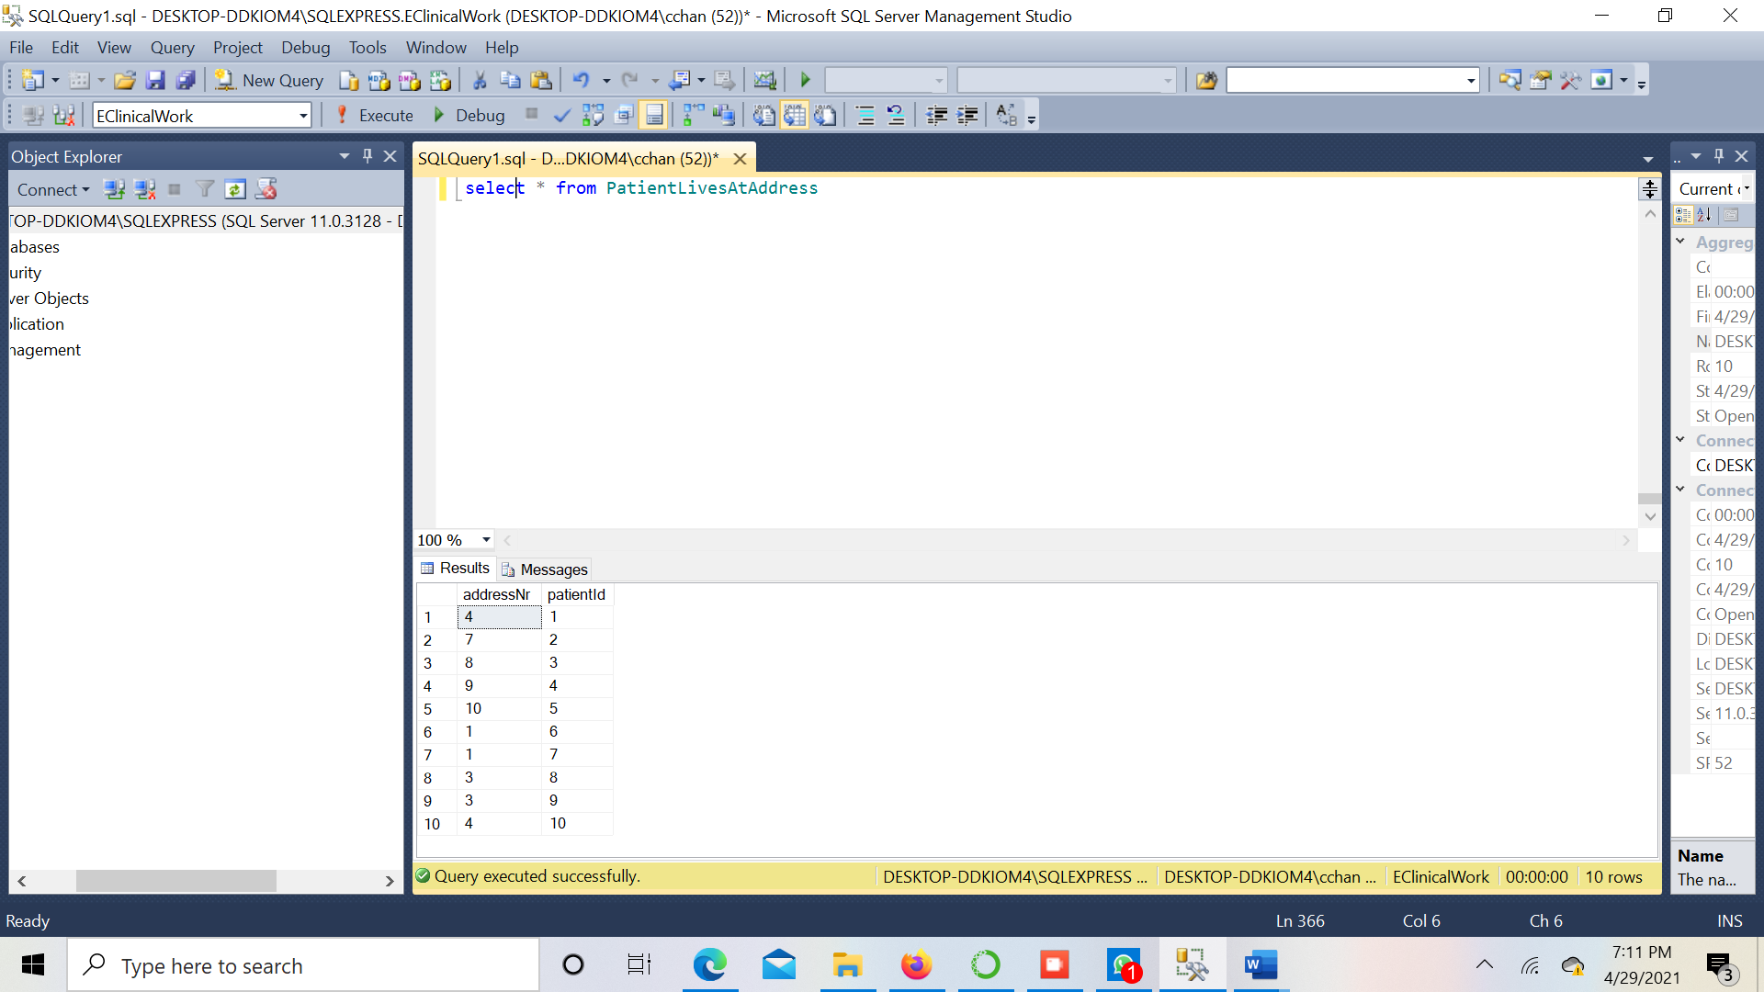

**Table 11– DoctorLivesAtAddress**

INSERT INTO DoctorLivesAtAddress(addressNr,doctorId)

VALUES

(11,1),

(12,2),

(13,3),

(14,4),

(15,5),

(1,6),

(12,7),

(13,8),

(4,9),

(5,10);

**Screenshots:**

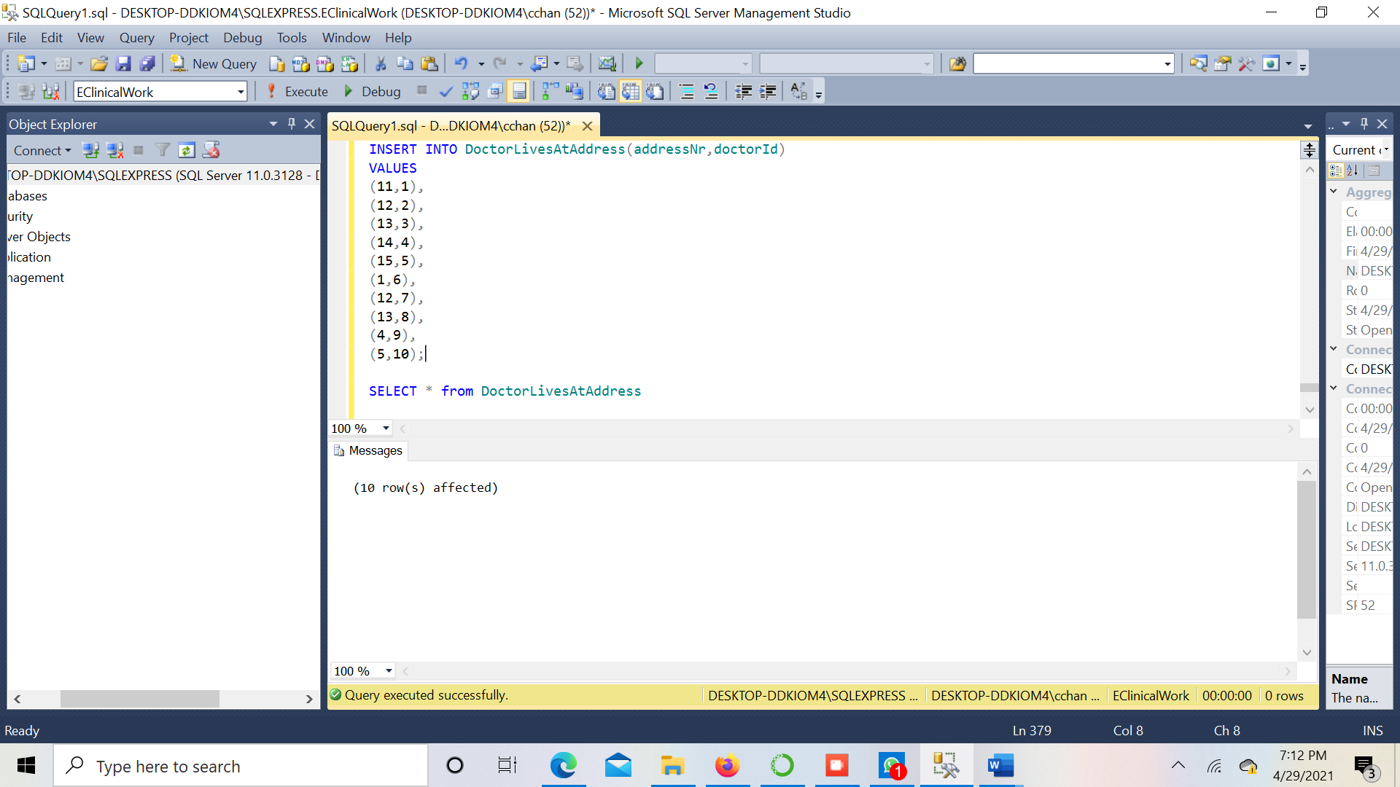

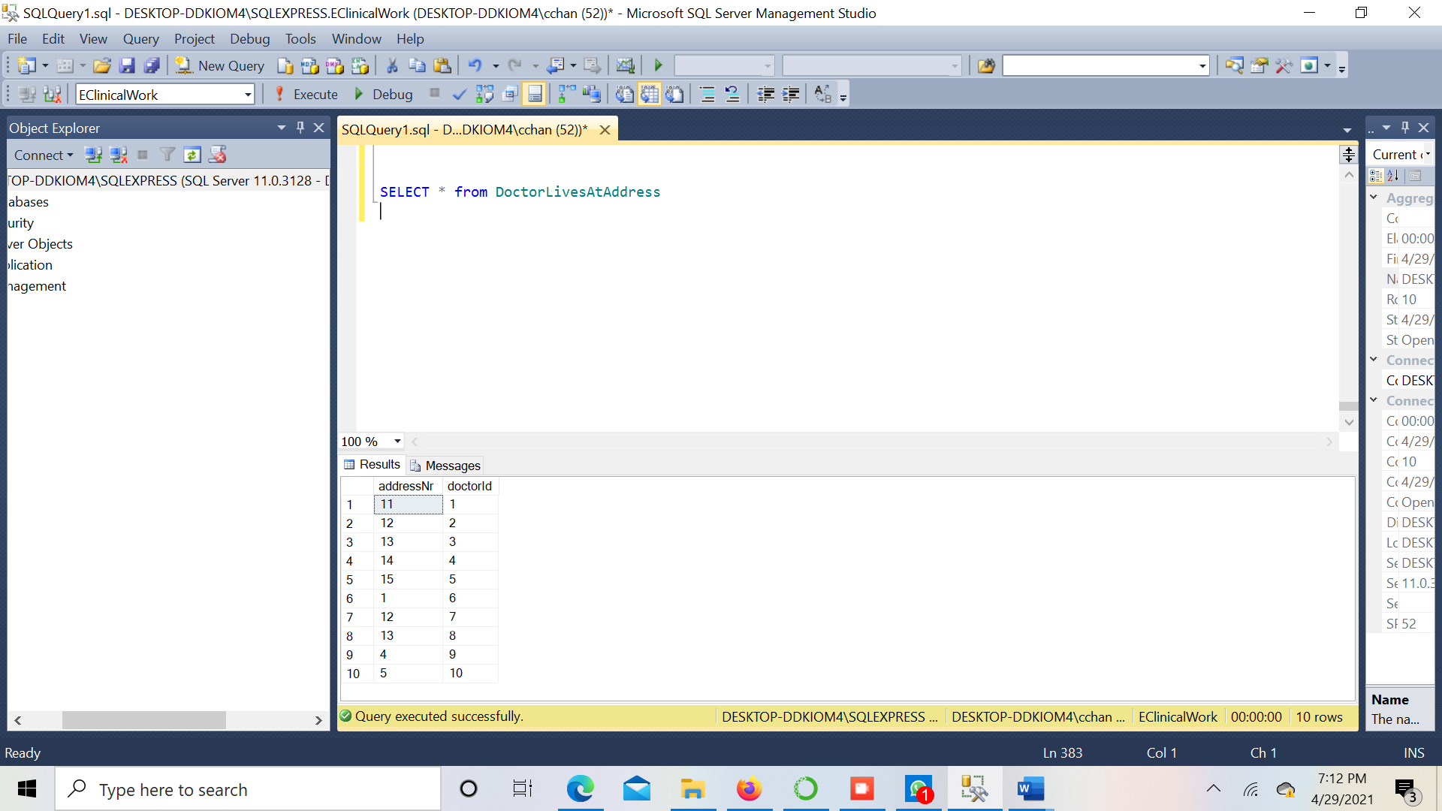

**Table 12 – DoctorProvidesReport**

INSERT INTO DoctorProvidesReport(doctorId,reportId) VALUES

(1,1),

(2,2),

(3,3),

(4,4),

(5,5),

(6,6),

(7,7),

(8,8),

(9,9),

(10,10);

**Screenshots:**

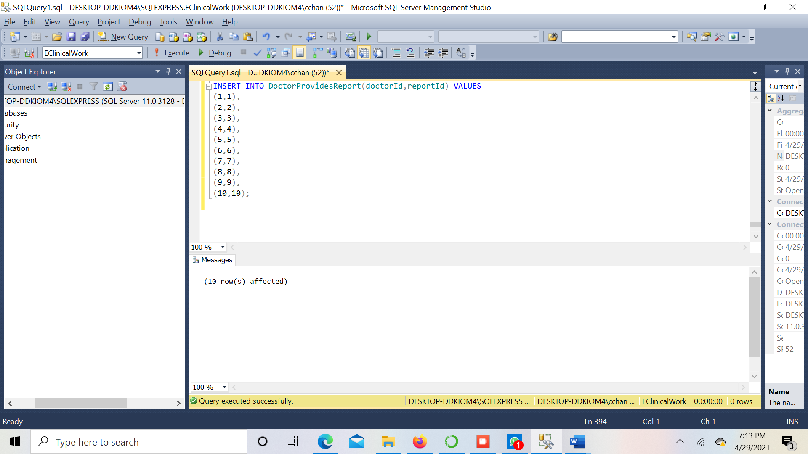

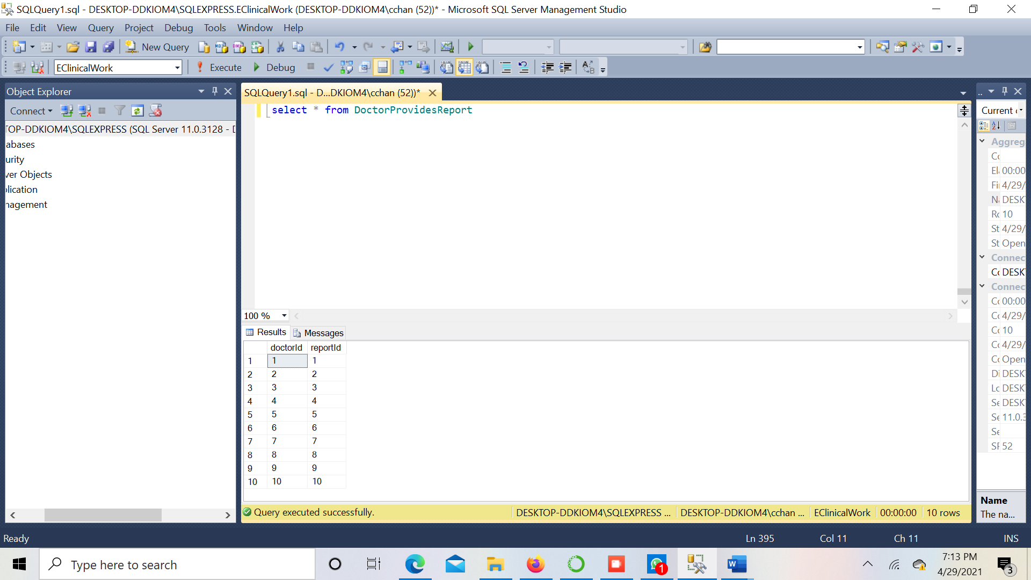

**Table 13 – Bed**

INSERT INTO Bed(bedId,bedDescption,bedType) VALUES

(1, 'ward1', 'ward'),

(2, 'ward2', 'ward'),

(3, 'ward2', 'ward'),

(4, 'icu1','icu'),

(5, 'icu2', 'icu'),

(6, 'ward3', 'ward'),

(7, 'ward4', 'ward'),

(8, 'icu2', 'icu'),

(9, 'icu3', 'icu'),

(10, 'ward4', 'ward');

**Screenshots:**

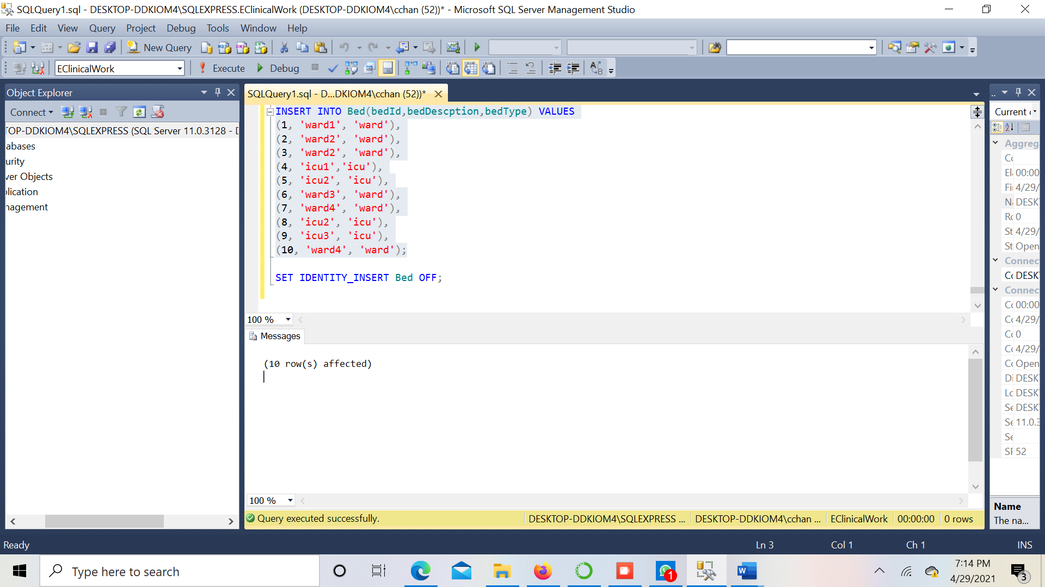

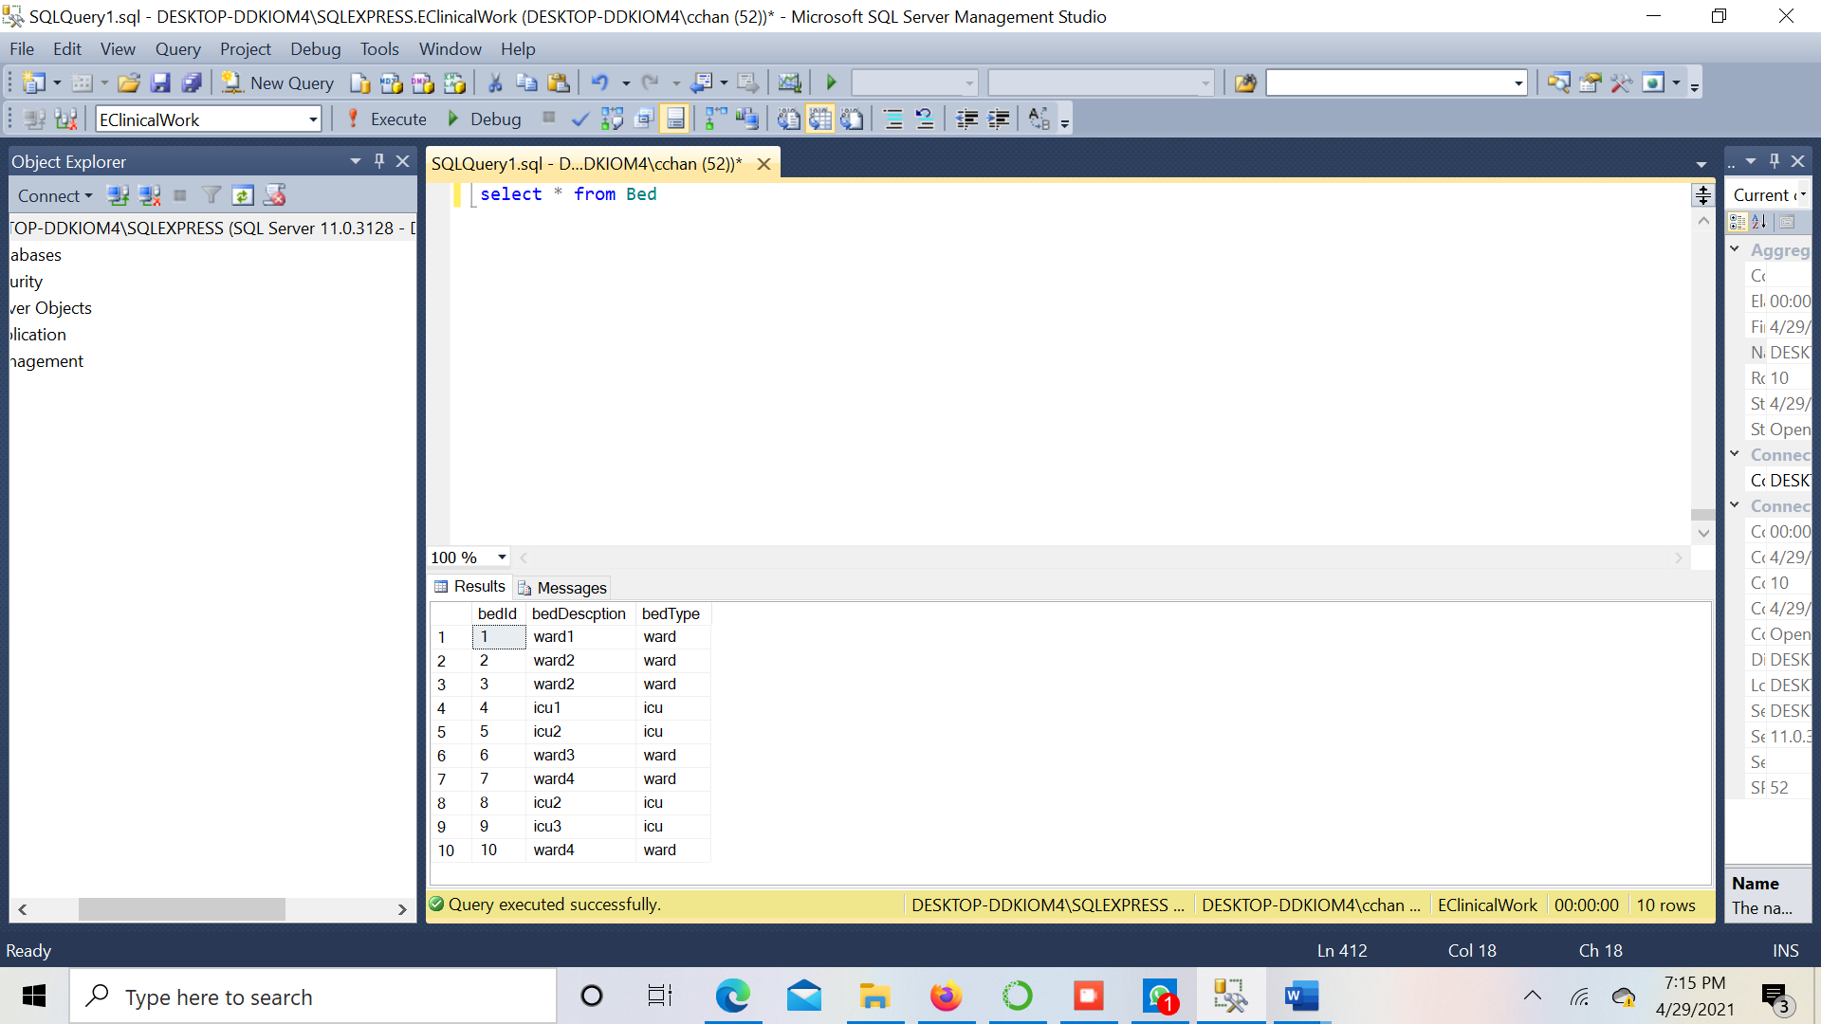

**Table 14 – AppointmentBookedByPatient**

INSERT INTO AppointmentBookedByPatient(appointmentId,patientId) VALUES

(1,1),

(2,2),

(3,3),

(4,4),

(5,5),

(6,6),

(7,7),

(8,8),

(9,9),

(10,10);

**Screenshots:**

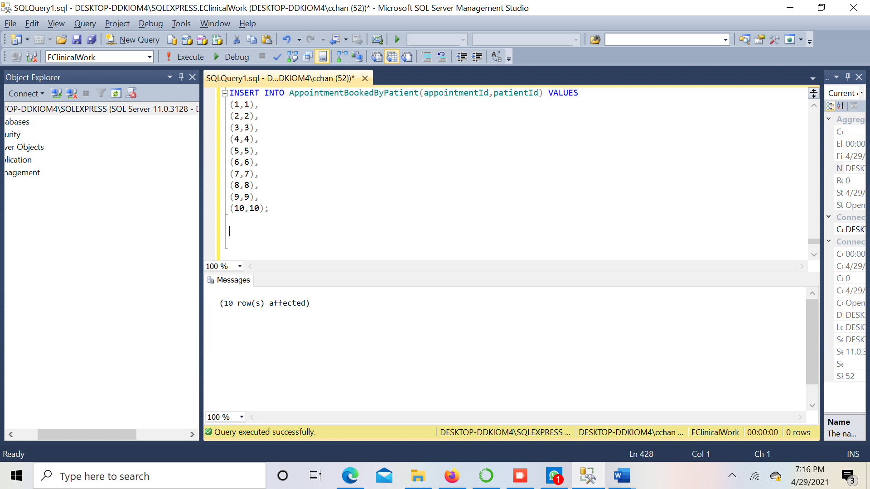

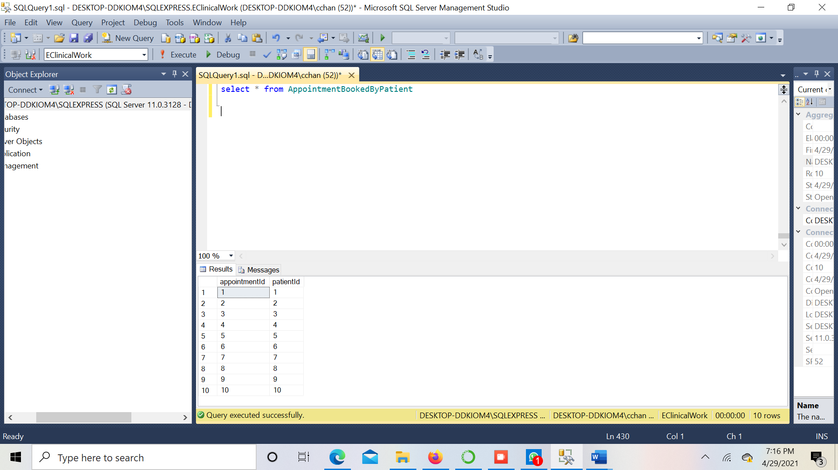

**Table 15 – BedAllotment**

INSERT INTO BedAllotment(bedAllotmentId,allotmentTimestamp,bedId,dischageTimestamp,patientId) VALUES

(9, '2021-03-24 10:34:09',1, '2021-03-29 11:34:10', 10),

(1, '2021-04-24 10:34:09', 2,'2021-05-01 10:34:09', 4),

(4, '2021-04-28 11:34:10',3, '2021-05-02 11:34:10', 5),

(3, '2021-06-24 10:34:09',3, '2021-02-26 11:34:10', 3),

(2, '2020-07-24 10:34:09',1, '2020-07-20 11:34:10', 2),

(5, '2021-04-26 9:34:09',4, '2021-04-28 11:34:10', 1),

(6, '2021-04-29 10:34:09',1, '2020-5-03 11:34:10', 7),

(7, '2021-03-26 9:34:09',4, '2021-03-28 11:34:10', 6)

**Screenshots:**

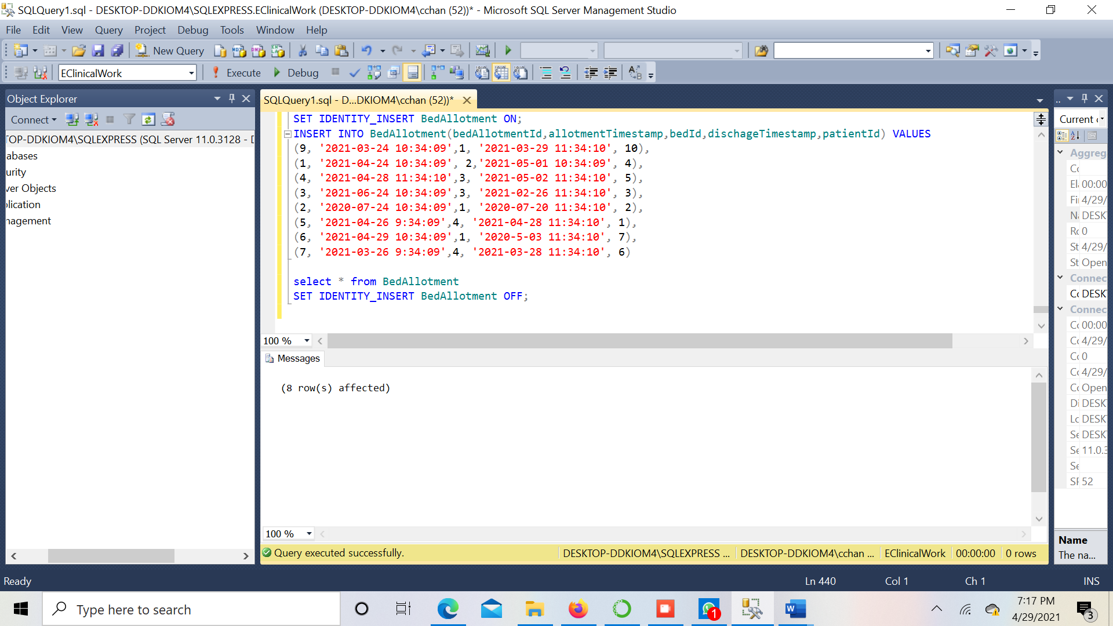

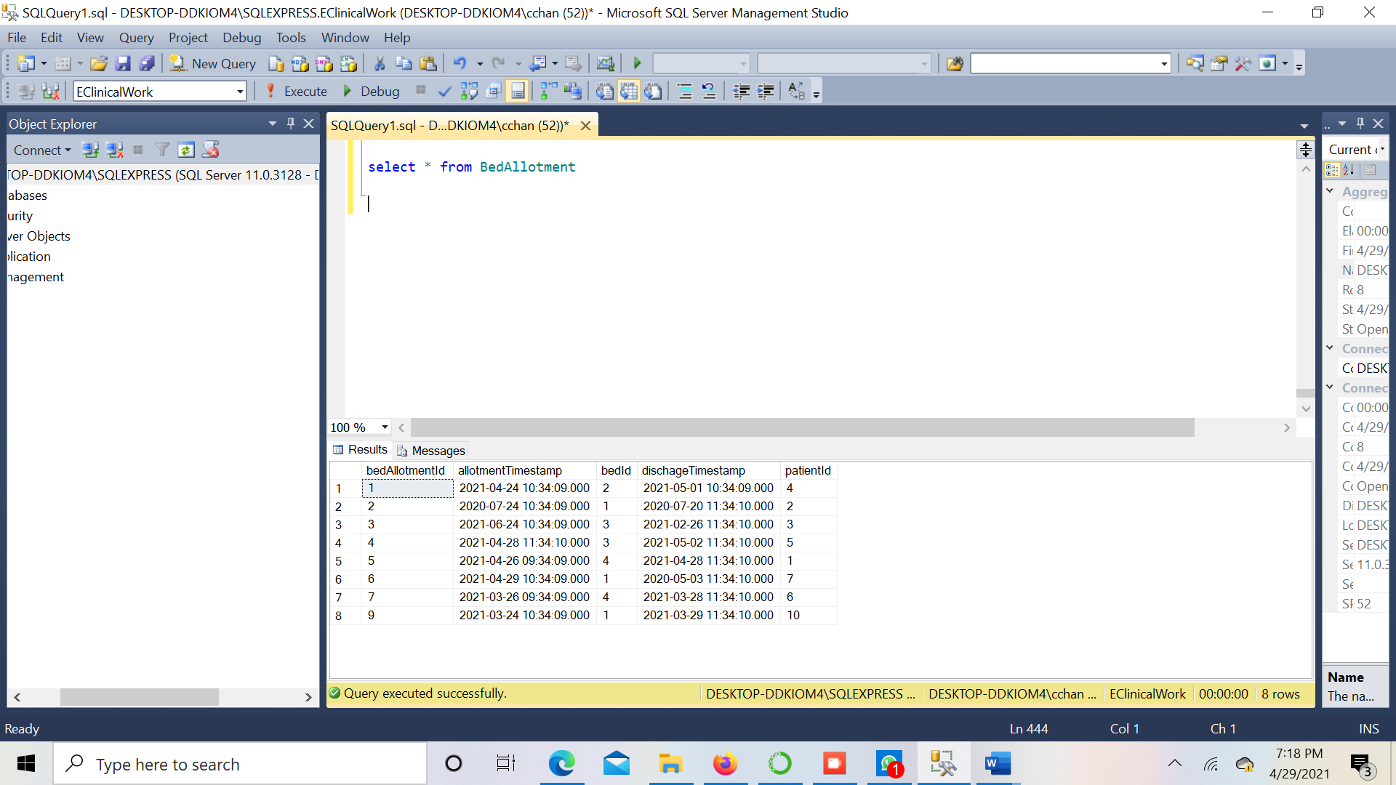

**Table 16 –** **Report**

INSERT INTO Report(reportId,description,patientId,type,caseHistory)

VALUES

(1,'Routine Checkup',1,'Normal','No'),

(2,'Follow Up', 2, 'Normal','Yes'),

(3, 'Routine Checkup', 3, 'Normal','Yes'),

(4, 'Follow Up', 4, 'Normal', 'Yes'),

(5, 'Routine Checkup', 5, 'Normal','No'),

(6, 'Emergency', 6, 'Emergency','No'),

(7, 'Routine Checkup', 7, 'Normal','No'),

(8, 'Follow UP', 8, 'Normal','No'),

(9, 'Follow UP', 5, 'Normal','No'),

(10, 'Emergency', 9, 'Emergency','No');

**Screenshots:**

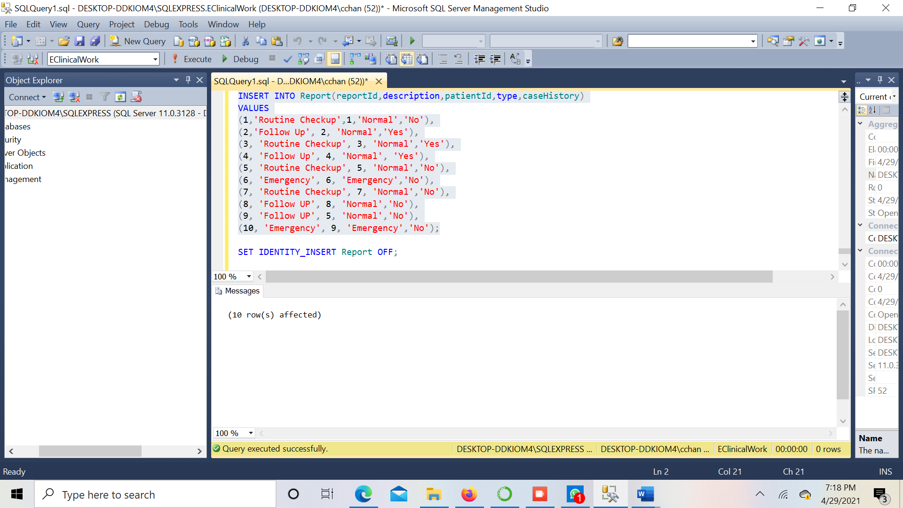

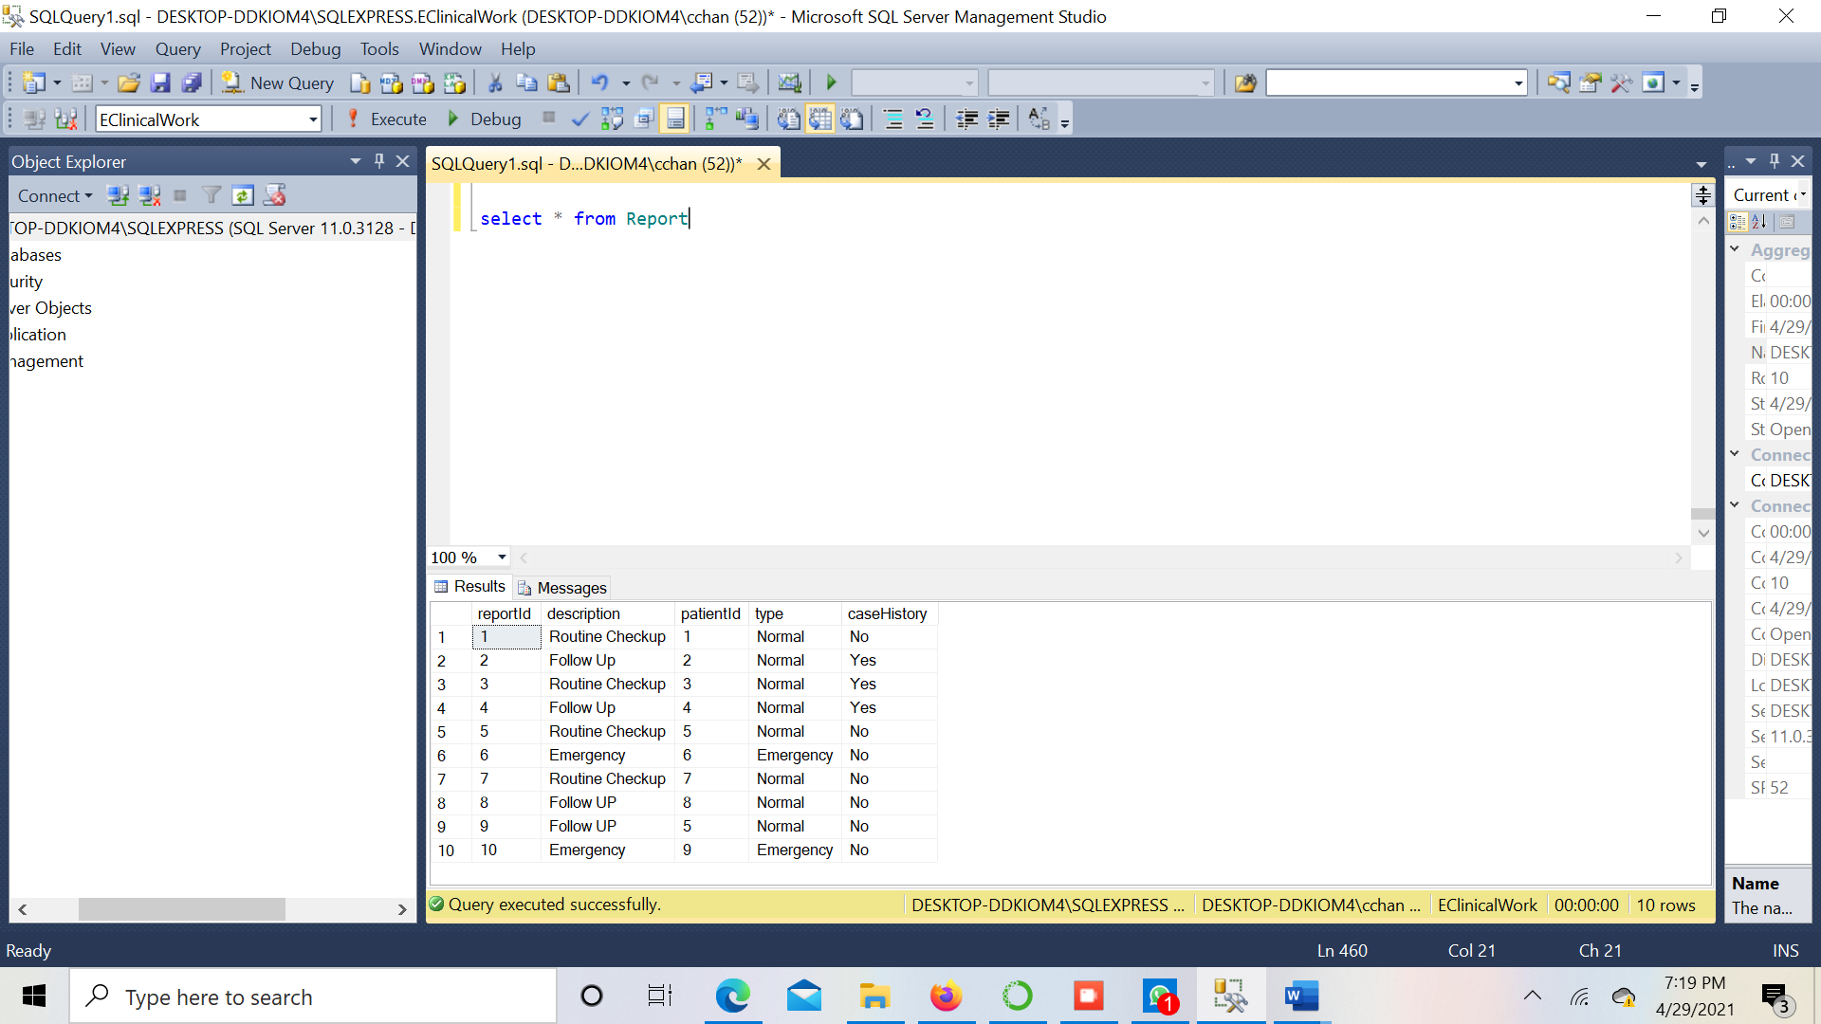

# Select Statements

**Query 1:**

This query provides information about the details of beds available in the hospital.

query 1*/

USE EClinicalWork;

GO

SELECT DISTINCT b.bedId, b.bedDescption, b.bedType

FROM Bed b, BedAllotment ba

Where b.bedId NOT IN(SELECT bedId FROM BedAllotment WHERE dischageTimestamp > CURRENT_TIMESTAMP)

**Screenshot:**

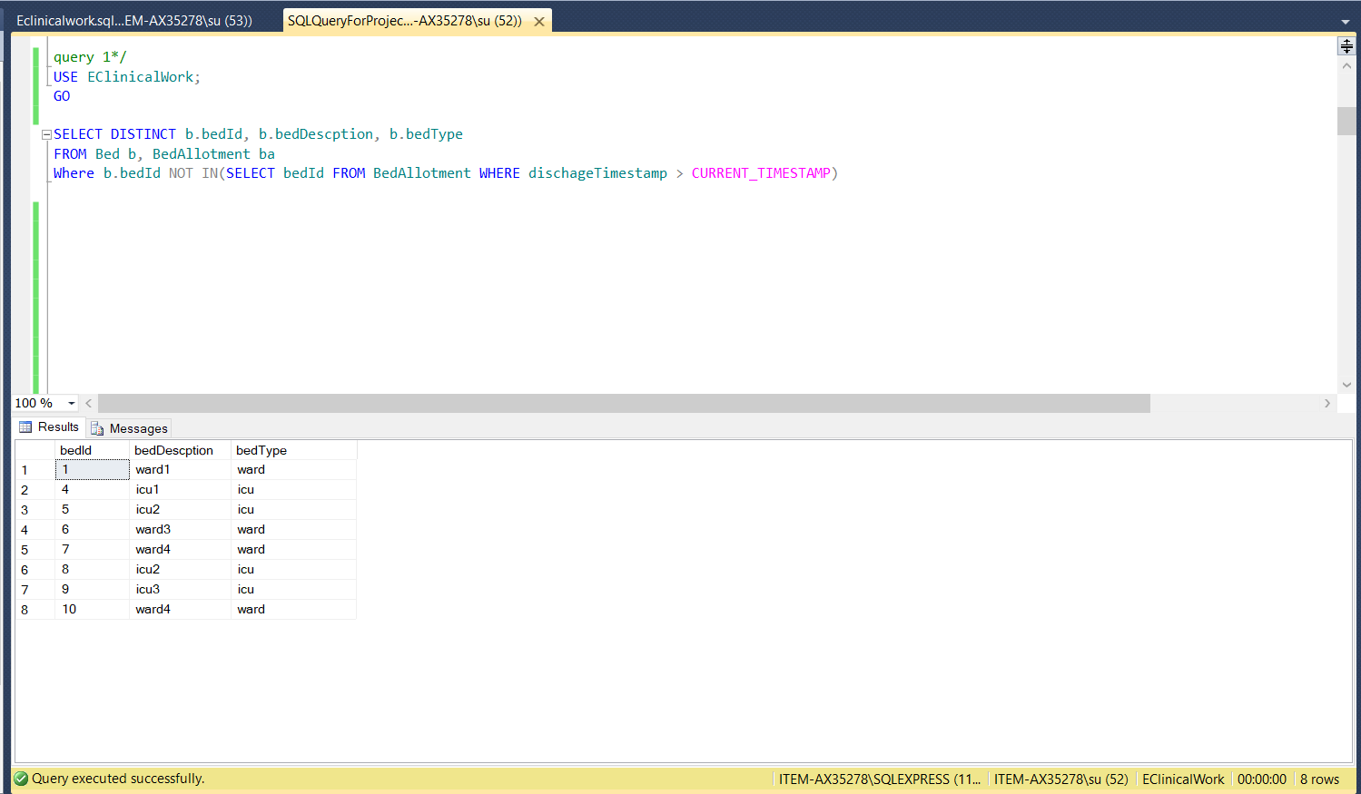

**Query 2:**

The below query provides information about the number of appointments registered in each month.

/*query 2 */

USE EClinicalWork;

GO

SELECT COUNT(*) As NumberOfAppointments, DateName(mm, appointmentTimestamp) as monthNames

FROM Appointment

GROUP BY DateName(mm, appointmentTimestamp);

**Screenshot:**

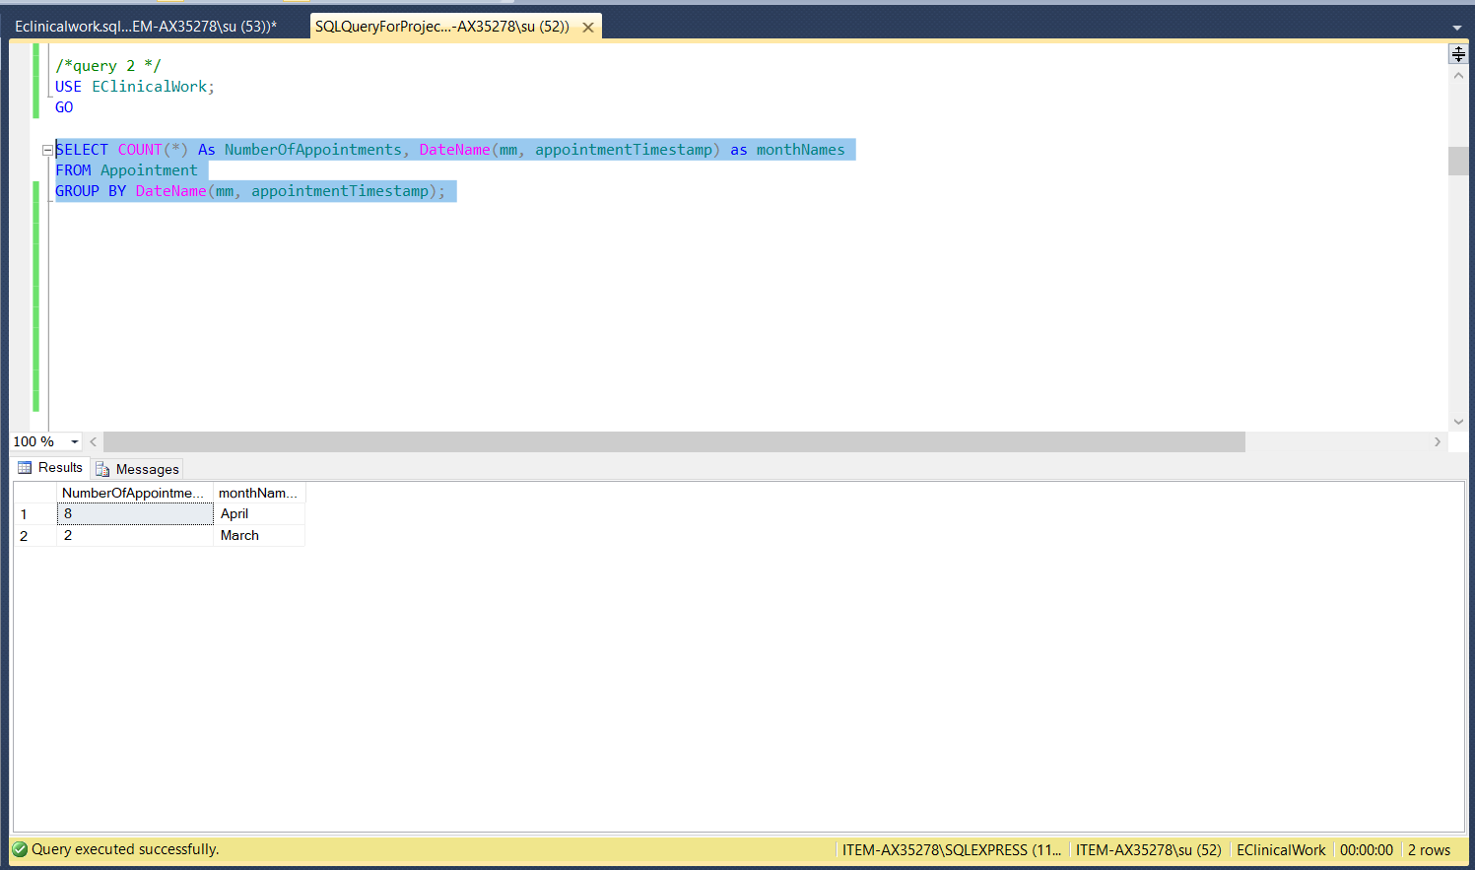

**Query 3:**

The below query provides information about the number of appointments on a Particular date.

/*query 3*/

USE EClinicalWork;

GO

SELECT COUNT(*), FORMAT(appointmentTimestamp, 'MMM dd') as dateNames

FROM Appointment

GROUP BY FORMAT(appointmentTimestamp, 'MMM dd');

**Screenshot:**

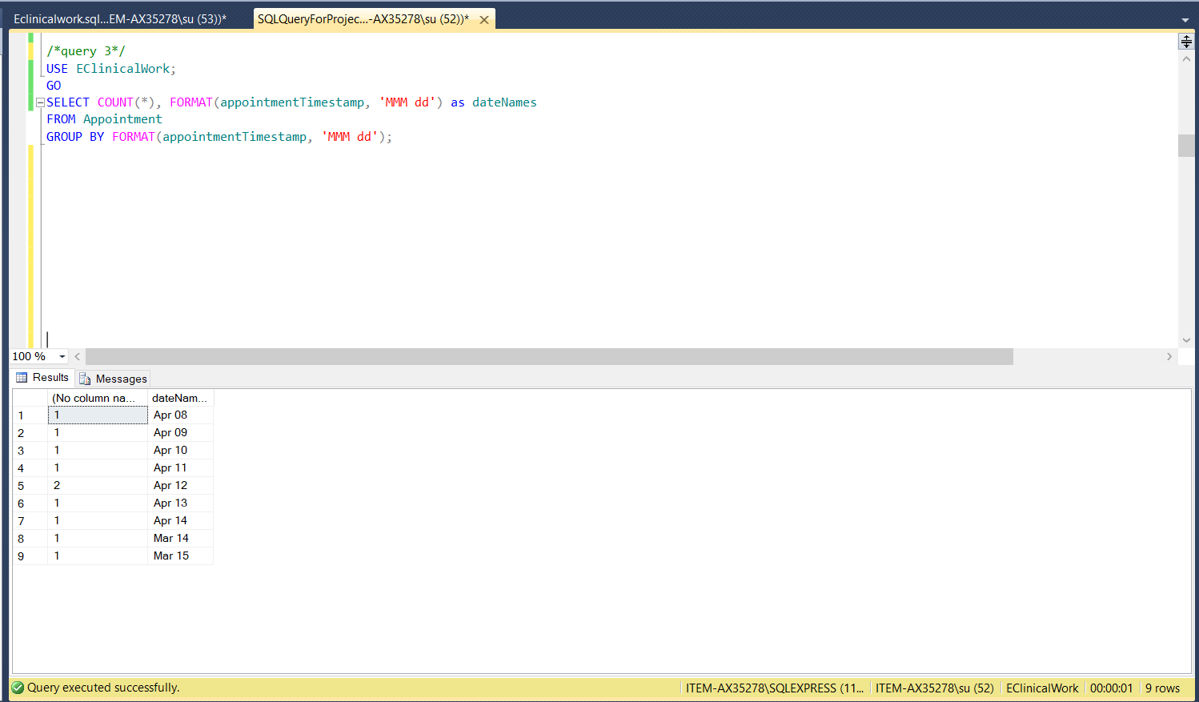

**Query 4:**

The below query yields information about the details of the patient which includes patient name, blood group, phone number, gender, assigned doctor name and timestamp etc.

/*query 4*/

USE EClinicalWork;

GO

SELECT p.patientName, p.bloodGroup, p.phone, p.genderCode, d.doctorName, a.appointmentTimestamp As AppointmentDate, r.description, r.type, r.caseHistory

FROM Report r, Patient p, Doctor d, Appointment a, DoctorProvidesReport dpr

Where p.patientId = r.patientId AND

d.appointmentId = a.appointmentId AND

d.doctorId = dpr.doctorId AND

r.reportId = dpr.reportId

**Screenshot:**

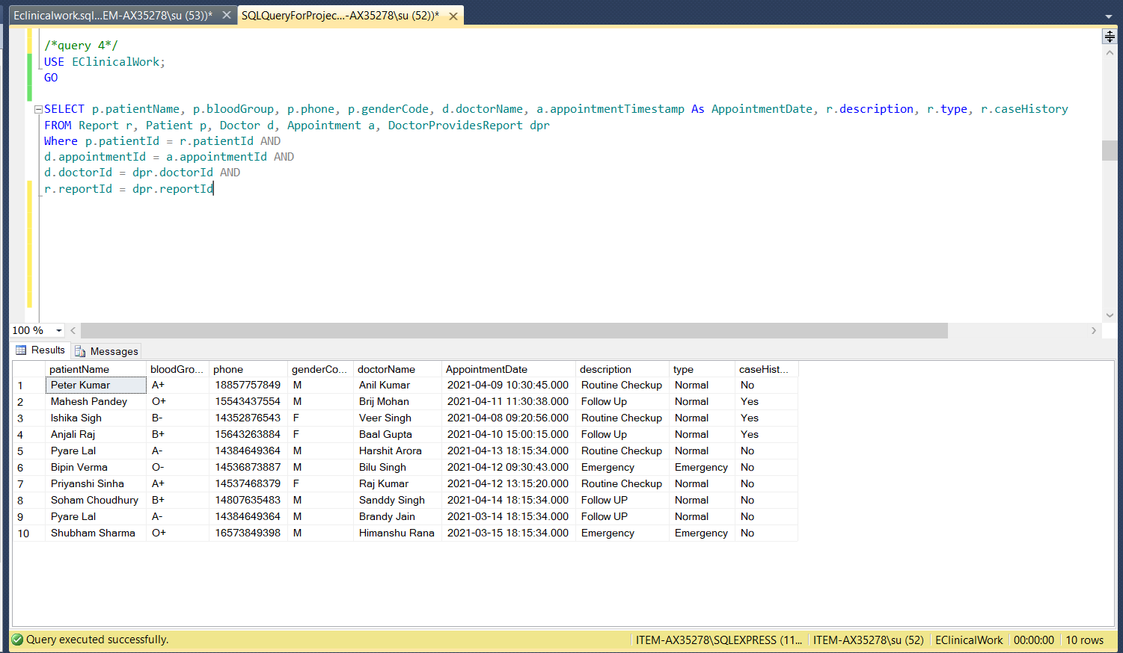

**Query 5:**

The below query gives information about the month wise count of payments and total amount received.

/* query 5 */

USE EClinicalWork;

GO

SELECT COUNT(*) As NumberOfPayments, SUM(Amount) As TotalCashReceived, DateName(mm, paymentTimestamp) as paymentMonth

FROM Payment

GROUP BY DateName(mm, paymentTimestamp);

**Screenshot:**

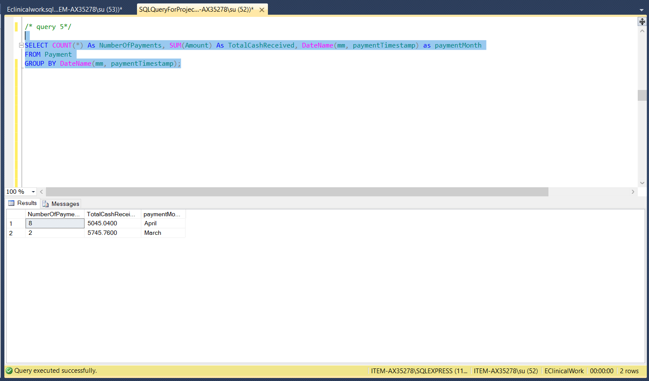

**Query 6:**

The below query yields information about the payment history which includes number of payments done on particular date along with the total cash received.

USE EClinicalWork;

GO

SELECT COUNT(*) As NumberOfPayments, SUM(Amount) As TotalCashReceived, FORMAT(paymentTimestamp, 'MMM dd') as paymentDate

FROM Payment

GROUP BY FORMAT(paymentTimestamp, 'MMM dd');

**Screenshot:**

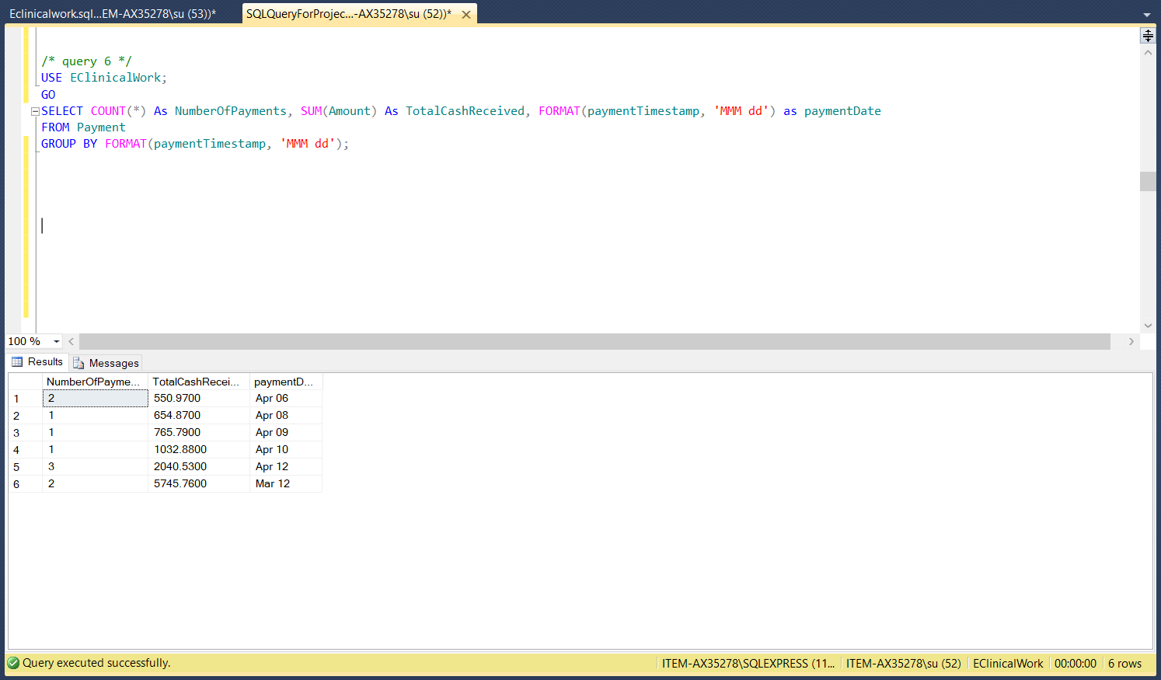

# Stored Procedures

1. The below stored procedure is beneficial to retrieve information about Particular Patient.

**Query:**

/* stored procedure for particular patient*/

CREATE PROCEDURE GetPatientDetail @Id int

AS

SELECT p.patientName, p.bloodGroup, p.drugName As AllegicDrug, p.genderCode, p.phone, p.email, a.cityName, pay.transactionId,

pay.paymentTimestamp,pay.amount, d.doctorName, r.description, r.type, r.caseHistory

FROM Address a

JOIN

PatientLivesAtAddress pla

ON pla.addressNr = a.addressNr

JOIN

Patient p

ON pla.patientId = p.patientId

JOIN

Payment pay

ON p.patientId = pay.patientId

JOIN

Report r

ON p.patientId = r.patientId

JOIN

DoctorProvidesReport dpr

ON r.reportId = dpr.reportId

JOIN

Doctor d ON dpr.doctorId = d.doctorId

WHERE p.patientId = @Id

GO

**Screenshot:**

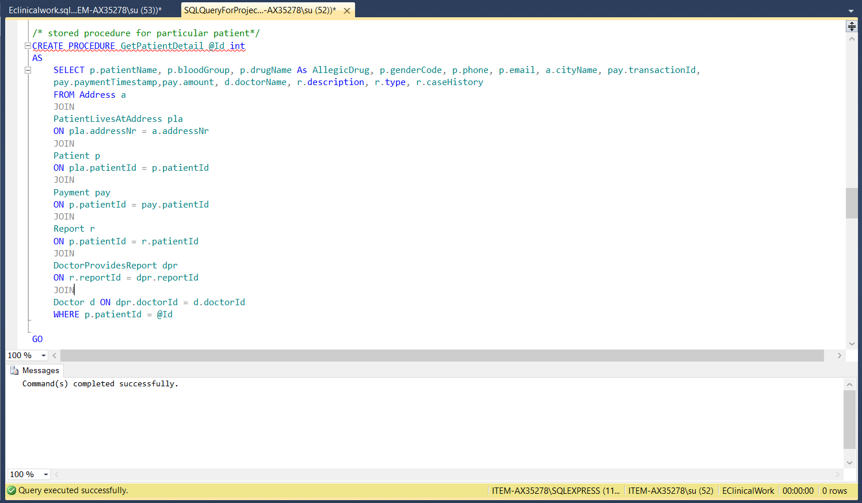

exec GetPatientDetail '1';

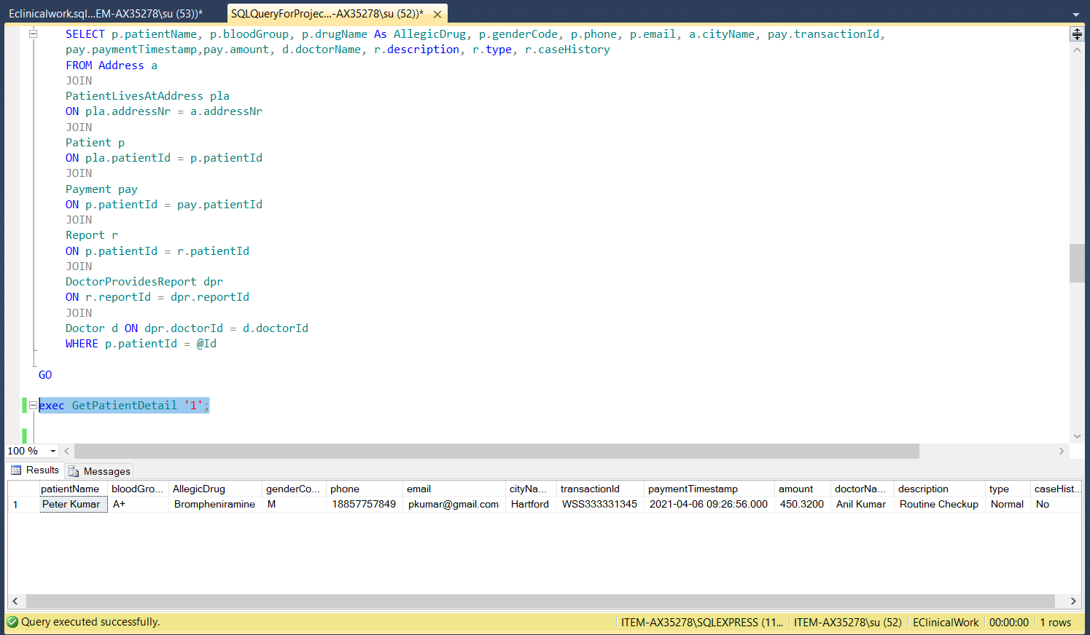

1. This Stored procedure is useful to retrieve details about patients based on state, city, and both.

**Query:**

CREATE PROC GetPatientByStateANDCity

(

@state varchar(2),

@city varchar(50) = NULL

) AS

/* Only with states */

IF @city IS NULL

SELECT p.patientName, a.cityName, a.countryCode, a.stateCode, p.phone

FROM Patient p ,PatientLivesAtAddress pla, Address a

WHERE p.patientId = pla.patientId AND

pla.addressNr=a.addressNr AND

a.stateCode =@state

/* Only with city */

ELSE IF @state IS NULL

SELECT p.patientName, a.cityName, a.countryCode, a.stateCode, p.phone

FROM Patient p ,PatientLivesAtAddress pla, Address a

WHERE p.patientId = pla.patientId AND

pla.addressNr=a.addressNr AND

a.cityName=@city

/* With states and city */

ELSE

SELECT p.patientName, a.cityName, a.countryCode, a.stateCode, p.phone

FROM Patient p ,PatientLivesAtAddress pla, Address a

WHERE p.patientId = pla.patientId AND

pla.addressNr=a.addressNr AND

stateCode=@state AND cityName=@city

Go

**Screenshot:**

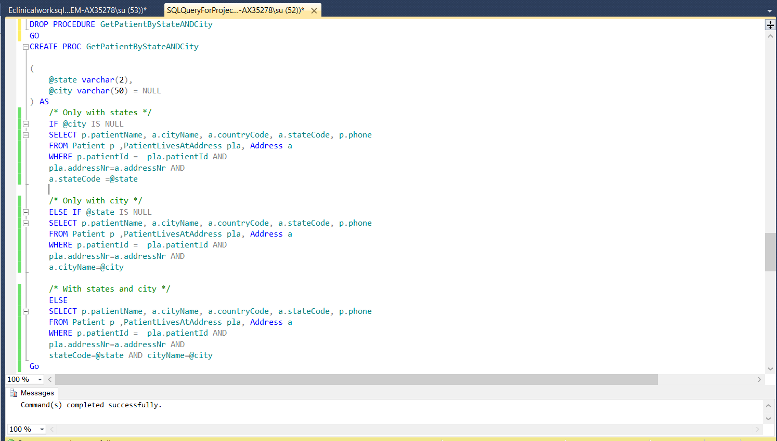

/* available patient according to state */

EXEC GetPatientByStateANDCity 'AZ'

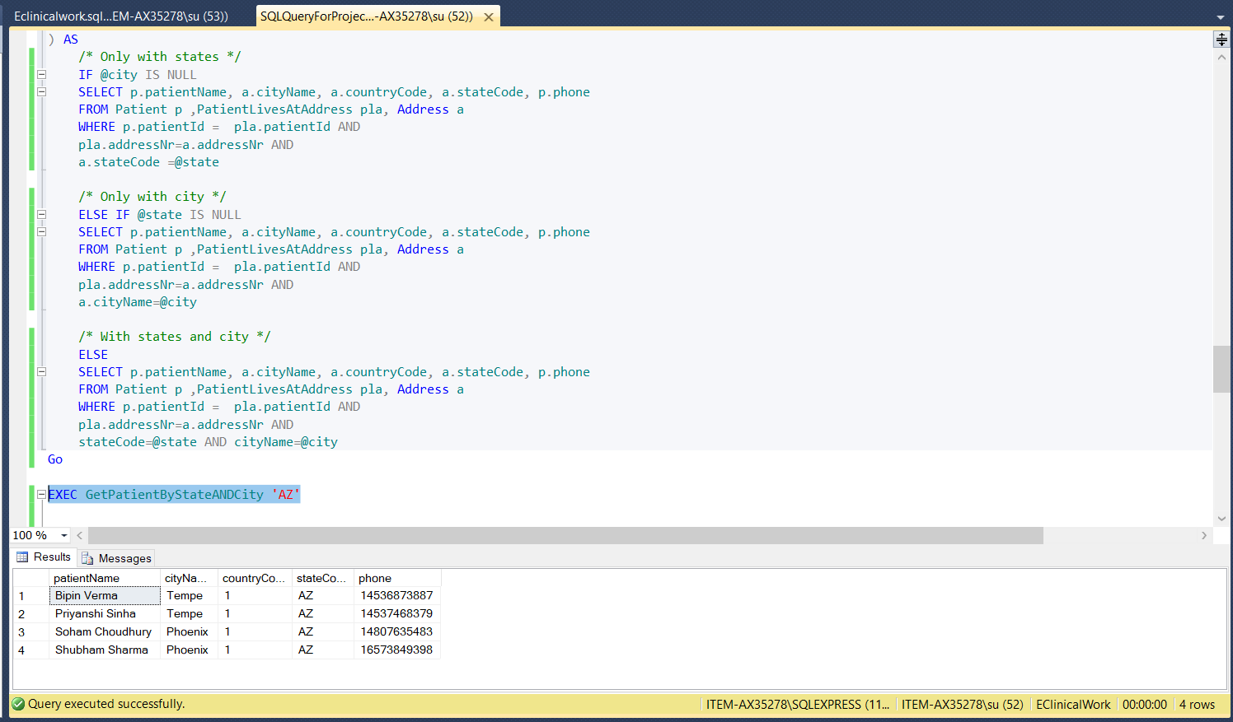

/* city and State */

EXEC GetPatientByStateANDCity 'AZ', 'Tempe'

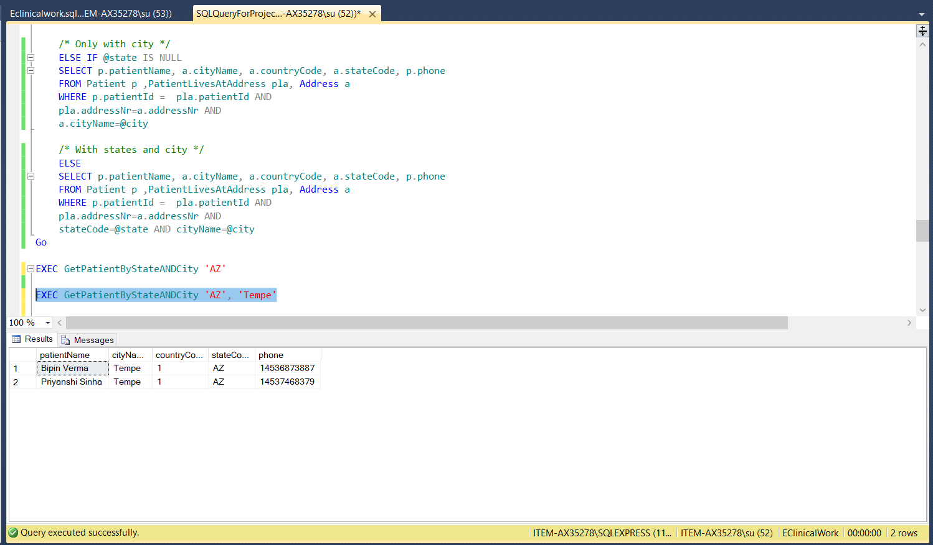

EXEC GetPatientByStateANDCity NULL, 'Phoenix'

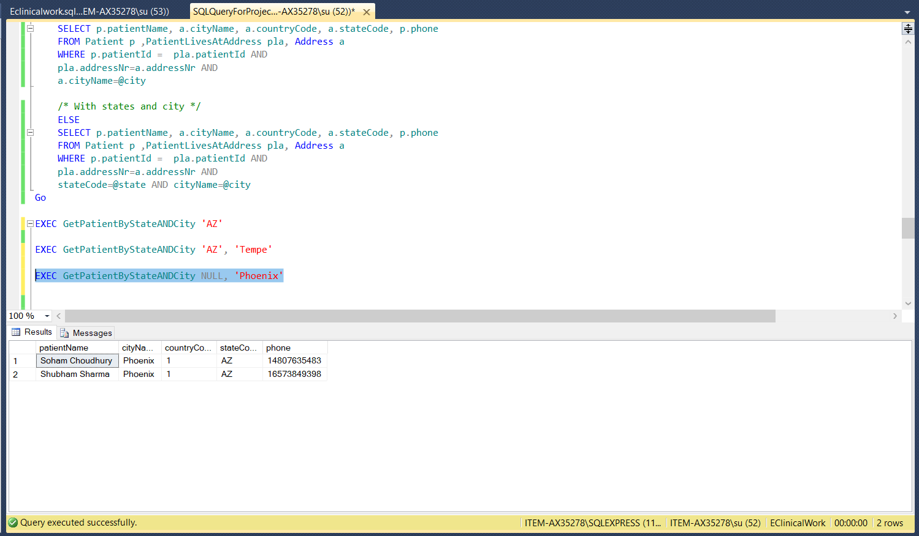

# Triggers

Whenever an accountant's record is deleted, then the trigger is activated, and that particular record is inserted into the audit table for auditing purposes.

**Query:**

-- After DELETE Triggers in SQL Server

USE [EClinicalWork]

GO

IF OBJECT_ID ('AfterDeleteAccountant', 'TR') IS NOT NULL

DROP TRIGGER AfterDeleteAccountant;

CREATE TRIGGER AfterDeleteAccountant on [Accountant]

FOR DELETE

AS DECLARE @AccountantId int,

@AccountantName nvarchar(20),

@AccountantEmail nvarchar(100),

@AccountantPhone bigint

SELECT @AccountantId = del.accountantId FROM DELETED del;

SELECT @AccountantName = del.accountantName FROM DELETED del;

SELECT @AccountantEmail = del.email FROM DELETED del;

SELECT @AccountantPhone = del.phone FROM DELETED del;

INSERT INTO [AccountantAuditTable](

accountantId ,[accountantName], [email], [phone], [deletedTime])

VALUES (@AccountantId, @AccountantName,@AccountantEmail,@AccountantPhone, CURRENT_TIMESTAMP);

PRINT 'We Successfully Fired the AFTER DELETE Triggers in SQL Server.'

GO

**Screenshots:**

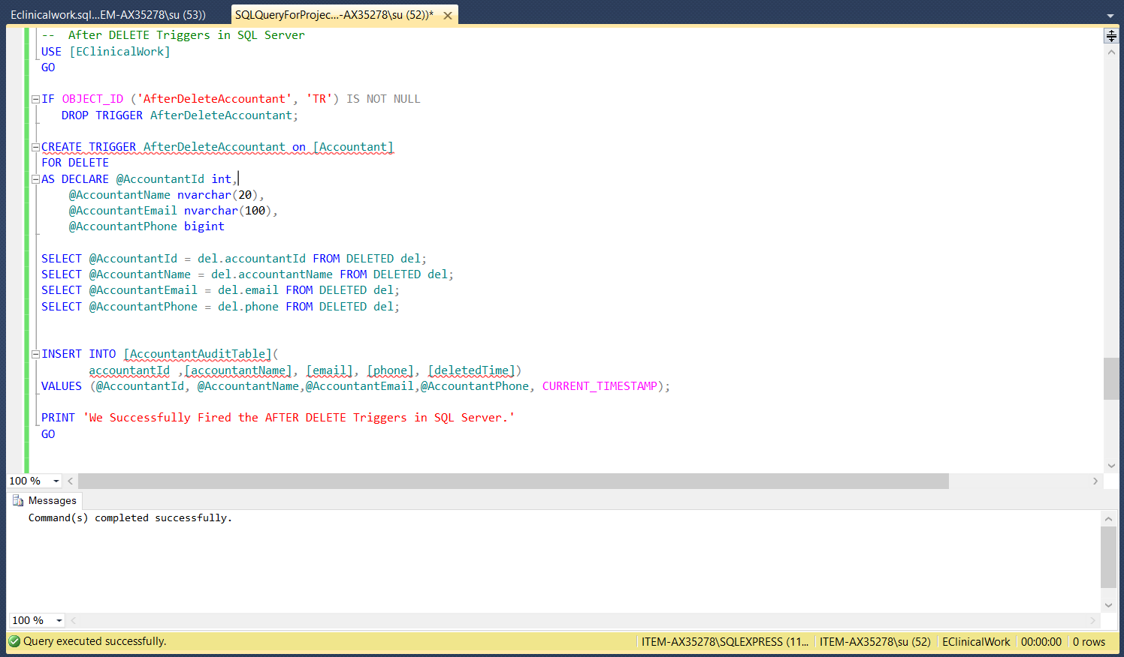

Delete from Accountant where accountantId = 5

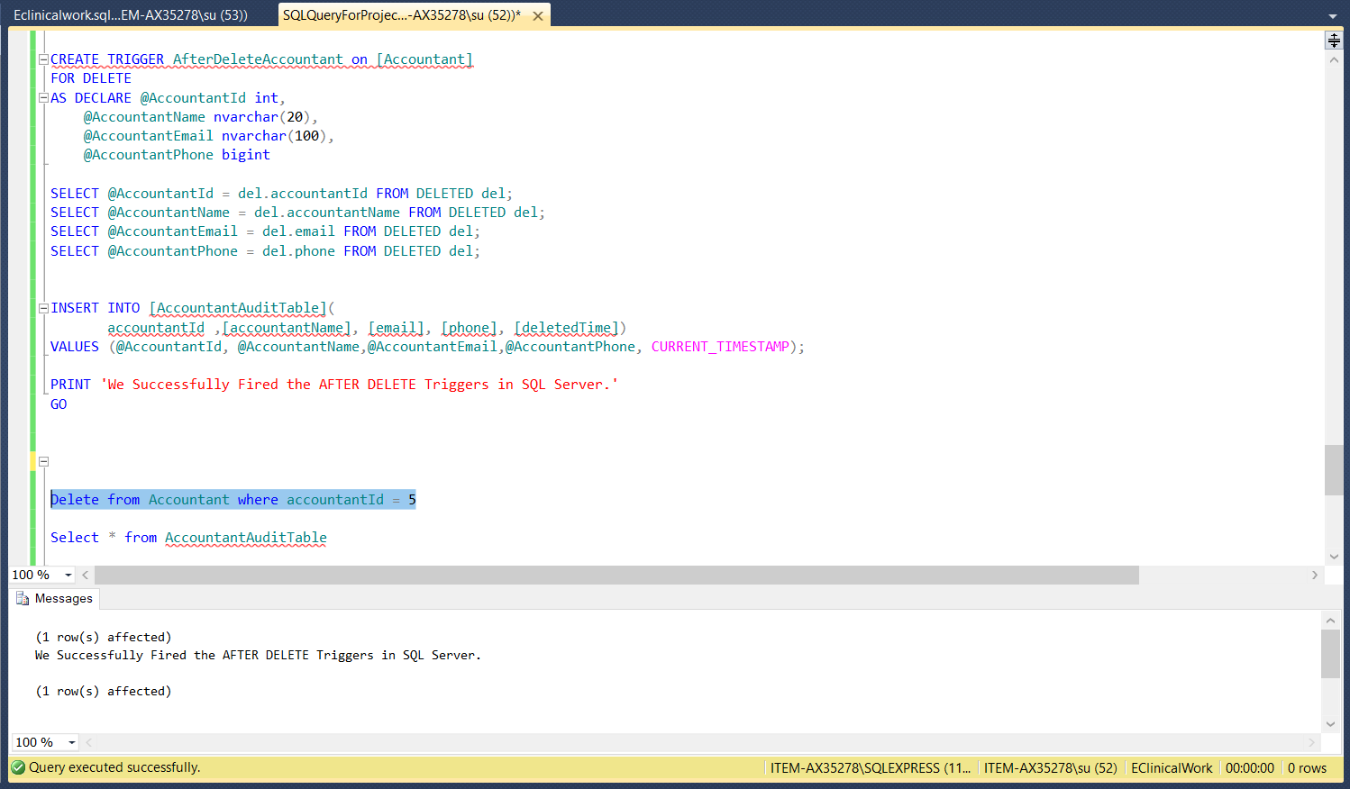

Select * from AccountantAuditTable

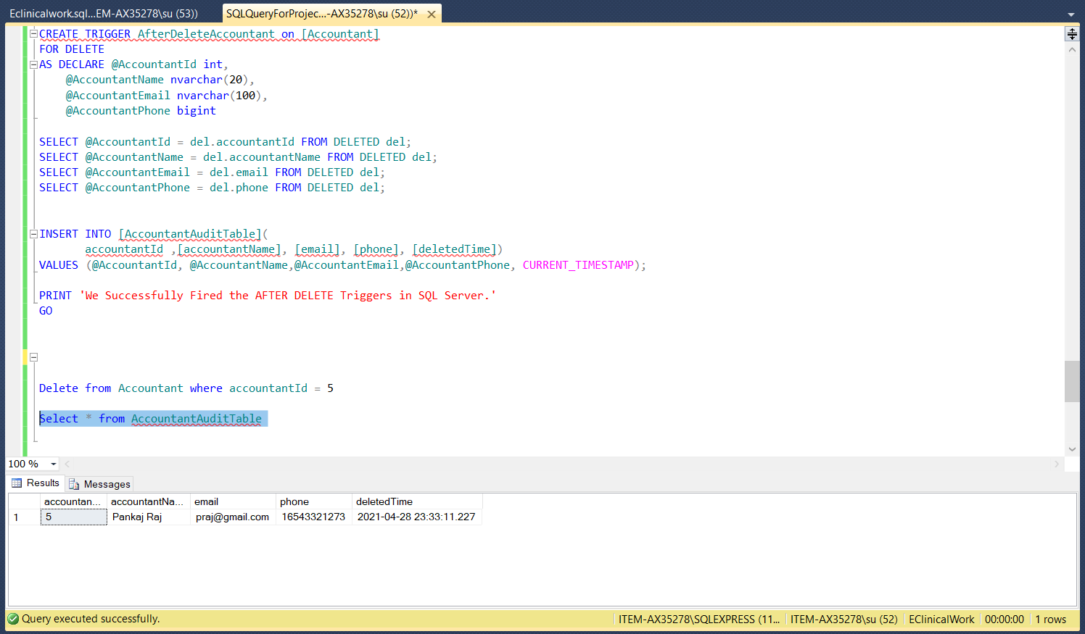

# Functions

**Function 1:**

This User-defined function is used to find the medication given to a Patient when only the Bed Number is known.

--drop function Patient_Medication

create FUNCTION Patient_Medication (@bedNo int = 0) returns table RETURN (

select P.patientName, P.genderCode, B.bedId, B.allotmentTimestamp,B.dischageTimestamp, P.drugName

from Patient P inner join BedAllotment B on P.patientId=B.patientId where B.bedId=@bedNo

);

Select * from Patient_Medication(4) order by 1;

**Screenshot:**

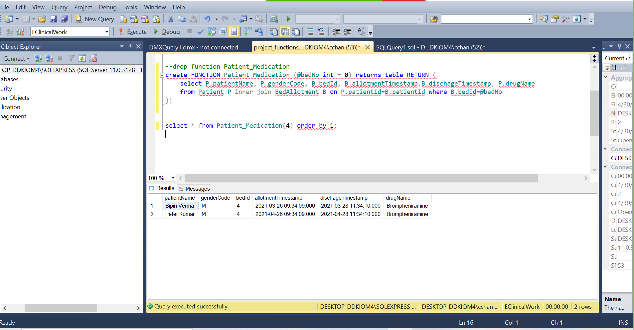

**Function 2:**

This User-defined function is used to find the treating Doctor for a particular Patient.

drop function Treating_Doctor

create FUNCTION Treating_Doctor (@name varchar(50) = NULL) returns table RETURN (

select P.patientId, P.patientName, D.doctorName, D.departmentId from Patient P join Report R on P.patientId=R.patientId join DoctorProvidesReport Dp on Dp.reportId=R.reportId

join Doctor D on D.doctorId=Dp.doctorId where P.patientName=@name

);

select * from Treating_Doctor('Mahesh Pandey') order by 1;

**Screenshot:**

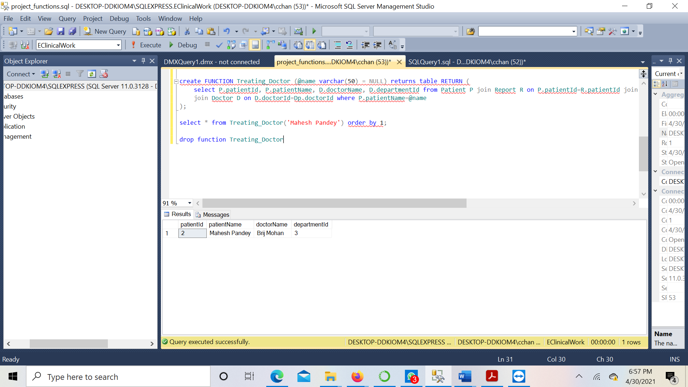

# Couchbase

Couchbase is an opensource NoSQL database used for interactive applications. This document-oriented database delivers unmatched versatility, scalability, and edge computing deployments. The data here is stored in the form of key-value pairs with some managed cache for performing many data operations and indexers for fast queries. In addition to this, it also has a powerful query engine for the execution of SQL-like queries. Couchbase Server is designed to handle large-scale interactive web, smartphone, and IoT applications with low latency data management.

# Creation of Buckets

**Buckets**

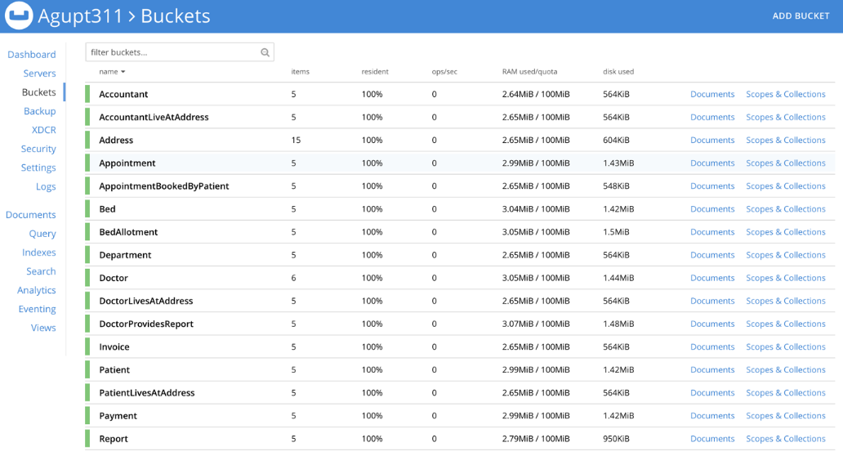

**Accountant**

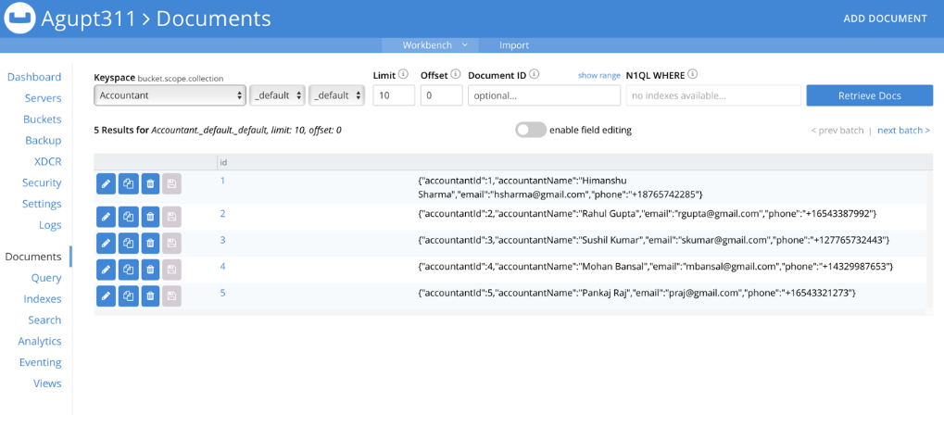

**AccountLiveAtAddress**

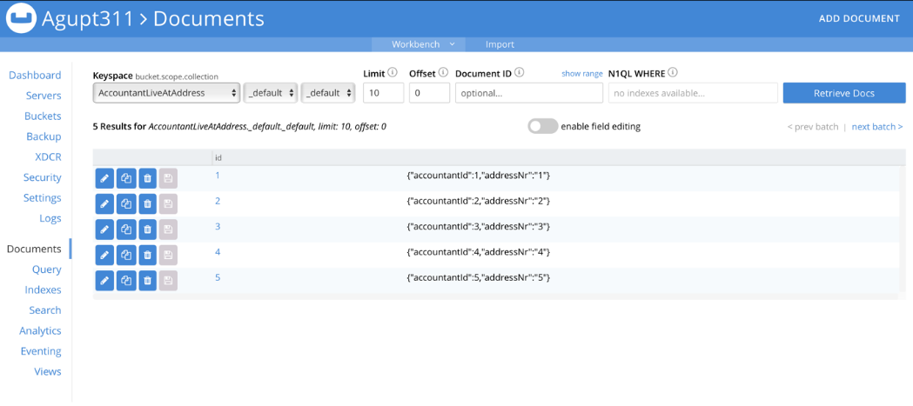

**Address**

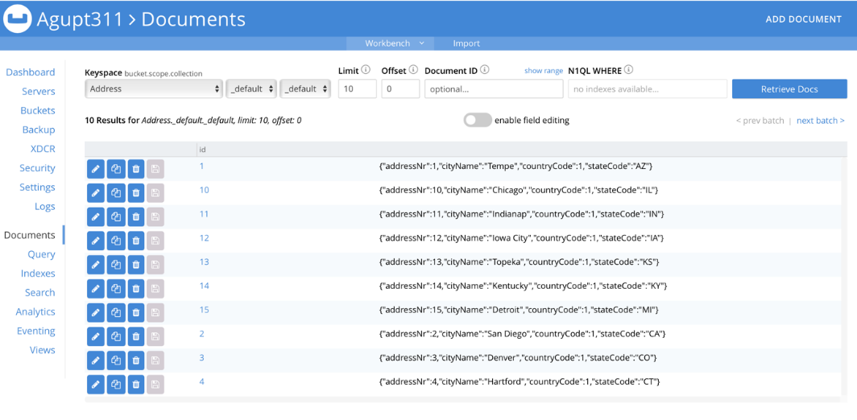

**Appointment**

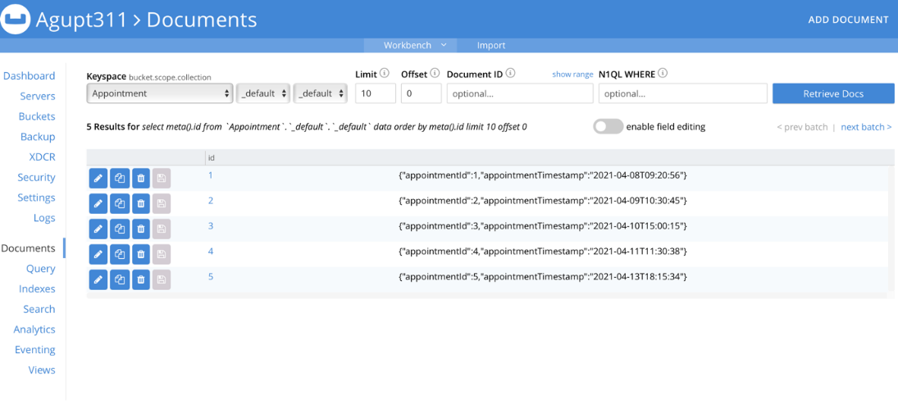

**AppointmentBookedByPatient**

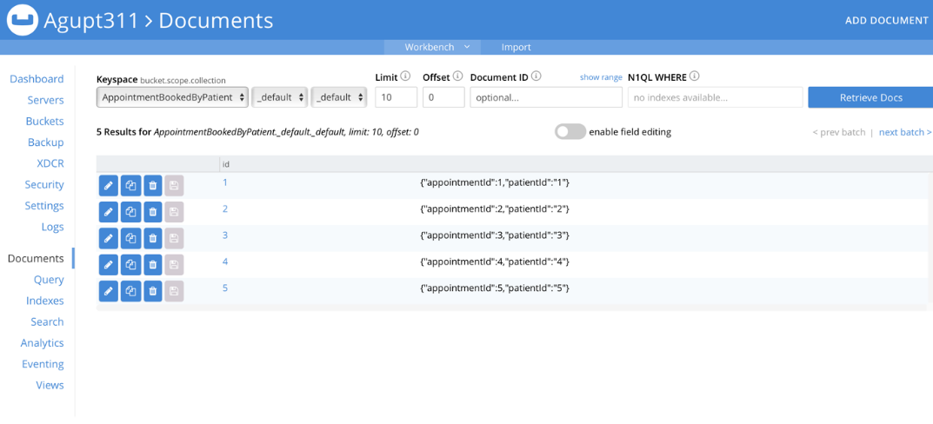

**Bed**

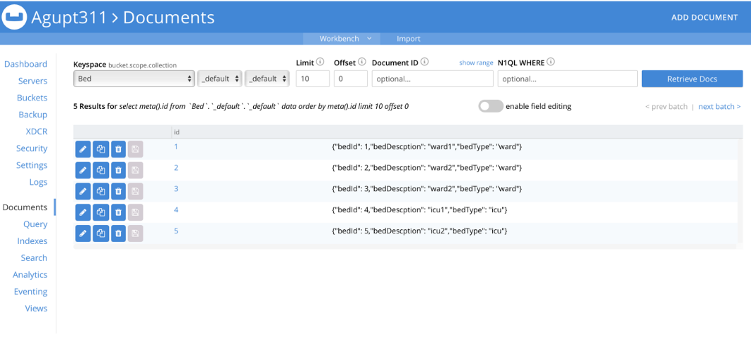

**BedAllotment**

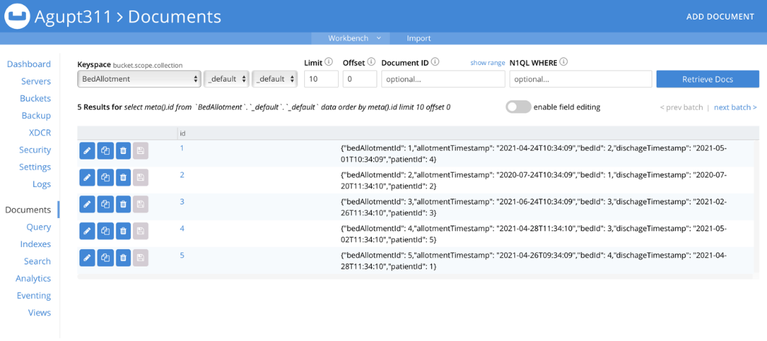

**Department**

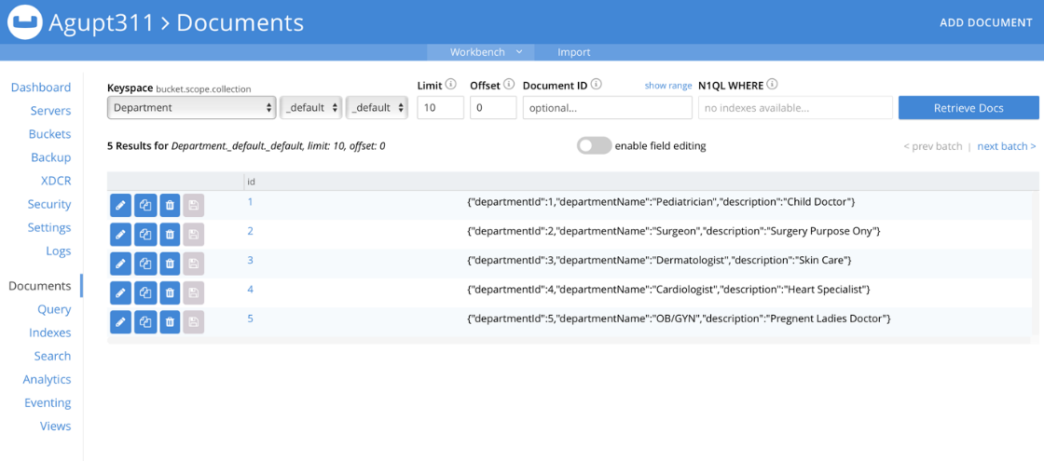

**Doctor**

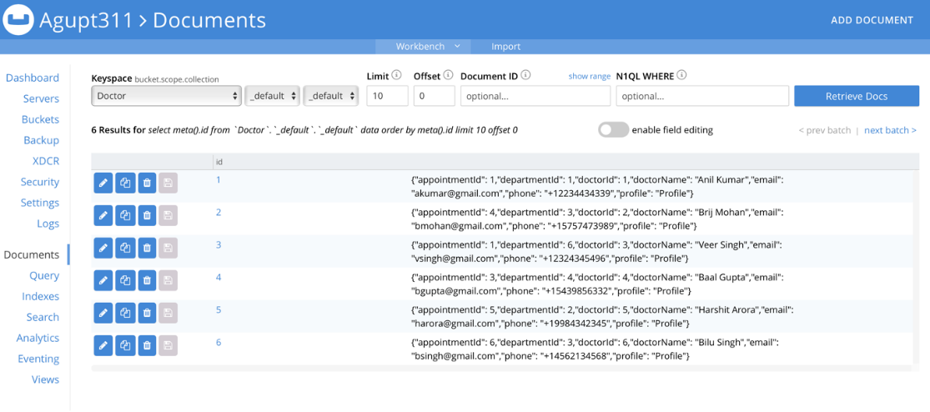

**DoctorLivesAtAddress**

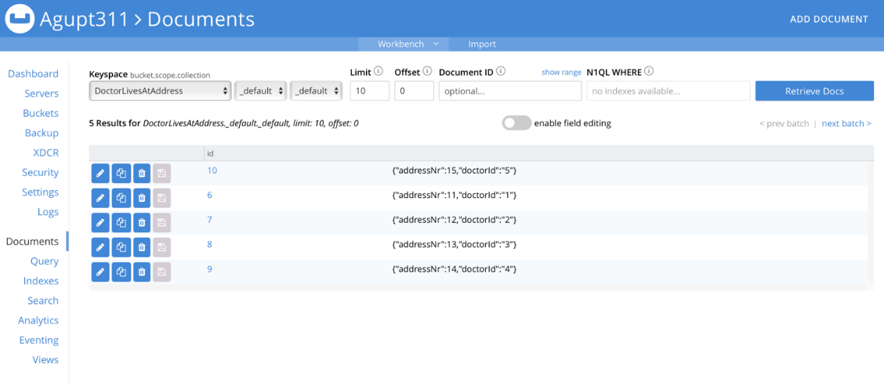

**DoctorProvidesReport**

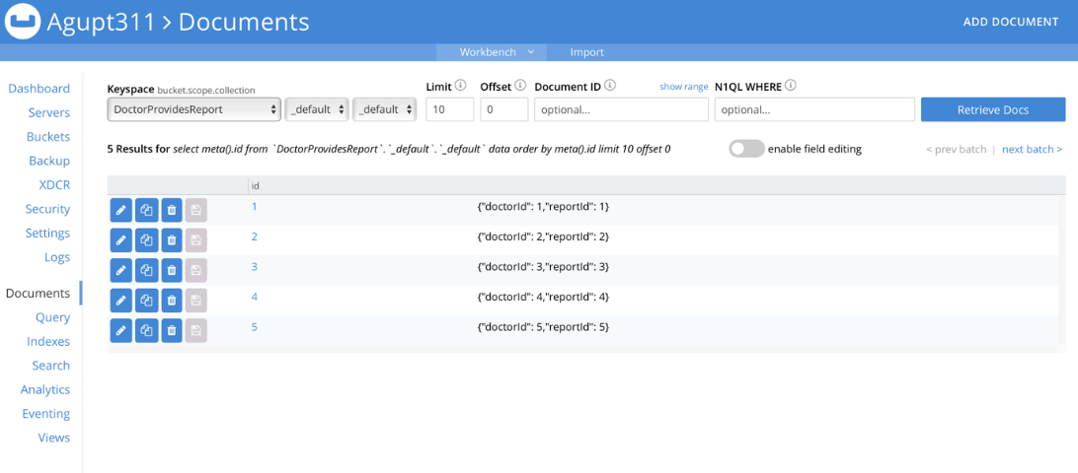

**Invoice**

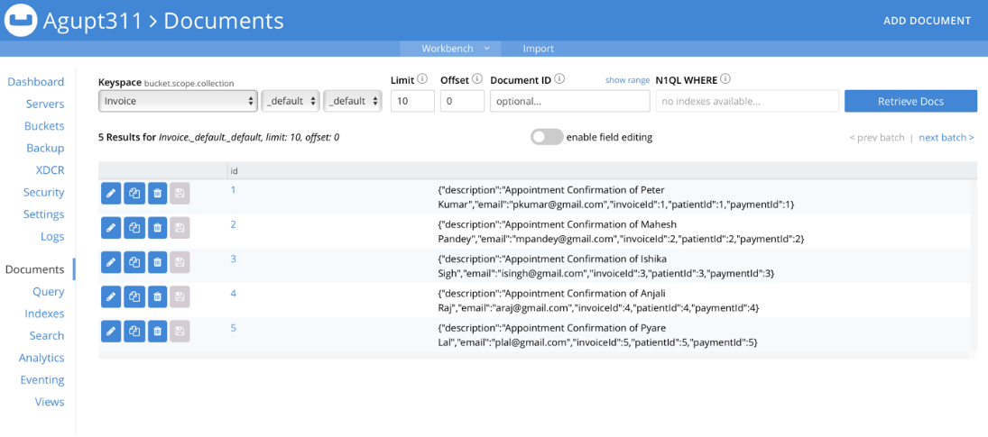

**Patient**

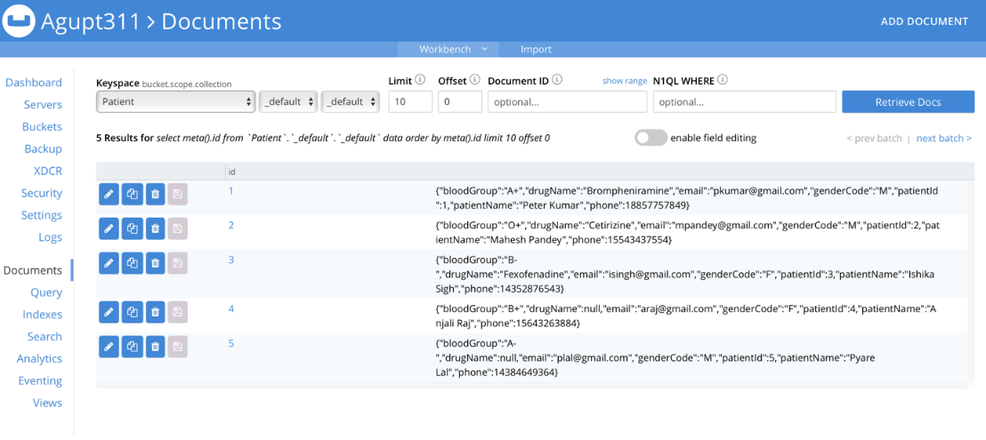

**PatientLivesAtAddress**

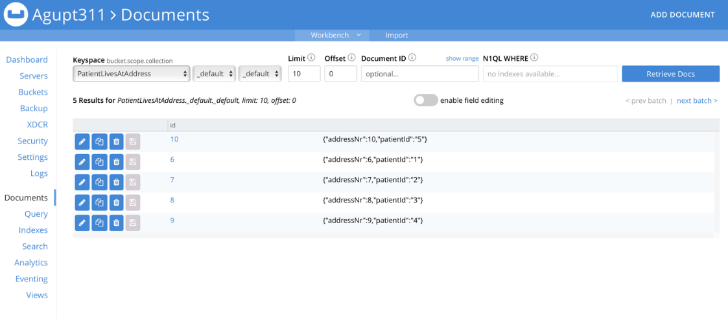

**Payment**

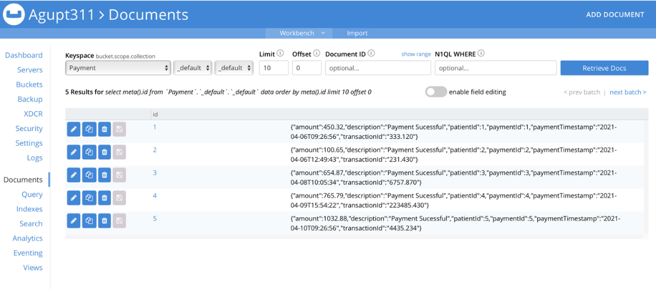

**Report**

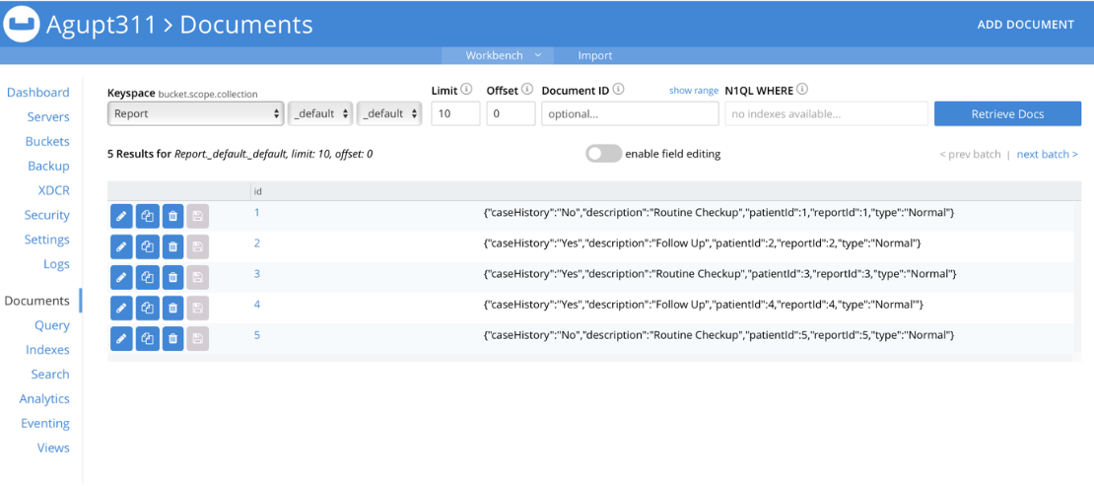

# Insertions

**Query:**

insert into Accountant (key, value)

values ( "1",

{ "accountantId": 1,

"accountantName": "Himanshu Sharma",

"email": "hsharma@gmail.com",

"phone": "+18765742285"

}

), ("2",

{ "accountantId": 2,

"accountantName": "Rahul Gupta",

"email": "rgupta@gmail.com",

"phone": "+16543387992"

}

), ("3",

{ "accountantId": 3,

"accountantName": "Sushil Kumar",

"email": "skumar@gmail.com",

"phone": "+127765732443"

}

), ("4",

{ "accountantId": 4,

"accountantName": "Mohan Bansal",

"email": "mbansal@gmail.com",

"phone": "+14329987653"

}

), ("5",

{ "accountantId": 5,

"accountantName": "Pankaj Raj",

"email": "praj@gmail.com",

"phone": "+16543321273"

}

), ("6",

{ "accountantId": 6,

"accountantName": "Harsh Vardhan",

"email": "hvardhan@gmail.com",

"phone": "+13434876484"

}

), ("7",

{ "accountantId": 7,

"accountantName": "Sidhant Lalvani",

"email": "sidlal@gmail.com",

"phone": "+14563827389"

}

), ("8",

{ "accountantId": 8,

"accountantName": "Bal Veer",

"email": "balveer@gmail.com",

"phone": "+18389493948"

}

), ("9",

{ "accountantId": 9,

"accountantName": "James Alabi",

"email": "jalabi@gmail.com",

"phone": "+14437782902"

}

), ("10",

{ "accountantId": 10,

"accountantName": "Om Kapoor",

"email": "omkap@gmail.com",

"phone": "+17564795389"

}

);

--------------------

------------------

insert into Address (key, value)

values ( "1",

{ "addressNr": 1,

"stateCode": "AZ",

"cityName": "Tempe",

"countryCode": 1

}

), ( "2",

{ "addressNr": 2,

"stateCode": "CA",

"cityName": "San Diego",

"countryCode": 1

}

), ( "3",

{ "addressNr": 3,

"stateCode": "CO",

"cityName": "Denver",

"countryCode": 1

}

), ( "4",

{ "addressNr": 4,

"stateCode": "CT",

"cityName": "Hartford",

"countryCode": 1

}

), ( "5",

{ "addressNr": 5,

"stateCode": "DE",

"cityName": "Dover",

"countryCode": 1

}

), ( "6",

{ "addressNr": 6,

"stateCode": "FL",

"cityName": "Miami",

"countryCode": 1

}

), ( "7",

{ "addressNr": 7,

"stateCode": "GA",

"cityName": "Atlanta",

"countryCode": 1

}

), ( "8",

{ "addressNr": 8,

"stateCode": "HI",

"cityName": "Hilo",

"countryCode": 1

}

), ( "9",

{ "addressNr": 9,

"stateCode": "ID",

"cityName": "Boise",

"countryCode": 1

}

), ( "10",

{ "addressNr": 10,

"stateCode": "IL",

"cityName": "Chicago",

"countryCode": 1

}

), ( "11",

{ "addressNr": 11,

"stateCode": "IN",

"cityName": "Indianap",

"countryCode": 1

}

), ( "12",

{ "addressNr": 12,

"stateCode": "IA",

"cityName": "Iowa City",

"countryCode": 1

}

), ( "13",

{ "addressNr": 13,

"stateCode": "KS",

"cityName": "Topeka",

"countryCode": 1

}

), ( "14",

{ "addressNr": 14,

"stateCode": "KY",

"cityName": "Kentucky",

"countryCode": 1

}

), ( "15",

{ "addressNr": 15,

"stateCode": "MI",

"cityName": "Detroit",

"countryCode": 1

}

);

------------------------

-----------------------

insert into Doctor (key, value)

values ( "1",

{ "doctorId": 1,

"doctorName": "Anil Kumar",

"email": "akumar@gmail.com",

"phone": "+12234434339",

"profile": "Profile",

"appointmentId": "2",

"departmentId": "1"

}

), ("2",

{ "doctorId": 2,

"doctorName": "Brij Mohan",

"email": "bmohan@gmail.com",

"phone": "+15757473989",

"profile": "Profile",

"appointmentId": "4",

"departmentId": "3"

}

), ("3",

{ "doctorId": 3,

"doctorName": "Veer Singh",

"email": "vsingh@gmail.com",

"phone": "+12324345496",

"profile": "Profile",

"appointmentId": "1",

"departmentId": "6"

}

), ("4",

{ "doctorId": 4,

"doctorName": "Baal Gupta",

"email": "bgupta@gmail.com",

"phone": "+15439856332",

"profile": "Profile",

"appointmentId": "3",

"departmentId": "4"

}

), ("5",

{ "doctorId": 5,

"doctorName": "Harshit Arora",

"email": "harora@gmail.com",

"phone": "+19984342345",

"profile": "Profile",

"appointmentId": "5",

"departmentId": "2"

}

), ("6",

{ "doctorId": 6,

"doctorName": "Bilu Singh",

"email": "bsingh@gmail.com",

"phone": "+14562134568",

"profile": "Profile",

"appointmentId": "6",

"departmentId": "3"

}

), ("7",

{ "doctorId": 7,

"doctorName": "Raj Kumar",

"email": "rajkum@gmail.com",

"phone": "+18478349827",

"profile": "Profile",

"appointmentId": "7",

"departmentId": "9"

}

), ("8",

{ "doctorId": 8,

"doctorName": "Sanddy Singh",

"email": "sandsing@gmail.com",

"phone": "+17654687652",

"profile": "Profile",

"appointmentId": "8",

"departmentId": "7"

}

), ("9",

{ "doctorId": 9,

"doctorName": "Brandy Jain",

"email": "brandjain@gmail.com",

"phone": "+17674537386",

"profile": "Profile",

"appointmentId": "9",

"departmentId": "8"

}

), ("10",

{ "doctorId": 10,

"doctorName": "Himanshu Rana",

"email": "himrana@gmail.com",

"phone": "+19654364736",

"profile": "Profile",

"appointmentId": "10",

"departmentId": "10"

}

);

--------------

--------------

insert into Patient (key, value)

values ( "1",

{ "patientId": 1,

"bloodGroup": "A+",

"email": "pkumar@gmail.com",

"patientName": "Peter Kumar",

"phone": "+18857757849",

"genderCode": "M"

}

), ("2",

{ "patientId": 2,

"bloodGroup": "O+",

"email": "mpandey@gmail.com",

"patientName": "Mahesh Pandey",

"phone": "+15543437554",

"genderCode": "M"

}

), ("3",

{ "patientId": "3",

"bloodGroup": "B-",

"email": "isingh@gmail.com",

"patientName": "Ishika Sigh",

"phone": "+14352876543",

"genderCode": "F"

}

), ("4",

{ "patientId": 4,

"bloodGroup": "B+",

"email": "araj@gmail.com",

"patientName": "Anjali Raj",

"phone": "+15643263884",

"genderCode": "F"

}

), ("5",

{ "patientId": "5",

"bloodGroup": "A-",

"email": "plal@gmail.com",

"patientName": "Pyare Lal",

"phone": "+14384649364",

"genderCode": "M"

}

), ("6",

{ "patientId": "6",

"bloodGroup": "O-",

"email": "bverma@gmail.com",

"patientName": "Bipin Verma",

"phone": "+14536873887",

"genderCode": "M"

}

), ("7",

{ "patientId": "7",

"bloodGroup": "A+",

"email": "psinha@gmail.com",

"patientName": "Priyanshi Sinha",

"phone": "+14537468379",

"genderCode": "F"

}

), ("8",

{ "patientId": "8",

"bloodGroup": "B+",

"email": "schoud@gmail.com",

"patientName": "Soham Choudhury",

"phone": "+14807635483",

"genderCode": "M"

}

), ("9",

{ "patientId": 9,

"bloodGroup": "O+",

"email": "ssharma@gmail.com",

"patientName": "Shubham Sharma",

"phone": "+16573849398",

"genderCode": "M"

}

), ("10",

{ "patientId": 10,

"bloodGroup": "B-",

"email": "pgupta@gmail.com",

"patientName": "Palak Gupta",

"phone": "+14809876745",

"genderCode": "F"

}

);

---------------------------------------------------------------------------------------------

---------------------------------------------------------------------------------------------

insert into Department (key, value)

values ( "1",

{ "departmentId": 1,

"departmentName": "Pediatrician",

"description": "Child Doctor"

}

), ("2",

{ "departmentId": 2,

"departmentName": "Surgeon",

"description": "Surgery Purpose Ony"

}

), ("3",

{ "departmentId": 3,

"departmentName": "Dermatologist",

"description": "Skin Care"

}

), ("4",

{ "departmentId": 4,

"departmentName": "Cardiologist",

"description": "Heart Specialist"

}

), ("5",

{ "departmentId": 5,

"departmentName": "OB/GYN",

"description": "Pregnent Ladies Doctor"

}

), ("6",

{ "departmentId": 6,

"departmentName": "Allergists",

"description": "some autoimmune diseases"

}

), ("7",

{ "departmentId": 7,

"departmentName": "Endocrinologists",

"description": "experts on hormones and metabolism"

}

), ("8",

{ "departmentId": 8,

"departmentName": "Gastroenterologists",

"description": "specialists in digestive organs"

}

), ("9",

{ "departmentId": 9,

"departmentName": "Hematologists",

"description": "specialists in diseases of the blood"

}

), ("10",

{ "departmentId": 10,

"departmentName": "Neurologists",

"description": "specialists in the nervous system"

}

);

---------------------------------------------------------------------------------------

----------------------------------------------------------------------------------------

insert into Invoice (key, value)

values ( "1",

{

"invoiceId": 1,

"patientId": 1,

"paymentId": 1,

"email": "pkumar@gmail.com",

"description": "Appointment Confirmation of Peter Kumar"

}

), ("2",

{

"invoiceId": 2,

"patientId": 2,

"paymentId": 2,

"email": "mpandey@gmail.com",

"description": "Appointment Confirmation of Mahesh Pandey"

}

), ("3",

{

"invoiceId": 3,

"patientId": 3,

"paymentId": 3,

"email": "isingh@gmail.com",

"description": "Appointment Confirmation of Ishika Sigh"

}

), ("4",

{

"invoiceId": 4,

"patientId": 4,

"paymentId": 4,

"email": "araj@gmail.com",

"description": "Appointment Confirmation of Anjali Raj"

}

), ("5",

{

"invoiceId": 5,

"patientId": 5,

"paymentId": 5,

"email": "plal@gmail.com",

"description": "Appointment Confirmation of Pyare Lal"

}

), ("6",

{

"invoiceId": 6,

"patientId": 6,

"paymentId": 6,

"email": "bverma@gmail.com",

"description": "Appointment Confirmation of Bipin Verma"

}

), ("7",

{

"invoiceId": 7,

"patientId": 7,

"paymentId": 7,

"email": "psinha@gmail.com",

"description": "Appointment Confirmation of Priyanshi Sinha"

}

), ("8",

{

"invoiceId": 8,

"patientId": 8,

"paymentId": 8,

"email": "schoud@gmail.com",

"description": "Appointment Confirmation of Soham Choudhury"

}

), ("9",

{

"invoiceId": 9,

"patientId": 9,

"paymentId": 9,

"email": "ssharma@gmail.com",

"description": "Appointment Confirmation of Shubham Sharma"

}

), ("10",

{

"invoiceId": 10,

"patientId": 10,

"paymentId": 10,

"email": "pgupta@gmail.com",

"description": "Appointment Confirmation of Palak Gupta"

}

);

-----------------------------------------------------------------------------

------------------------------------------------------------------------------------

insert into Payment (key, value)

values ( "1",

{

"paymentId": 1,

"amount": 450.32,

"patientId": 1,

"paymentTimestamp": " 2021-04-06 09:26:56",

"transactionId": 333.12,

"description": "Payment Sucessful"

}

), ("2",

{

"paymentId": 2,

"amount": 100.65,

"patientId": 2,

"paymentTimestamp": " 2021-04-06 12:49:43",

"transactionId": 231.43,

"description": "Payment Sucessful"

}

), ("3",

{

"paymentId": 3,

"amount": 654.87,

"patientId": 3,

"paymentTimestamp": " 2021-04-08 10:05:34",

"transactionId": 6757.87,

"description": "Payment Sucessful"

}

), ("4",

{

"paymentId": 4,

"amount": 765.79,

"patientId": 4,

"paymentTimestamp": " 2021-04-09 15:54:22",

"transactionId": 223485.43,

"description": "Payment Sucessful"

}

), ("5",

{

"paymentId": 5,

"amount": 1032.88,

"patientId": 5,

"paymentTimestamp": " 2021-04-10 09:26:56",

"transactionId": 4435.234,

"description": "Payment Sucessful"

}

), ("6",

{

"paymentId": 6,

"amount": 567.43,

"patientId": 6,

"paymentTimestamp": " 2021-04-12 13:39:42",

"transactionId": 5327.621,

"description": "Payment Sucessful"

}

), ("7",

{

"paymentId": 7,

"amount": 648.21,

"patientId": 7,

"paymentTimestamp": " 2021-04-12 17:15:31",

"transactionId": 783.98,

"description": "Payment Sucessful"

}

), ("8",

{

"paymentId": 8,

"amount": 824.89,

"patientId": 8,

"paymentTimestamp": " 2021-04-12 17:15:31",

"transactionId": 5652.421,

"description": "Payment Sucessful"

}

), ("9",

{

"paymentId": 9,

"amount": 2324.44,

"patientId": 9,

"paymentTimestamp": " 2021-04-12 17:15:31",

"transactionId": 4234.23,

"description": "Payment Sucessful"

}

), ("10",

{

"paymentId": 10,

"amount": 3421.32,

"patientId": 10,

"paymentTimestamp": " 2021-04-12 17:15:31",

"transactionId": 2213.54,

"description": "Payment Sucessful"

}

);

---------------------------------------------------------------------------------

-----------------------------------------------------------------------------------------

insert into Appointment (key, value)

values ( "1",

{

"appointmentId": 1,

"appointmentTimestamp": "2021-04-08 09:20:56"

}

), ("2",

{

"appointmentId": 2,

"appointmentTimestamp": "2021-04-09 10:30:45"

}

), ("3",

{

"appointmentId": 3,

"appointmentTimestamp": "2021-04-10 15:00:15"

}

), ("4",

{

"appointmentId": 4,

"appointmentTimestamp": "2021-04-11 11:30:38"

}

), ("5",

{

"appointmentId": 5,

"appointmentTimestamp": "2021-04-13 18:15:34"

}

), ("6",

{

"appointmentId": 6,

"appointmentTimestamp": "2021-04-12 09:30:43"

}

), ("7",

{

"appointmentId": 7,

"appointmentTimestamp": " 2021-04-12 13:15:18"

}

), ("8",

{

"appointmentId": 8,

"appointmentTimestamp": "2021-04-14 18:15:34"

}

), ("9",

{

"appointmentId": 9,

"appointmentTimestamp": "2021-04-14 18:15:34"

}

), ("10",

{

"appointmentId": 10,

"appointmentTimestamp": "2021-04-15 18:15:34"

}

);

----------------------------------------------------------------

----------------------------------------------------------------------

insert into Report (key, value)

values ( "1",

{

"reportId": 1,

"description": "Routine Checkup",

"patientId": 1,

"type": "Normal",

"caseHistory": "No"

}

), ("2",

{

"reportId": 2,

"description": "Follow Up",

"patientId": 2,

"type": "Normal",

"caseHistory": "Yes"

}

), ("3",

{

"reportId": 3,

"description": "Routine Checkup",

"patientId": 3,

"type": "Normal",

"caseHistory": "Yes"

}

), ("4",

{

"reportId": 4,

"description": "Follow Up",

"patientId": 4,

"type": "Normal'",

"caseHistory": "Yes"

}

), ("5",

{

"reportId": 5,

"description": "Routine Checkup",

"patientId": 5,

"type": "Normal",

"caseHistory": "No"

}

), ("6",

{

"reportId": 6,

"description": "Emergency",

"patientId": 5,

"type": "Emergency",

"caseHistory": "No"

}

), ("7",

{

"reportId": 7,

"description": "Routine Checkup",

"patientId": 5,

"type": "Normal",

"caseHistory": "No"

}

), ("8",

{

"reportId": 8,

"description": "Follow UP",

"patientId": 5,

"type": " Normal",

"caseHistory": "No"

}

), ("9",

{

"reportId": 9,

"description": "Follow UP",

"patientId": 5,

"type": " Normal",

"caseHistory": "No"

}

), ("10",

{

"reportId": 10,

"description": "Emergency",

"patientId": 5,

"type": " Emergency",

"caseHistory": "No"

}

);

-----------------------------------------------------------------------

-----------------------------------------------------------------------

insert into AccountantLiveAtAddress (key, value)

values ( "1",

{

"accountantId": 1,

"addressNr": "1"

}

), ("2",

{

"accountantId": 2,

"addressNr": "2"

}

), ("3",

{

"accountantId": 3,

"addressNr": "3"

}

), ("4",

{

"accountantId": 4,

"addressNr": "4"

}

), ("5",

{

"accountantId": 5,

"addressNr": "5"

}

);

----------------------------------------------------------------

----------------------------------------------------------------------------------

insert into PatientLivesAtAddress (key, value)

values ( "6",

{

"addressNr": 6,

"patientId": "1"

}

), ("7",

{

"addressNr": 7,

"patientId": "2"

}

), ("8",

{

"addressNr": 8,

"patientId": "3"

}

), ("9",

{

"addressNr": 9,

"patientId": "4"

}

), ("10",

{

"addressNr": 10,

"patientId": "5"

}

);

-------------------------------------------------------------------------------

---------------------------------------------------------------------------------

insert into DoctorLivesAtAddress (key, value)

values ( "6",

{

"addressNr": 11,

"doctorId": "1"

}

), ("7",

{

"addressNr": 12,

"doctorId": "2"

}

), ("8",

{

"addressNr": 13,

"doctorId": "3"

}

), ("9",

{

"addressNr": 14,

"doctorId": "4"

}

), ("10",

{

"addressNr": 15,

"doctorId": "5"

}

);

-----------------------------------------------------------------------

---------------------------------------------------------------------

insert into DoctorProvidesReport (key, value)

values ( "1",

{

"doctorId": 1,

"reportId": "1"

}

), ("2",

{

"doctorId": 2,

"reportId": "2"

}

), ("3",

{

"doctorId": 3,

"reportId": "3"

}

), ("4",

{

"doctorId": 4,

"reportId": "4"

}

), ("5",

{

"doctorId": 5,

"reportId": "5"

}

), ( "6",

{

"doctorId": 6,

"reportId": "6"

}

), ("7",

{

"doctorId": 7,

"reportId": "7"

}

), ("8",

{

"doctorId": 8,

"reportId": "8"

}

), ("9",

{

"doctorId": 9,

"reportId": "9"

}

), ("10",

{

"doctorId": 10,

"reportId": "10"

}

);

------------------------------------------------------------------------------------------

----------------------------------------------------------------------------------------

insert into Bed (key, value)

values ( "1",

{

"bedId": 1,

"bedDescption": " ward1",

"bedType": "ward"

}

), ("2",

{

"bedId": 2,

"bedDescption": " ward2",

"bedType": "ward"

}

), ("3",

{

"bedId": 3,

"bedDescption": " ward2",

"bedType": "ward"

}

), ("4",

{

"bedId": 4,

"bedDescption": "icu1",

"bedType": "icu"

}

), ("5",

{

"bedId": 5,

"bedDescption": "icu2",

"bedType": "icu"

}

),( "6",

{

"bedId": 6,

"bedDescption": "ward3",

"bedType": "ward"

}

), ("7",

{

"bedId": 7,

"bedDescption": "ward4",

"bedType": "ward"

}

), ("8",

{

"bedId": 8,

"bedDescption": "icu2",

"bedType": "icu"

}

), ("9",

{

"bedId": 9,

"bedDescption": "icu3",

"bedType": "icu"

}

), ("10",

{

"bedId": 10,

"bedDescption": "ward4",

"bedType": "ward"

}

);

--------------------------------------------------------------------------------------

---------------------------------------------------------------------------------------

insert into AppointmentBookedByPatient (key, value)

values ( "1",

{

"appointmentId": 1,

"patientId": "1"

}

), ("2",

{

"appointmentId": 2,

"patientId": "2"

}

), ("3",

{

"appointmentId": 3,

"patientId": "3"

}

), ("4",

{

"appointmentId": 4,

"patientId": "4"

}

), ("5",

{

"appointmentId": 5,

"patientId": "5"

}

),( "6",

{

"appointmentId": 6,

"patientId": "6"

}

), ("7",

{

"appointmentId": 7,

"patientId": "7"

}

), ("8",

{

"appointmentId": 8,

"patientId": "8"

}

), ("9",

{

"appointmentId": 9,

"patientId": "9"

}

), ("10",

{

"appointmentId": 10,

"patientId": "10"

}

);

----------------------------------------------------------------------

----------------------------------------------------------------------

insert into BedAllotment (key, value)

values ( "1",

{

"bedAllotmentId": 1,

"allotmentTimestamp": " 2021-04-24 10:34:09",

"bedId": 2,

"dischageTimestamp": "2021-05-01 10:34:09",

"patientId": 4

}

), ("4",

{

"bedAllotmentId": 4,

"allotmentTimestamp": " 2021-04-28 11:34:10",

"bedId": 3,

"dischageTimestamp": " 2021-05-02 11:34:10'",

"patientId": 5

}

), ("3",

{

"bedAllotmentId": 3,

"allotmentTimestamp": " 2021-06-24 10:34:09",

"bedId": 3,

"dischageTimestamp": "2021-02-26 11:34:10'",

"patientId": 3

}

), ("2",

{

"bedAllotmentId": 2,

"allotmentTimestamp": "2020-07-24 10:34:09",

"bedId": 1,

"dischageTimestamp": "2020-07-20 11:34:10'",

"patientId": 2

}

), ("5",

{

"bedAllotmentId": 5,

"allotmentTimestamp": "2021-04-26 9:34:09",

"bedId": 4,

"dischageTimestamp": "2021-04-28 11:34:10'",

"patientId": 1

}

);

--------------------------------------------------------------------

**Screenshots:**

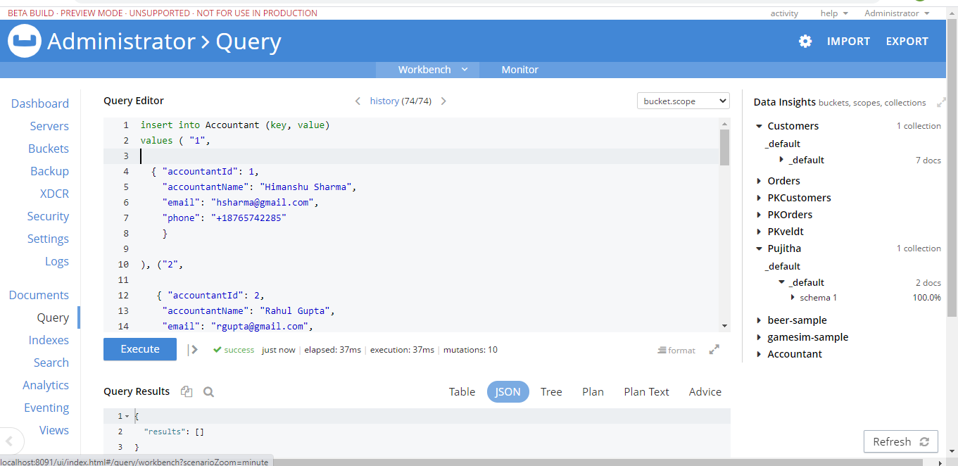

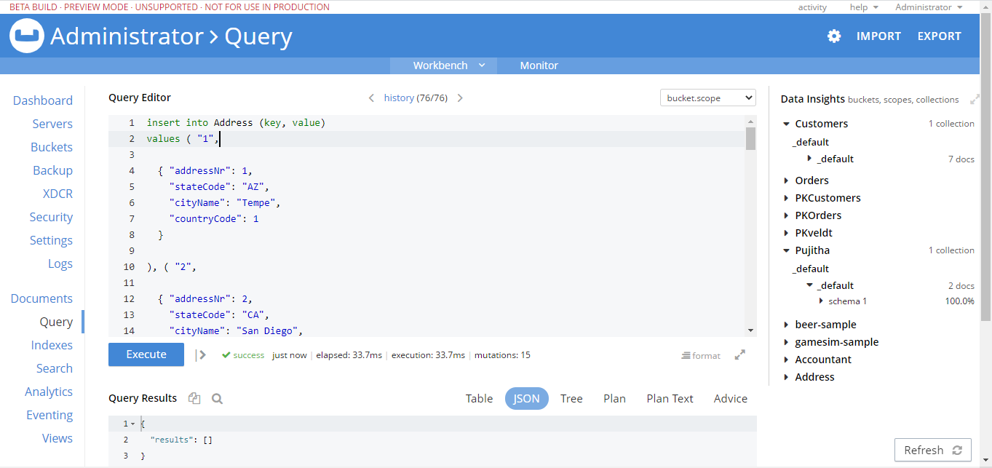

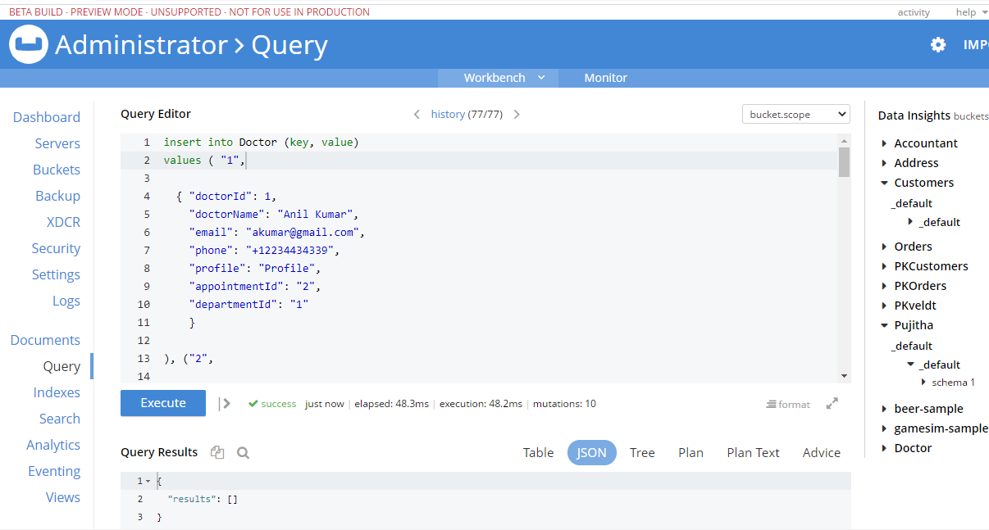

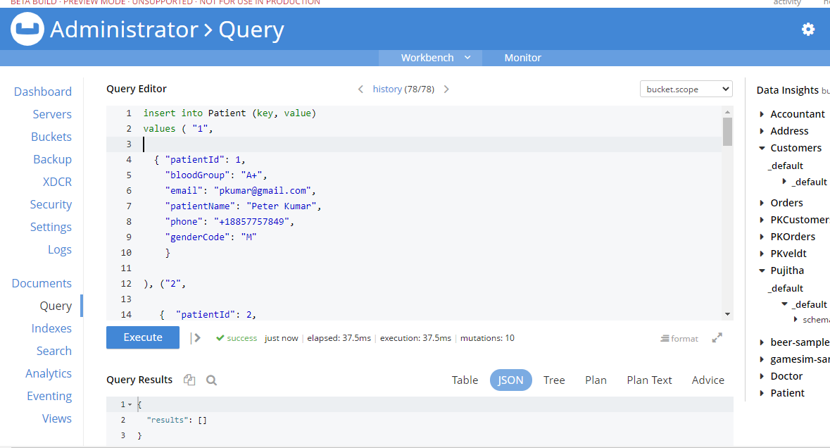

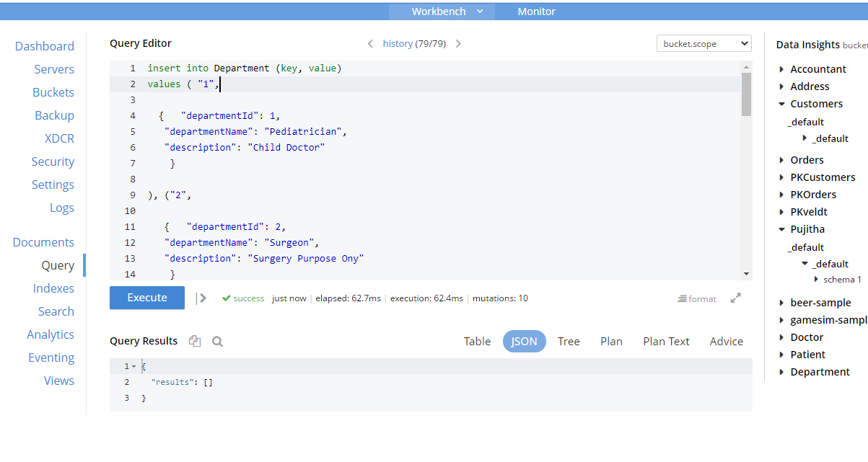

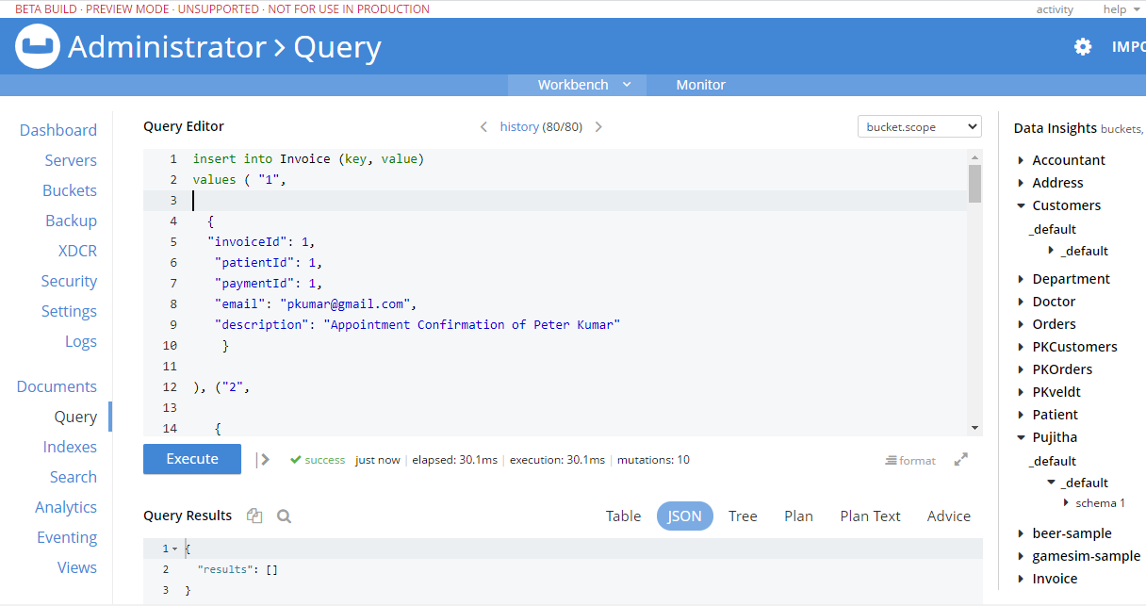

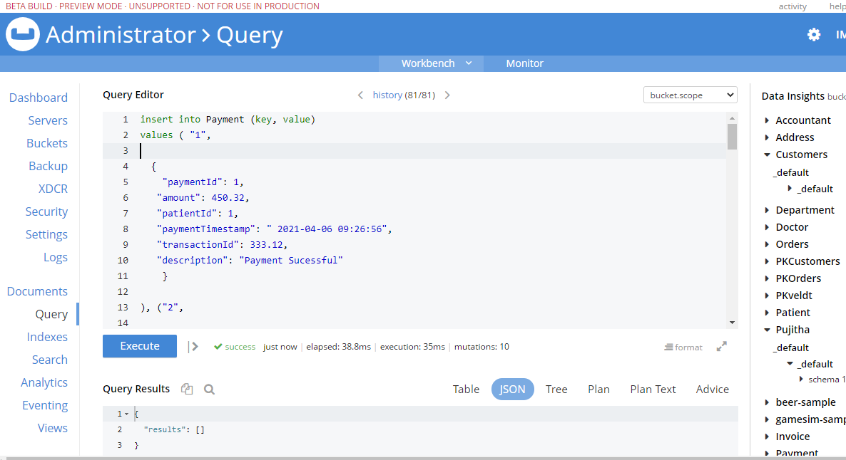

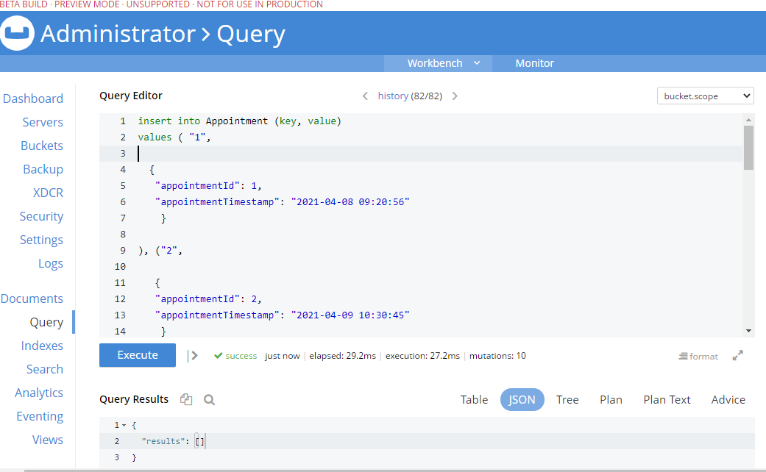

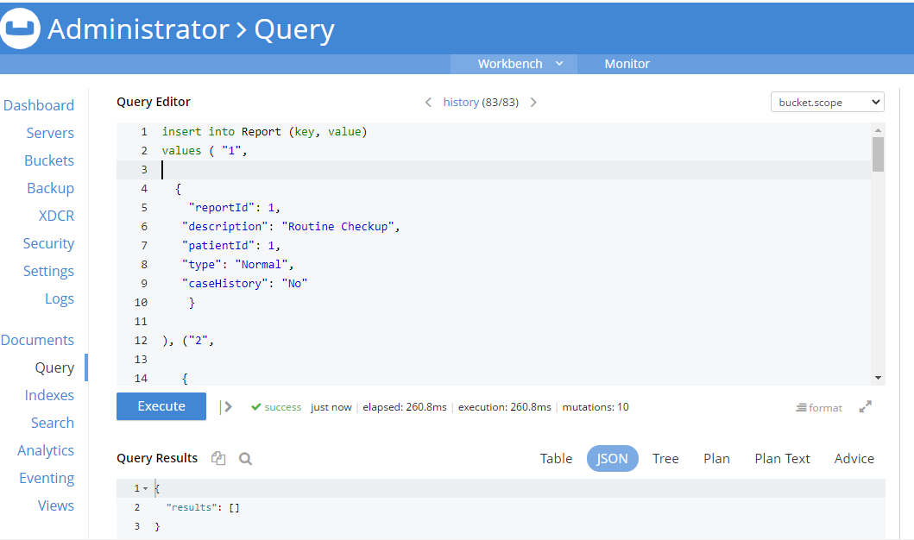

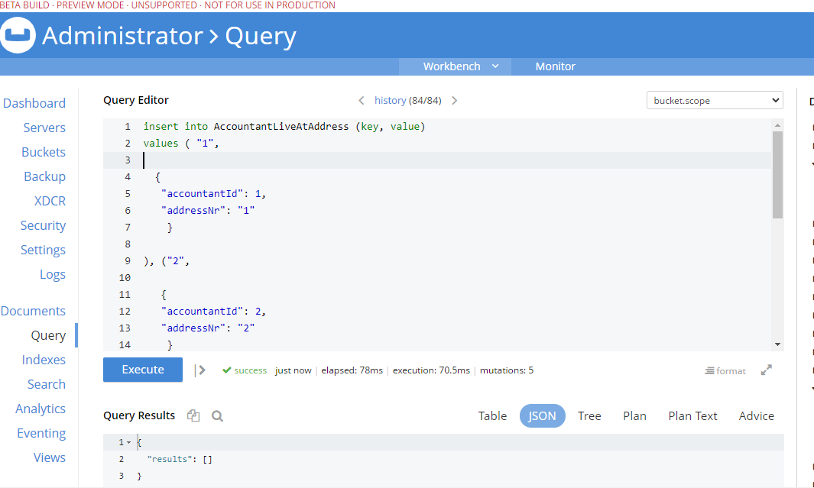

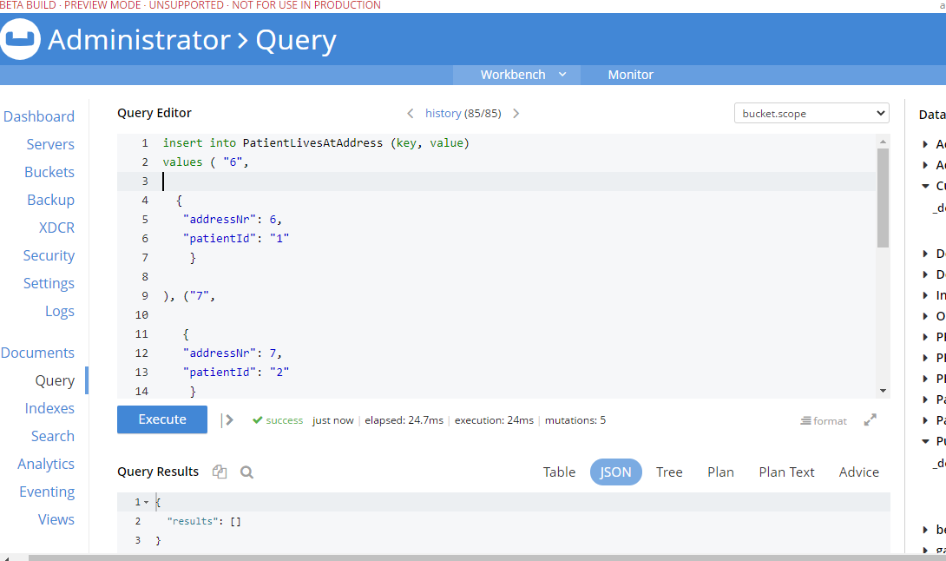

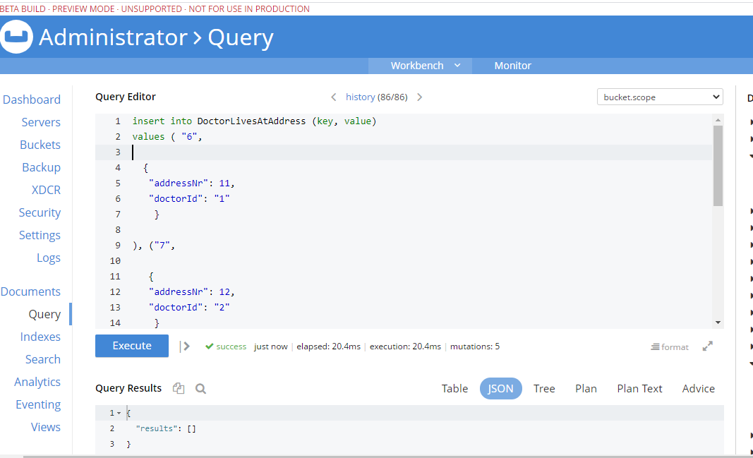

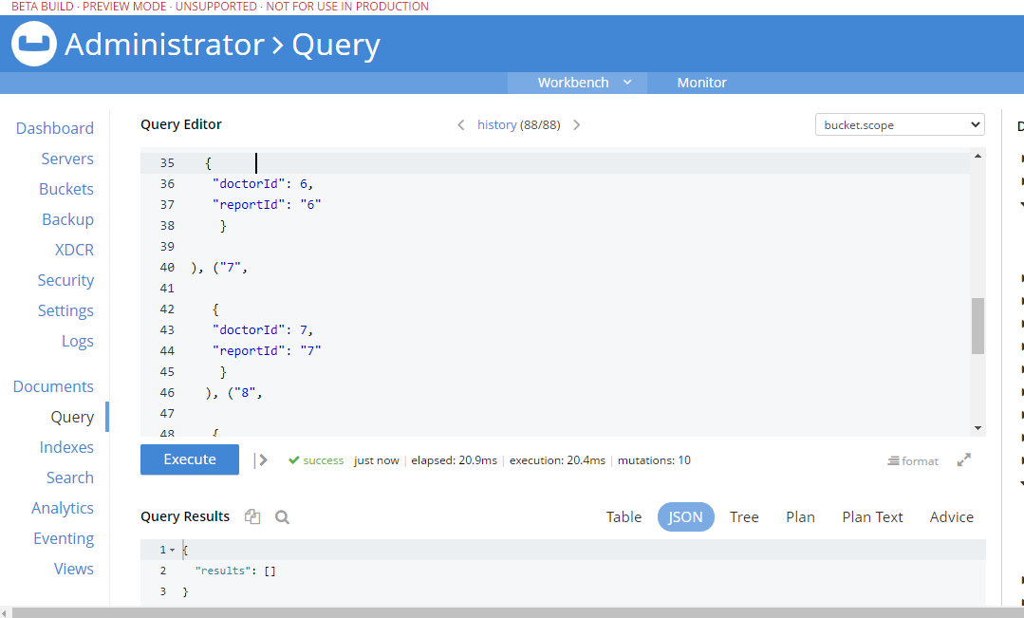

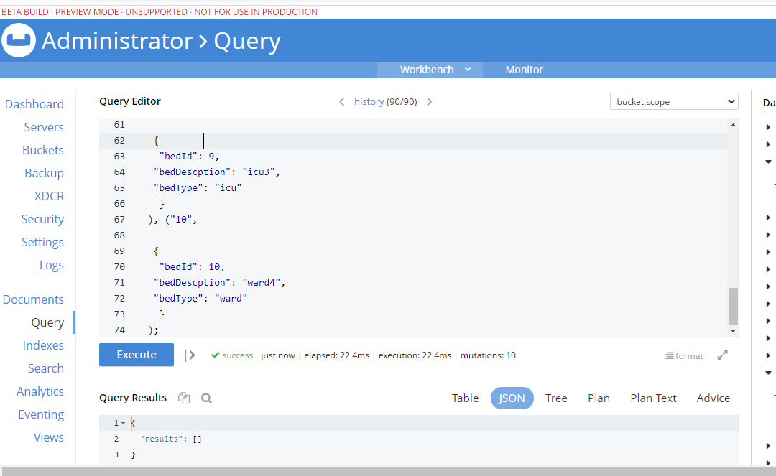

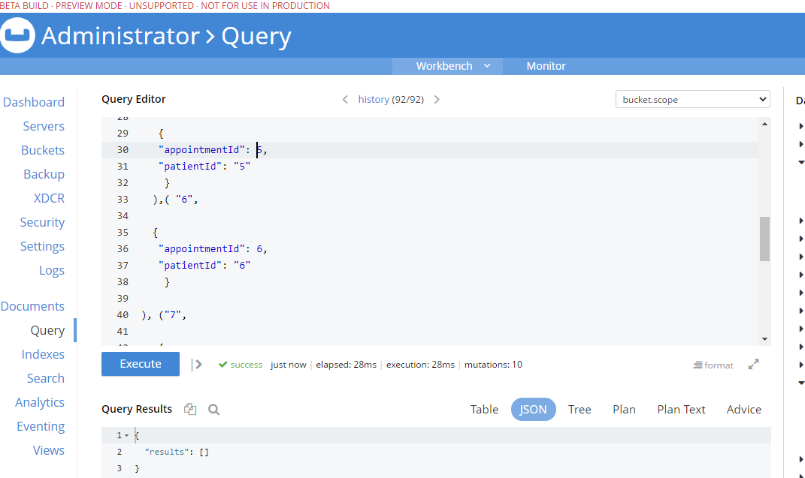

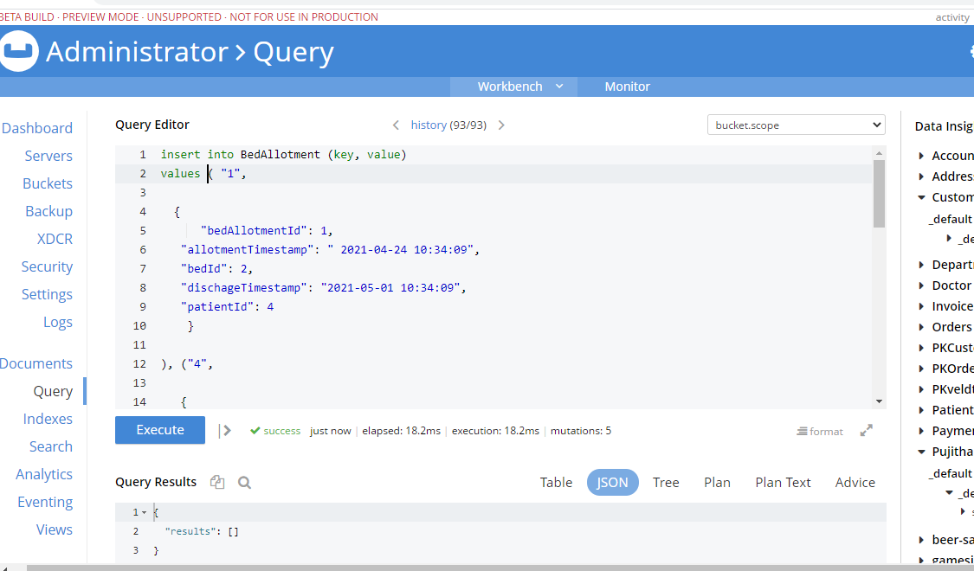

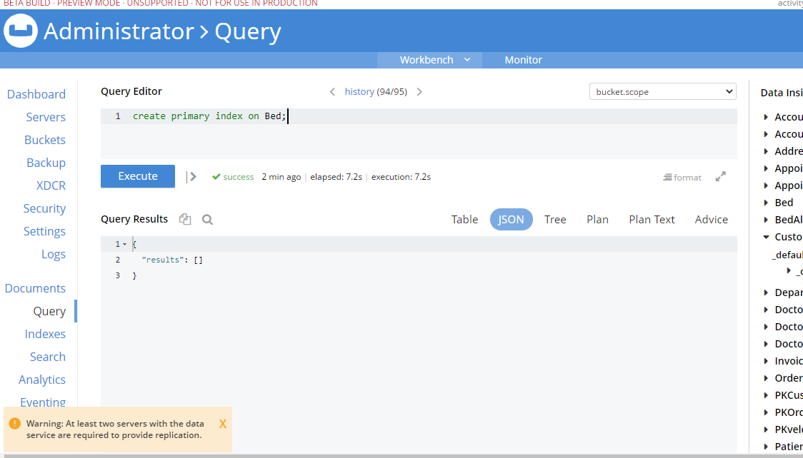

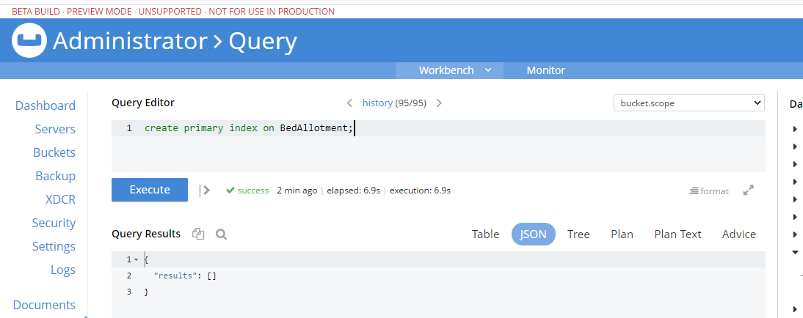

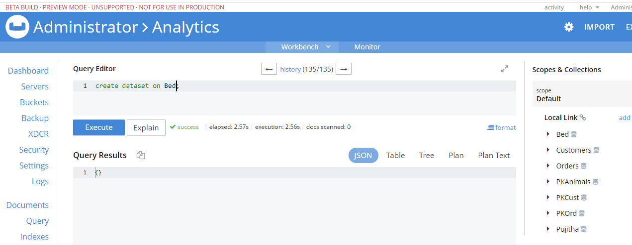

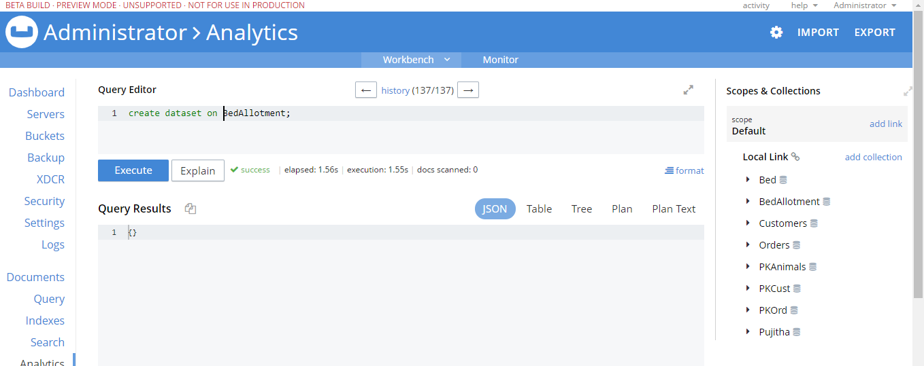

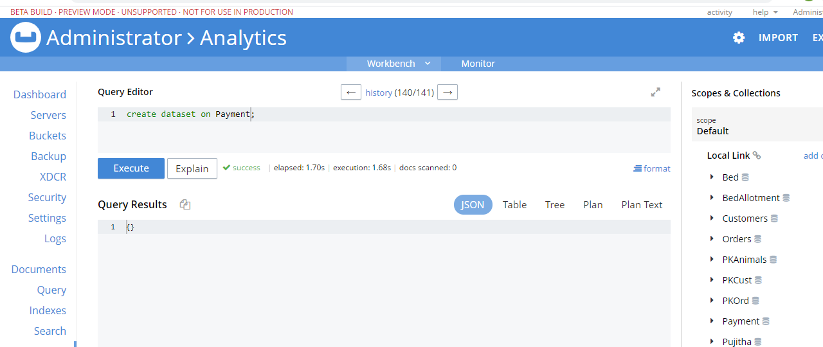

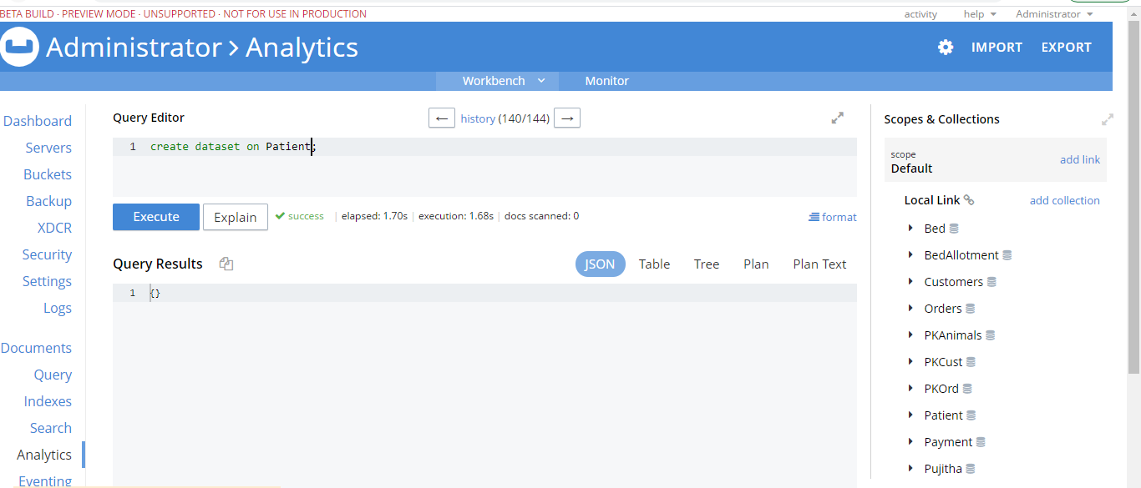

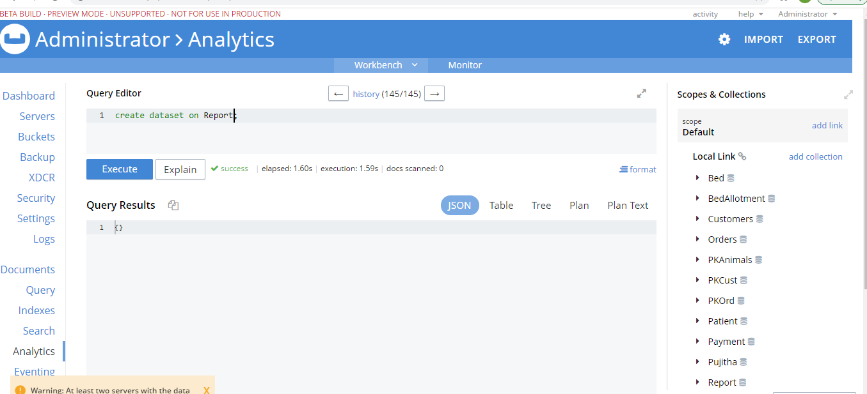

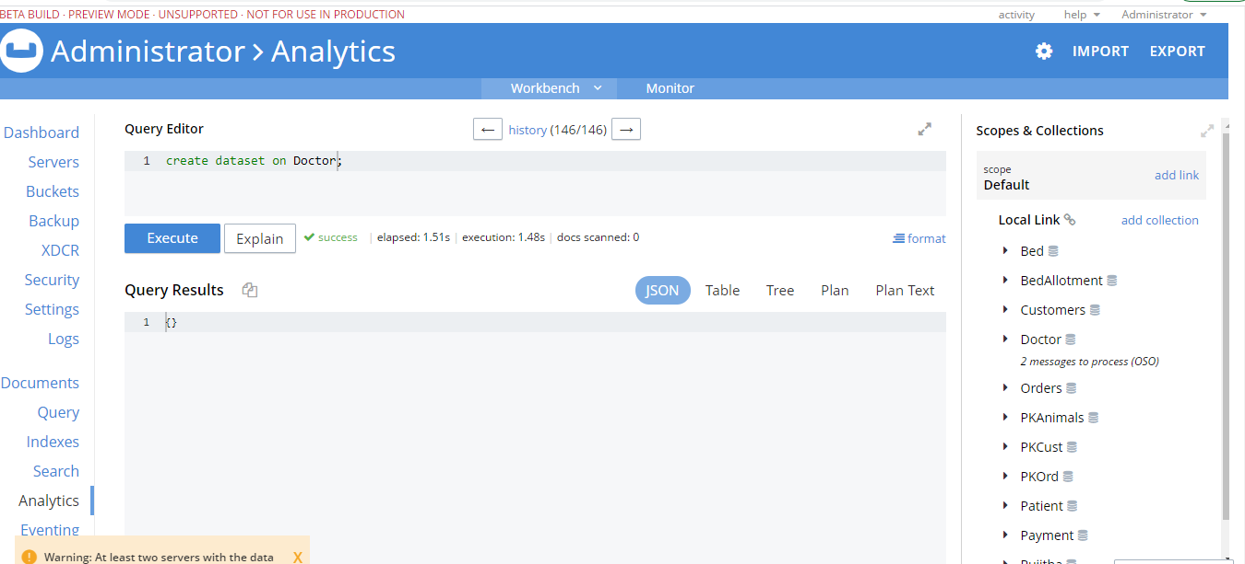

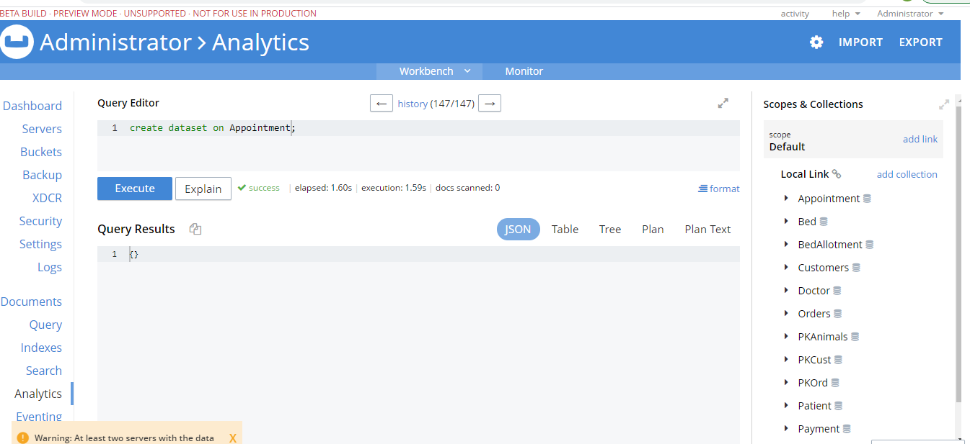

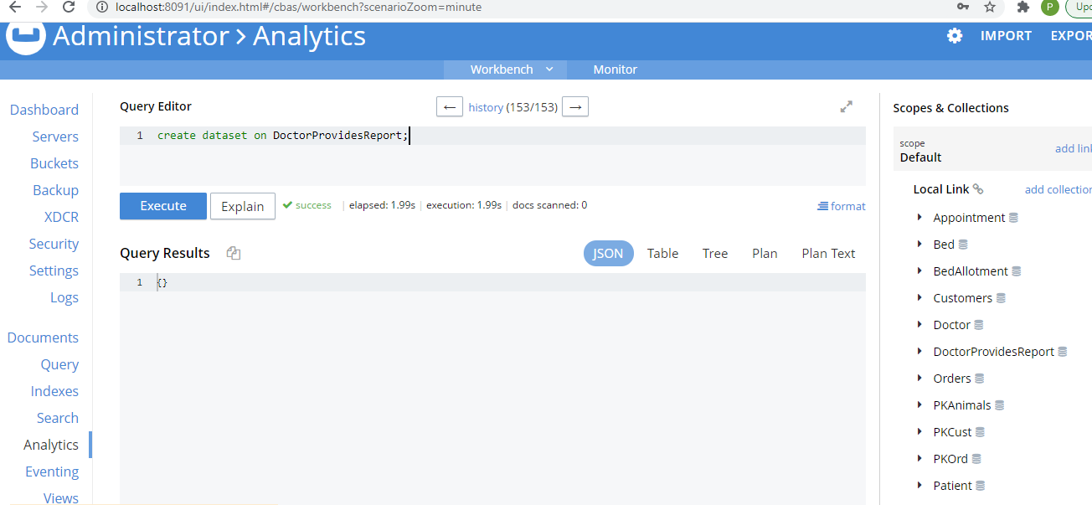

# Queries

**Query 1**

The below query provides information about the number of appointments registered in each month.

FROM Appointment

GROUP BY DATE_PART_STR(appointmentTimestamp, "month")

SELECT COUNT(*) AS NumberOfAppointments,

DATE_PART_STR(appointmentTimestamp, "month") AS monthNumber

**Screenshot:**

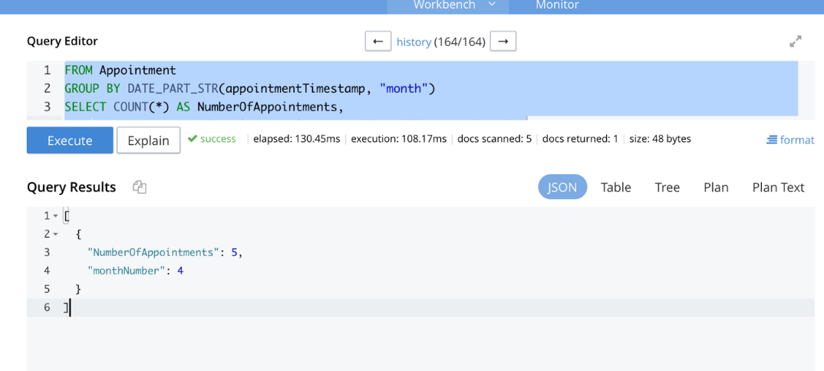

**Query 2**

The below query yields information about the details of the patient which includes patient name, blood group, phone number, gender, assigned doctor name and timestamp etc.

FROM Report AS r,

Patient AS p,

Doctor AS d,

Appointment AS a,

DoctorProvidesReport AS dpr

WHERE p.patientId = r.patientId

AND d.appointmentId = a.appointmentId

AND d.doctorId = dpr.doctorId

AND r.reportId = dpr.reportId SELECT p.patientName,

p.bloodGroup,

p.phone,

p.genderCode,

d.doctorName,

a.appointmentTimestamp AS AppointmentDate,

r.description,

r.caseHistory

**Screenshot:**

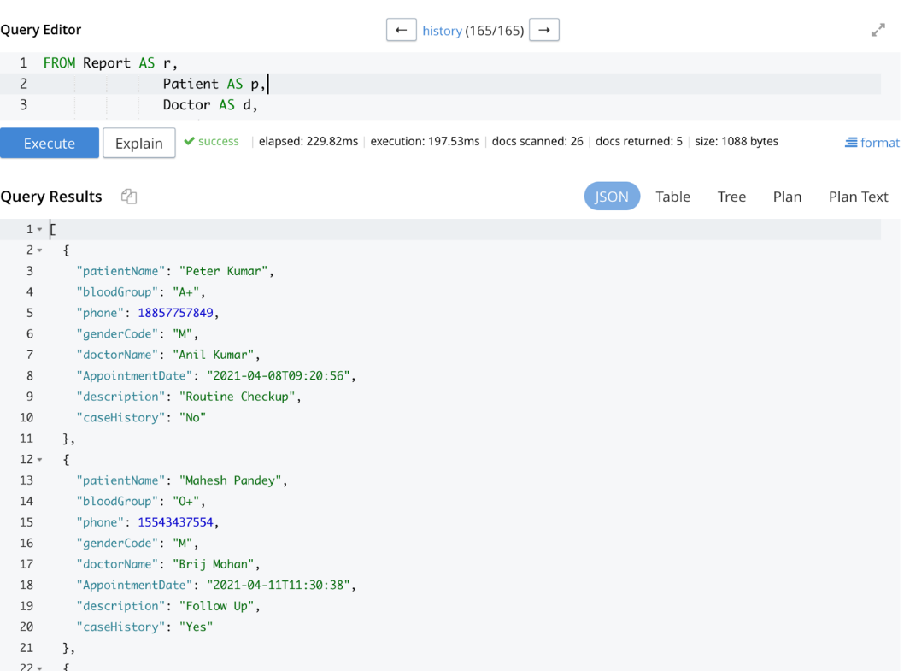

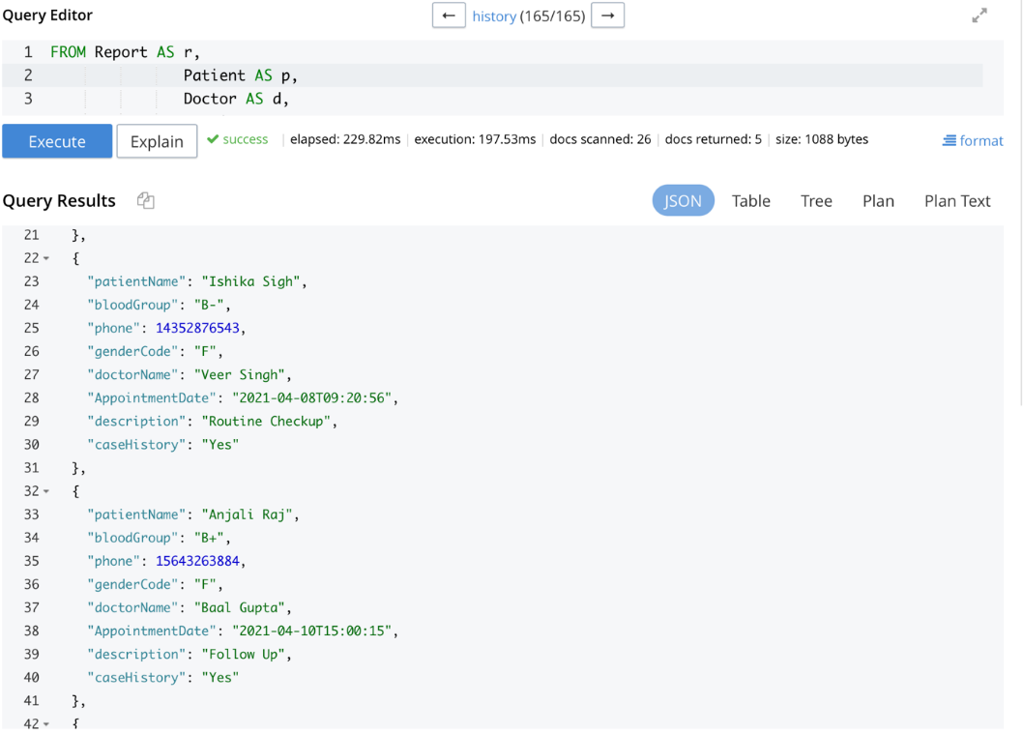

**Query 3**

The below query gives information about the month wise count of payments and total amount received.

FROM Payment

GROUP BY DATE_PART_STR(paymentTimestamp, "month")

SELECT COUNT(*) AS NumberOfPayments,

SUM(Amount) AS TotalCashReceived,

DATE_PART_STR(paymentTimestamp, "month") AS paymentMonth

**Screenshot:**

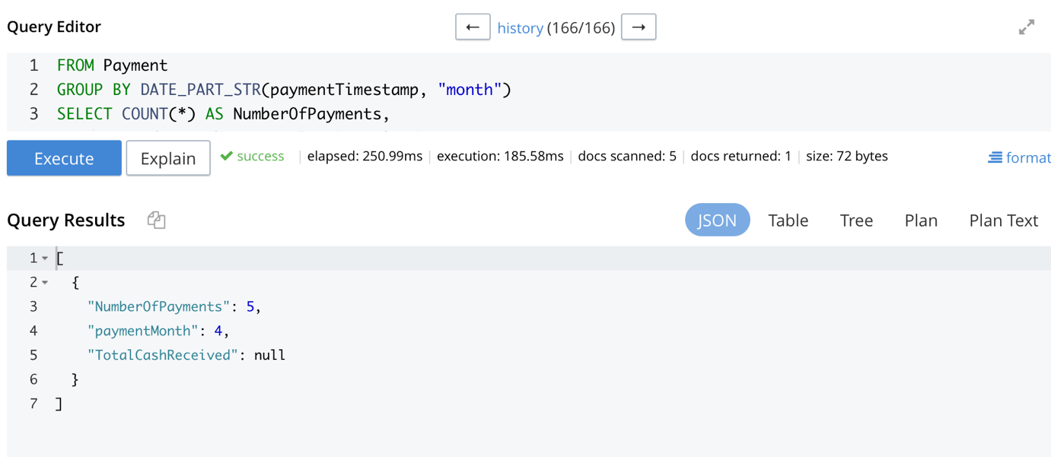

# Window Function

**Query1**

Window function to find the average amount in the Payment Bucket.

FROM Payment select avg(amount) as avg_payment;

**Screenshot:**

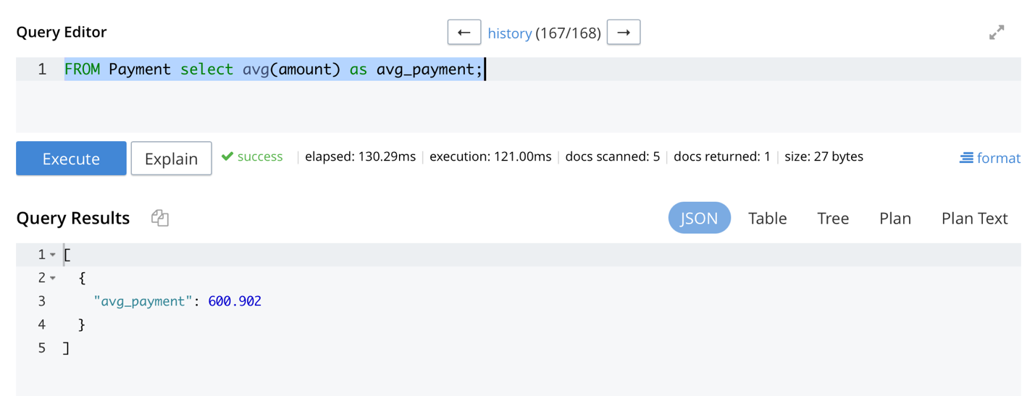

**Query2**

Window Function to find the minimum amount in the Payment Bucket.

FROM Payment select min(amount) as min_amount;

**Screenshot:**

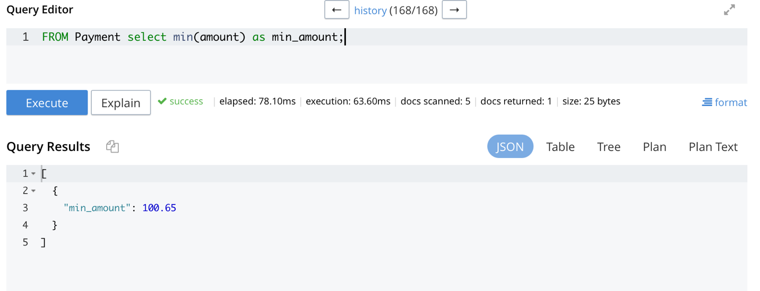

# Summary

E Clinical Work system is a computer system that helps manage the information related to health care and aids in the job completion of health care providers effectively. They manage the data related to all departments of healthcare such as, [Clinical](https://mocdoc.in/util/clinic-management-system), Laboratory, Patients, Beds, Bed Allotment, Doctor, staff etc. In today’s world, the management of healthcare starts from the hands of the patients through their mobile phones and facilitates the needs of the patient. Reduces the work of documentation. Maintain the medical records of the patient. It maintains the contact details of the patients. It Keeps track of the appointment dates and it will also track the bill payments.

# Conclusion

E-Clinical work digitalizes all the manual and ad hoc work in the hospital and simplifies the life of day-to-day work that is done manually by all the staff in the hospital, data entry of the patients. It effectively overcomes the delay in day-to-day manual ad hoc paperwork by staff, doctors, and patients. E-Clinical improves efficiency and saves time which otherwise takes more time manually. Updating the information becomes much easier.

# References

John Sokpo (Sep 22, 2017)[*Hospital-management-system*](https://github.com/jsokpo/Hospital-management-system) from

<https://github.com/jsokpo/Hospital-management-system/commit/0eee24eed49979bd79d5f7de21495604d6a401a1>

Syverson. B, Murach. J (2016). *Murach’s SQL Server 2016 for Developers* (Training & Reference)